**SOFTWARE ENGINEERING**

FALL 2017





CMPE 273

ENTERPRISE DISTRIBUTED SYSTEMS

Team 17

|  |  |
| --- | --- |
| **SJSU ID** | **TEAM MEMBER** |
| 012461371 | Vishweshkumar Patel |
| 010823657 | Varun Shah |
| 012457289 | Sunny Udhani |
| 012482990 | Pritam Meher |
| 012415988 | Rutvik Pensionwar |

Contributions:

1. Vishweshkumar Patel

* Database design for MySQL and MongoDB Models.
* Admin dashboard analytics charts using user activity logs and processed them using elastic search.
* Frontend for admin dashboard
* Backend for admin dashboard
* Validations for Admin module

2. Varun Shah

* Front-end for whole admin module with functionality to add, edit and view hotels, flights, cars(listings and bookings), users, hosts with filtering functionality
* Backend for admin module with functionality to add, edit, view hotels, flights, cars (listings and bookings), , users, hosts with filtering functionality
* Admin module validations

3. Sunny Udhani

* Frontend for hotel listing, flight listing, car listing with filtering functionality for hotels, flights, cars based on appropriate inputs.
* Backend for hotel listing, flight listing, car listing with filtering functionality for hotels, flights, cars based on appropriate inputs.
* Redis caching
* JMeter testing

4. Pritam Meher

* Frontend for hotel detail page, user profile with view,edit functionality for preferences, managing credit card details and trip history.
* Backend hotel detail page, user profile with view,edit functionality for preferences, managing credit card details and trip history.

5. Rutvik Pensionwar

* Frontend for hotel - flight - car booking with respective payment and billing details, sign in, sign up.
* Backend for hotel - flight - car booking with respective payment and billing details, sign in, sign up.

**1 Introduction**

The objective of the project is to develop ‘KAYAK’ prototype. KAYAK is a travel metasearch engine, which enables users to search and book hotels, flights, and cars. KAYAK’s other services include packages, rentals, cruises, guides, trains, flight tracker, routes, and deals. The application compares the prices with other websites and views the best deal.

Users are able to create (sign-up) an account. In order to view/manage their booking they must login and click account preferences under the Account tab. They have the privilege to set up their own profile image which appears at the top-right corner. Users can view and edit all their personal details under the preferences tab. This information include first name, last name, email, gender, address (street, city, state, zipcode) , contact info and date of birth.

One can add and view all the credit/debit cards linked to their account. They may also view all of their past bookings (hotel | flights | cars).

We have included validations on every user input of the application. Server is tested for myriad concurrent users at a time. We have used Jmeter as a load testing tool for analyzing and measuring performance. Mocha, a javascript enabled framework serves the purpose testing the REST APIs.

Refer the requirement section for more info on implementation.

**2 Purpose**

Learn and apply MERN stack to develop an online travel reservation system and use distributed publish-subscribe messaging system like Kafka to develop scalable, durable, reliable, and high-throughput distributed system. Moreover, we have used Redis for cache management.

**3 System Design**

Technologies used for development of KAYAK prototype

|  |  |
| --- | --- |
| **Part of application** | **Technologies used** |
| Front end | React.js  We use React, the JS library for building our application’s user interface. It enables us to create large webapps that change overtime w/o reloading page. |
| Back end | Node.js  We have used Node.js for server-side JS execution and Express.js as a web application framework for Node. |
| Markup, UI/UX | HTML5, CSS3, bootstrap, react-strap  Just like bootstrap, we have used React’s in-built front-end component library, popularly known as react-strap. This is an open source toolkit for developing front-end along with other markup languages.. |
| Database | SQL  Structured Query Language is used to manage transactional data like  **1** user credentials  **2** user profile  **3** booking details  **4** traveller information  **5** payment information  **6** billing information  Mongo  MongoDB is used as a database to store all other records like  **1** hotel details  **2** flight details  **3** car details  **4** sessions |
| Password hashing | Bcrypt  We have used Bcrypt as a password hashing function. It is one of the efficient encryption algorithms and resistant to brute force attacks |
| Authentication middleware | Passport.js  We make use of an express-compatible middleware called Passport whose sole purpose is to authenticate requests which is accomplished by strategies. |
| Log generation | Winston  We use versatile logging library named Winston to log messages to console. |
| Stream processing | Kafka  We use Kafka as a streaming platform to build real-time streaming data pipelines that reliably get data between applications. |
| Data caching | Redis  Redis is an in-memory data structure store used for cache. Depending on your use case, you can persist it either by dumping the dataset to disk every once in awhile, or by appending each command to a log |
| Scripting language | Javascript |

**4 Connection pooling**

Large amount of time is spent in waiting to get the connection back from mysql, since we re-use a single connection again and again. This degrades the performance. Using a connection pool, we can reuse existing connections avoiding the cost of initiating a connection, parsing SQL etc. This helps server handle requests efficiently and send responses faster.

**5 Validations**

Validations are performed at various user inputs. These include

1. While hotel-booking:

1. Enter appropriate city (must not be *blank*)
2. Check-in date should not be after check-out date
3. Enter valid number of people (must not be *blank*)
4. Enter valid number of rooms (must not be *blank*)

2. While flight-booking:

1. Selecting valid to & from airports (must not be *blank*)
2. Mandatory selection of ‘departure-date’ for return booking
3. Enter valid number of persons traveling
4. Mandatory selection of flight class

3. While car-booing:

1. Enter appropriate city (must not be *blank*)
2. Pick-up date should not be afte drop-off date
3. None of the two date fields must be blank

4. Pin code validation (length must *not be more than 5*)

**6 Architecture**

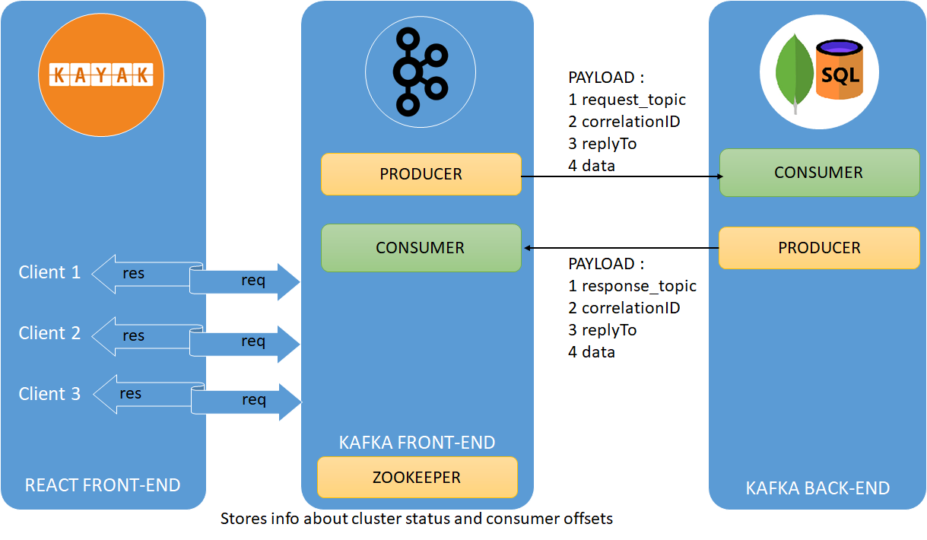

**7 Project Overview**

A 3-tier application is developed that will implement all the basic functionalities of that of a online travel reservation system, like KAYAK.com. This include travel services like hotel, flight and car booking.

We managed distinct types of objects viz.

1 User

2 Administrator

3 Listing

4 Biling

We stored all the transactional data into SQL whereas stored all the travel services data/listings into the MongoDB.

Respective SQL schemas are listed one-by-one.

|  |  |
| --- | --- |
| USER.sql   |  | | --- | | DROP TABLE IF EXISTS `user`;  /*!40101 SET @saved_cs_client = @@character_set_client */;  /*!40101 SET character_set_client = utf8 */;  CREATE TABLE `user` (  `username` varchar(50) NOT NULL,  `password` varchar(500) NOT NULL,  `accessInd` varchar(10) NOT NULL,  PRIMARY KEY (`username`)  ) ENGINE=InnoDB DEFAULT CHARSET=utf8; | |

|  |  |
| --- | --- |
| USERPROFILE.sql   |  | | --- | | DROP TABLE IF EXISTS `userprofile`;  /*!40101 SET @saved_cs_client = @@character_set_client */;  /*!40101 SET character_set_client = utf8 */;  CREATE TABLE `userprofile` (  `username` varchar(50) NOT NULL,  `firstName` varchar(50) NOT NULL,  `lastName` varchar(50) NOT NULL,  `street` varchar(50) DEFAULT NULL,  `city` varchar(50) DEFAULT NULL,  `state` varchar(50) DEFAULT NULL,  `zipCode` varchar(50) DEFAULT NULL,  `phoneNumber` varchar(45) DEFAULT NULL,  `profileImage` varchar(100) DEFAULT NULL,  `dateofbirth` date DEFAULT NULL,  `gender` varchar(10) DEFAULT NULL,  PRIMARY KEY (`username`),  CONSTRAINT `username` FOREIGN KEY (`username`) REFERENCES `user` (`username`) ON DELETE CASCADE  ) ENGINE=InnoDB DEFAULT CHARSET=utf8; | |

|  |  |
| --- | --- |
| HOTELBOOKING.sql   |  | | --- | | DROP TABLE IF EXISTS `hotelbooking`;  /*!40101 SET @saved_cs_client = @@character_set_client */;  /*!40101 SET character_set_client = utf8 */;  CREATE TABLE `hotelbooking` (  `bookingId` mediumint(10) NOT NULL AUTO_INCREMENT,  `hotelId` varchar(100) NOT NULL,  `noOfPeople` int(1) NOT NULL,  `roomType` varchar(10) NOT NULL,  `fromDate` date NOT NULL,  `toDate` date NOT NULL,  `ticketPrice` float NOT NULL,  `totalAmount` float NOT NULL,  `username` varchar(50) NOT NULL,  `hostId` mediumint(6) NOT NULL,  `bill_day` varchar(45) DEFAULT NULL,  `bill_month` varchar(45) DEFAULT NULL,  `bill_year` varchar(45) DEFAULT NULL,  PRIMARY KEY (`bookingId`),  KEY `username_idx` (`username`),  CONSTRAINT `hotelbooking_ibfk_1` FOREIGN KEY (`username`) REFERENCES `user` (`username`) ON DELETE NO ACTION ON UPDATE NO ACTION  ) ENGINE=InnoDB AUTO_INCREMENT=16 DEFAULT CHARSET=utf8; | |

|  |  |
| --- | --- |
| FLIGHTBOOKING.js   |  | | --- | | DROP TABLE IF EXISTS `flightbooking`;  /*!40101 SET @saved_cs_client = @@character_set_client */;  /*!40101 SET character_set_client = utf8 */;  CREATE TABLE `flightbooking` (  `bookingId` mediumint(10) NOT NULL AUTO_INCREMENT,  `flightId` varchar(100) NOT NULL,  `noOfPassengers` int(3) NOT NULL,  `flightClass` varchar(50) NOT NULL,  `tripType` varchar(10) NOT NULL,  `fromDate` date NOT NULL,  `toDate` date DEFAULT NULL,  `ticketPrice` float NOT NULL,  `totalAmount` float NOT NULL,  `username` varchar(50) NOT NULL,  `hostId` mediumint(6) NOT NULL,  `bill_day` varchar(45) DEFAULT NULL,  `bill_month` varchar(45) DEFAULT NULL,  `bill_year` varchar(45) DEFAULT NULL,  PRIMARY KEY (`bookingId`),  KEY `username_idx` (`username`),  CONSTRAINT `flightbooking_ibfk_1` FOREIGN KEY (`username`) REFERENCES `user` (`username`) ON DELETE CASCADE  ) ENGINE=InnoDB AUTO_INCREMENT=26 DEFAULT CHARSET=utf8; | |

|  |  |
| --- | --- |
| CARBOOKING.sql   |  | | --- | | DROP TABLE IF EXISTS `carbooking`;  /*!40101 SET @saved_cs_client = @@character_set_client */;  /*!40101 SET character_set_client = utf8 */;  CREATE TABLE `carbooking` (  `bookingId` mediumint(10) NOT NULL AUTO_INCREMENT,  `carId` varchar(100) NOT NULL,  `noOfDays` int(10) NOT NULL,  `fromDate` date NOT NULL,  `toDate` date NOT NULL,  `ticketPrice` float NOT NULL,  `totalAmount` float NOT NULL,  `username` varchar(50) NOT NULL,  `hostId` mediumint(6) NOT NULL,  `bill_day` varchar(45) DEFAULT NULL,  `bill_month` varchar(45) DEFAULT NULL,  `bill_year` varchar(45) DEFAULT NULL,  PRIMARY KEY (`bookingId`),  KEY `username_idx` (`username`),  CONSTRAINT `username_hotelbooking` FOREIGN KEY (`username`) REFERENCES `user` (`username`) ON DELETE NO ACTION ON UPDATE NO ACTION  ) ENGINE=InnoDB AUTO_INCREMENT=18 DEFAULT CHARSET=utf8; | |

|  |  |
| --- | --- |
| TRAVELERDETAILS.sql   |  | | --- | | DROP TABLE IF EXISTS `travelerdetails`;  /*!40101 SET @saved_cs_client = @@character_set_client */;  /*!40101 SET character_set_client = utf8 */;  CREATE TABLE `travelerdetails` (  `travelerId` mediumint(10) NOT NULL AUTO_INCREMENT,  `bookingtype` varchar(20) NOT NULL,  `bookingId` mediumint(10) DEFAULT NULL,  `firstname` varchar(50) DEFAULT NULL,  `lastname` varchar(50) DEFAULT NULL,  `email` varchar(50) DEFAULT NULL,  `phonenumber` varchar(50) DEFAULT NULL,  PRIMARY KEY (`travelerId`)  ) ENGINE=InnoDB AUTO_INCREMENT=50 DEFAULT CHARSET=utf8; | |

|  |  |
| --- | --- |
| PAYMENTDETAILS.sql   |  | | --- | | DROP TABLE IF EXISTS `paymentdetails`;  /*!40101 SET @saved_cs_client = @@character_set_client */;  /*!40101 SET character_set_client = utf8 */;  CREATE TABLE `paymentdetails` (  `username` varchar(50) NOT NULL,  `nameoncard` varchar(50) NOT NULL,  `creditCardNumber` varchar(45) NOT NULL,  `validThrough` varchar(45) NOT NULL,  `cvv` varchar(3) NOT NULL,  PRIMARY KEY (`creditCardNumber`),  KEY `username_idx` (`username`),  CONSTRAINT `paymentdetails_ibfk_1` FOREIGN KEY (`username`) REFERENCES `user` (`username`) ON DELETE CASCADE ON UPDATE NO ACTION  ) ENGINE=InnoDB DEFAULT CHARSET=utf8; | |

|  |  |
| --- | --- |
| BILLINGADDRESS.sql   |  | | --- | | DROP TABLE IF EXISTS `billingaddress`;  /*!40101 SET @saved_cs_client = @@character_set_client */;  /*!40101 SET character_set_client = utf8 */;  CREATE TABLE `billingaddress` (  `username` varchar(50) NOT NULL,  `street1` varchar(30) NOT NULL,  `street2` varchar(30) DEFAULT NULL,  `postalcode` varchar(10) NOT NULL,  `city` varchar(20) DEFAULT NULL,  `state` varchar(20) DEFAULT NULL,  `country` varchar(20) DEFAULT NULL,  PRIMARY KEY (`username`,`street1`,`postalcode`),  CONSTRAINT `billingaddress_ibfk_1` FOREIGN KEY (`username`) REFERENCES `user` (`username`) ON DELETE NO ACTION ON UPDATE NO ACTION  ) ENGINE=InnoDB DEFAULT CHARSET=utf8; | |

|  |  |
| --- | --- |
| HOST.sql   |  | | --- | | DROP TABLE IF EXISTS `host`;  /*!40101 SET @saved_cs_client = @@character_set_client */;  /*!40101 SET character_set_client = utf8 */;  CREATE TABLE `host` (  `hostId` mediumint(9) NOT NULL AUTO_INCREMENT,  `hostName` varchar(100) NOT NULL,  `serviceType` enum('flight','hotel','car') NOT NULL,  PRIMARY KEY (`hostId`)  ) ENGINE=InnoDB AUTO_INCREMENT=8 DEFAULT CHARSET=utf8; | |

We have managed the following information for the **USER** entity.

1 User ID

2 First Name

3 Last Name

4 Address

5 City

6 State

7 Zip Code

8 Phone number

9 Email (*is the username of the user*)

10 Trip ID (*username maintained in respective booking tables*)

11 Profile Image

12 Credit Card details

Similarly, the listing for all the three objects were maintained properly.

|  |  |  |
| --- | --- | --- |
| **HOTELS** | **FLIGHTS** | **CARS** |
| _id | _id | _id |
| hostId | flightNo | hostId |
| hotelName | hostId | carName |
| hotelAddress | flightOperator | carType |
| city | departureDate | carMake |
| state | arrivalDate | carModel |
| zipcode | departureTime | capacity |
| stars | arrivalTime | city |
| rooms  _id  noOfRooms  roomPrice  roomCapacity  roomType | classes  classType  price  noOfSeats | state |
|  | duration | zipcode |
|  | origin | price |
|  | destination |  |

However, for the **billing** entity, we have maintained 3 different tables to record most important information.

|  |  |  |
| --- | --- | --- |
| **TRAVELERDETAILS** | **PAYMENTDETAILS** | **BILLINGADDRESS** |
| travelerID | username | username |
| bookingType | nameoncard | street1 |
| bookingId | creditCardNumber | street2 |
| firstname | validThrough | postalcode |
| username | cvv | city |
| lastname |  | state |
| email |  | country |
| phonenumber |  |  |

**8 Project Requirements**

The project consists of three states:

1. Client tier

2. Middleware/messaging tier

3. Database tier

All the project requirements are implemented successfully. A brief introduction to all those functionalities are described below:

**OBJECT MANAGEMENT POLICY**

**TIER 1 - CLIENT REQUIREMENTS**

Here, the user will interact with our system.

The application allows the **user** to do the following:

1. Sign up the user to use the application

2. Edit user profile. Attributes include email, firstname, lastname, gender, street, city, state, zipcode, phone number and date of birth

3. View user profile under account preferences tab

4. Search for hotels, flights and cars

5. Filter the listing/query outcomes

a. Filter hotels based on ratings and hotel price

b. Filter flights based on its arrival time, departure time and price range

c. Filter cars based on car type and price range

6. Book a hotel, flight, car

7. View all his/her past bookings under ‘Trip History’

Functionalities for **admin** module,

1. Only the authorized user (admin) is able to access Admin module.

2. Add new hotel, flight, car entries to the DB

3. Edit/Modify the existing object (hotel, flight, car) entries

4. Edit/Modify the existing users information

5. Search for a booking based on attributes like username, bookingId

Moreover, the admin is authorized to monitor the stats using graphs. The admin dashboard consists of graphs that depict

1. Number of clicks per page - Bar graph

2. Top 10 hotels with their revenue - Bar graph

3. Least seen area/page of the website - Pie chart

4. Number of clicks per property - Donut chart

5. Top 10 flight operators based on revenue generated - Bar graph

6. Reviews/property - Pie chart

7. Revenue generated based on city (segregated based on booking service) - Bar chart

8. Top 10 cars based on revenue (segregated based on car type) - Bar graph

9. Top 10 hosts (inclusive of all services) - Donut chart

* The data required to plot the graphs is fetched from the logs.

**TIER 2 - MIDDLEWARE TIER**

The middleware tier in our system is used for sending and recieving messages from the client side to the server side. The middleware tier used in our system is Apache Kafka. Multiple consumers are created which are dedicatedly listening to the requests on the topics.

**TIER 3 - DATABASE TIER**

Our system uses two different database systems :

1. MySQL: All the transactional details of the user for eg Payment details, Billing Address is stored in MYSQL to preserve ACID properties

2. MONGODB: In mongodb the data whose size is large is stored. Also the data which do not have any predefined schema is stored.

Database Design:

The database design heavily depends upon different modules which have been implemented in the application. Different modules such as User, Admin, Host, Analytics , Billing have been used in our Kayak application. The modules like User details and Billing have predefined schema. The modules like Hotel details, Flight details and Car details have been in stored in MongoDB as they do need flexible schema.

UI and Server side Development:

The user interface is built as per Kayak application. All the required functionalities for Hotels, Cars and Flight system that are performed by Kayak.com are being successfully implemented by our system as well. Apache Kafka streams is used to handle 1000s of request.

Testing:

Testing is done heavily on the application to make the system robust. Mocha and Apache Jmeter testing is done for performance testing.

Different strategies used to store data in database:

The data is stored in database only when some validations are verified. For eg if the admin wants to insert data in database, admin validation is done first to check whether the logged in user is admin. Similarly validations are done in input fields before inserting data in database. For eg during inserting credit card details, the credit card number should be 16 digits. The session in our application is stored in mongodb using PassportJS.

**9 Modules**

**SIGN IN**

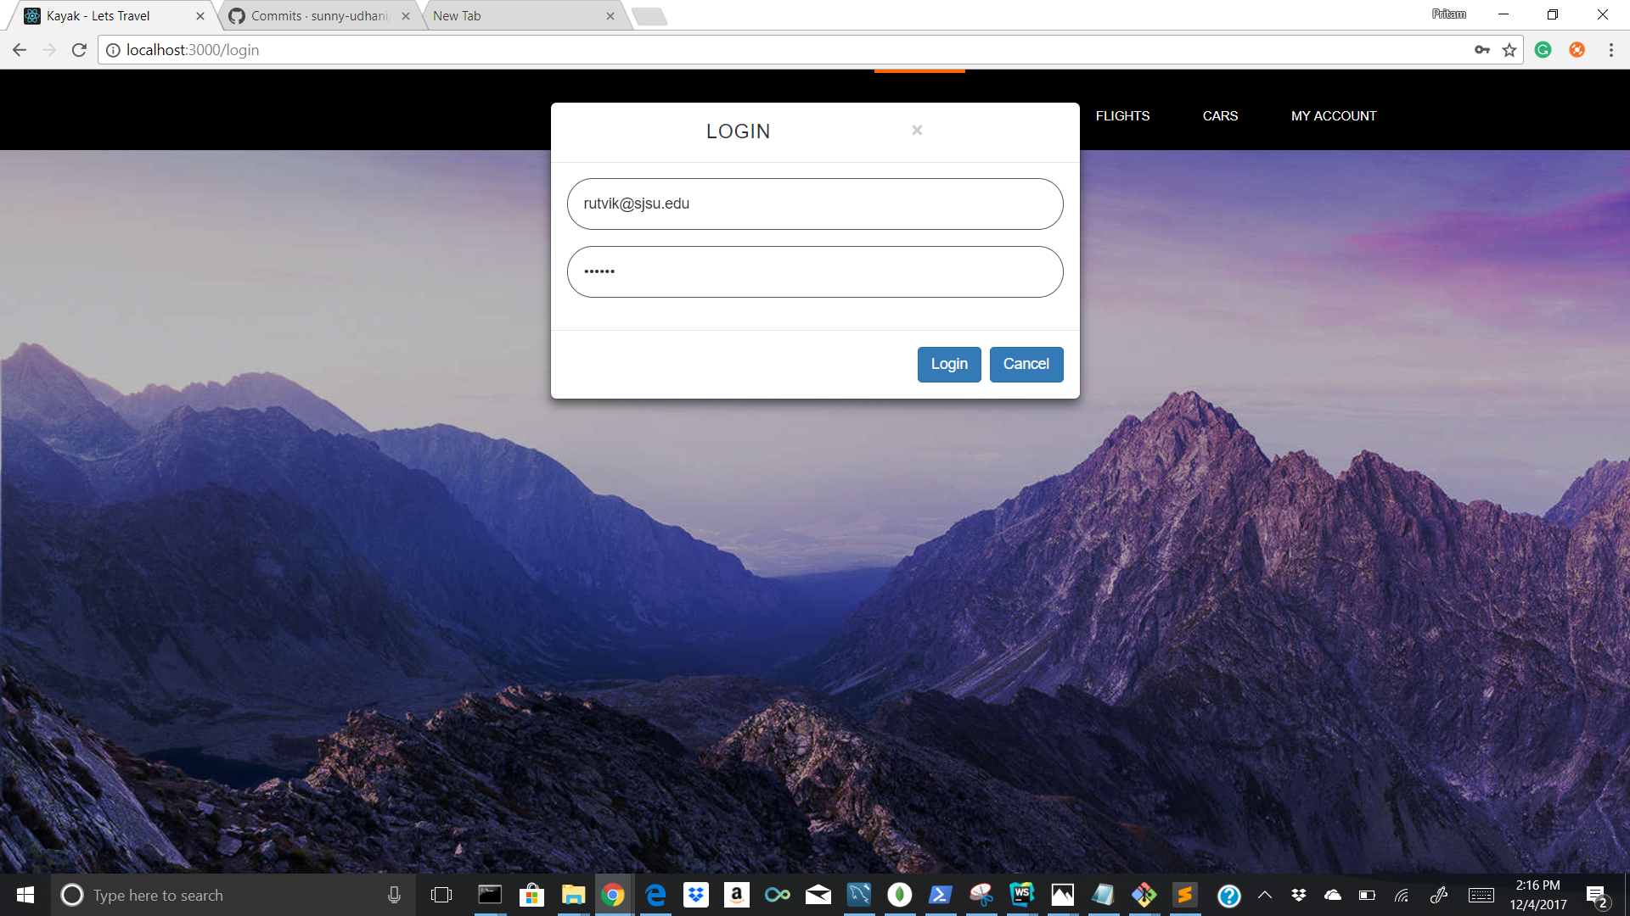

**SIGN UP**

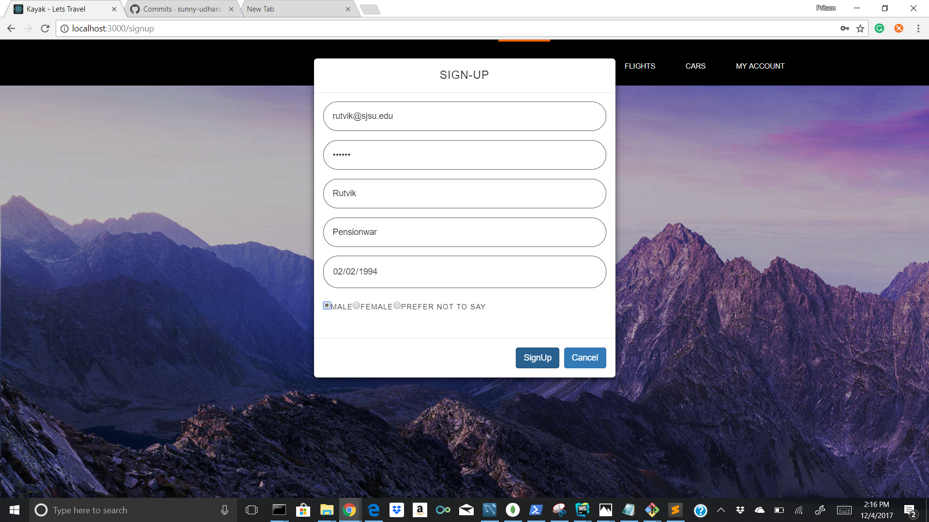

1. Homepage - Hotel

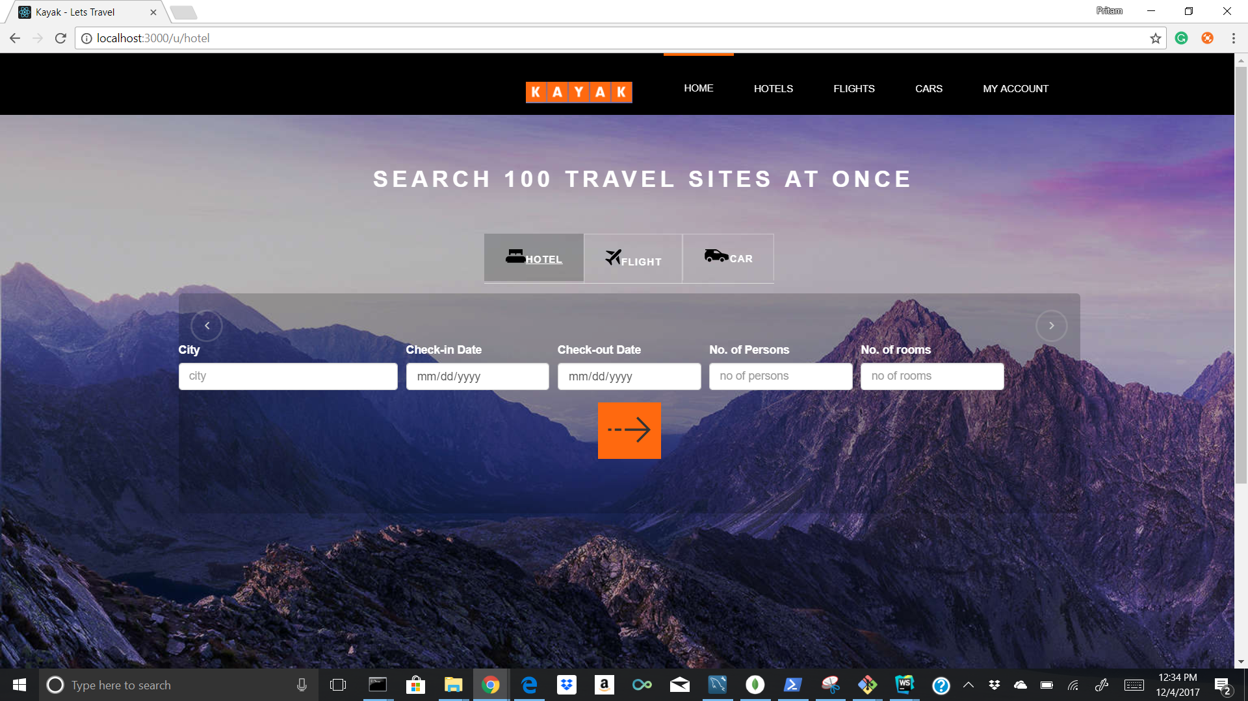

2. Homepage - Flight (One-way)

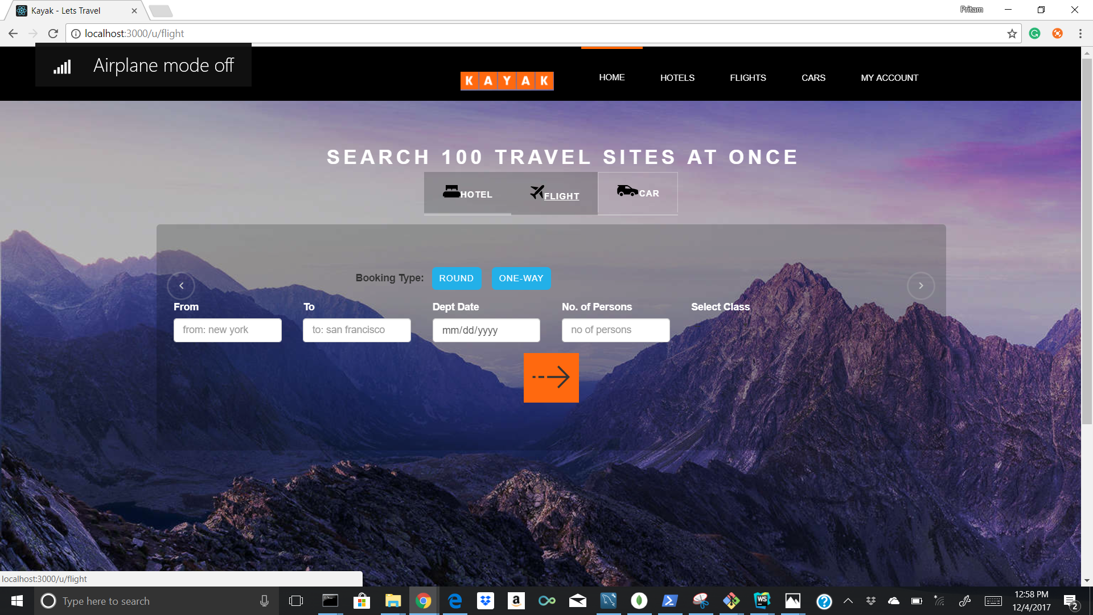

3. Homepage - Flight (Round-way)

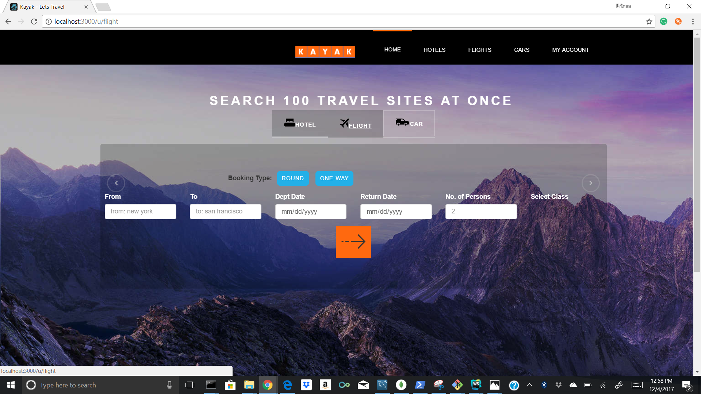

4. Homepage - Car

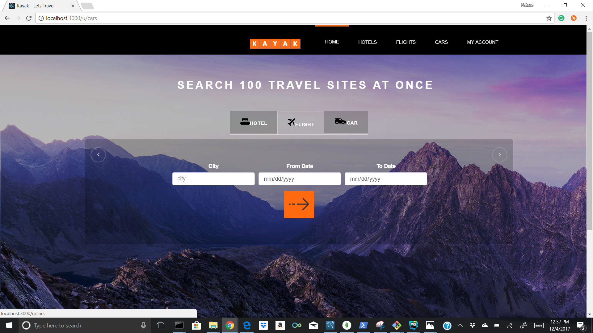

5. Homepage - Hotel Validation (select appropriate city)

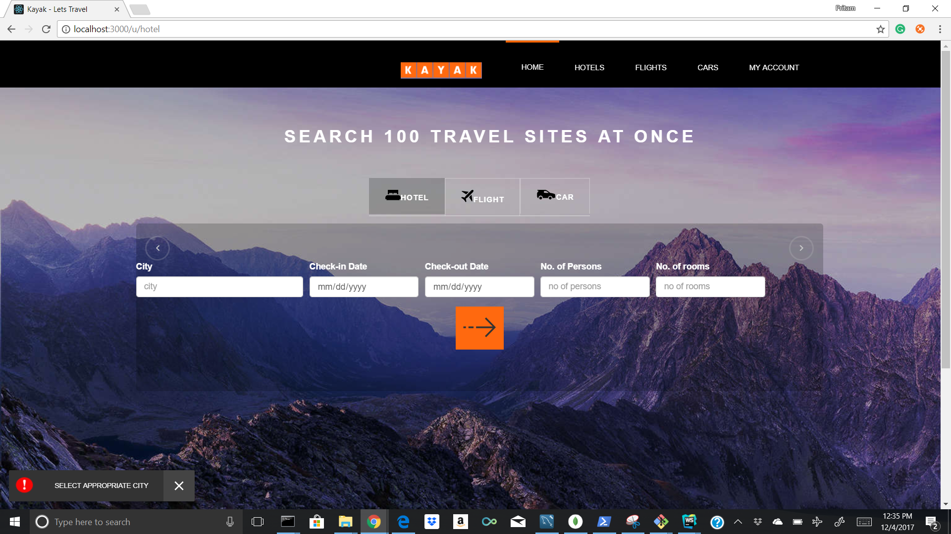

6. Homepage - Hotel Validation (select appropriate check-in and check-out dates)

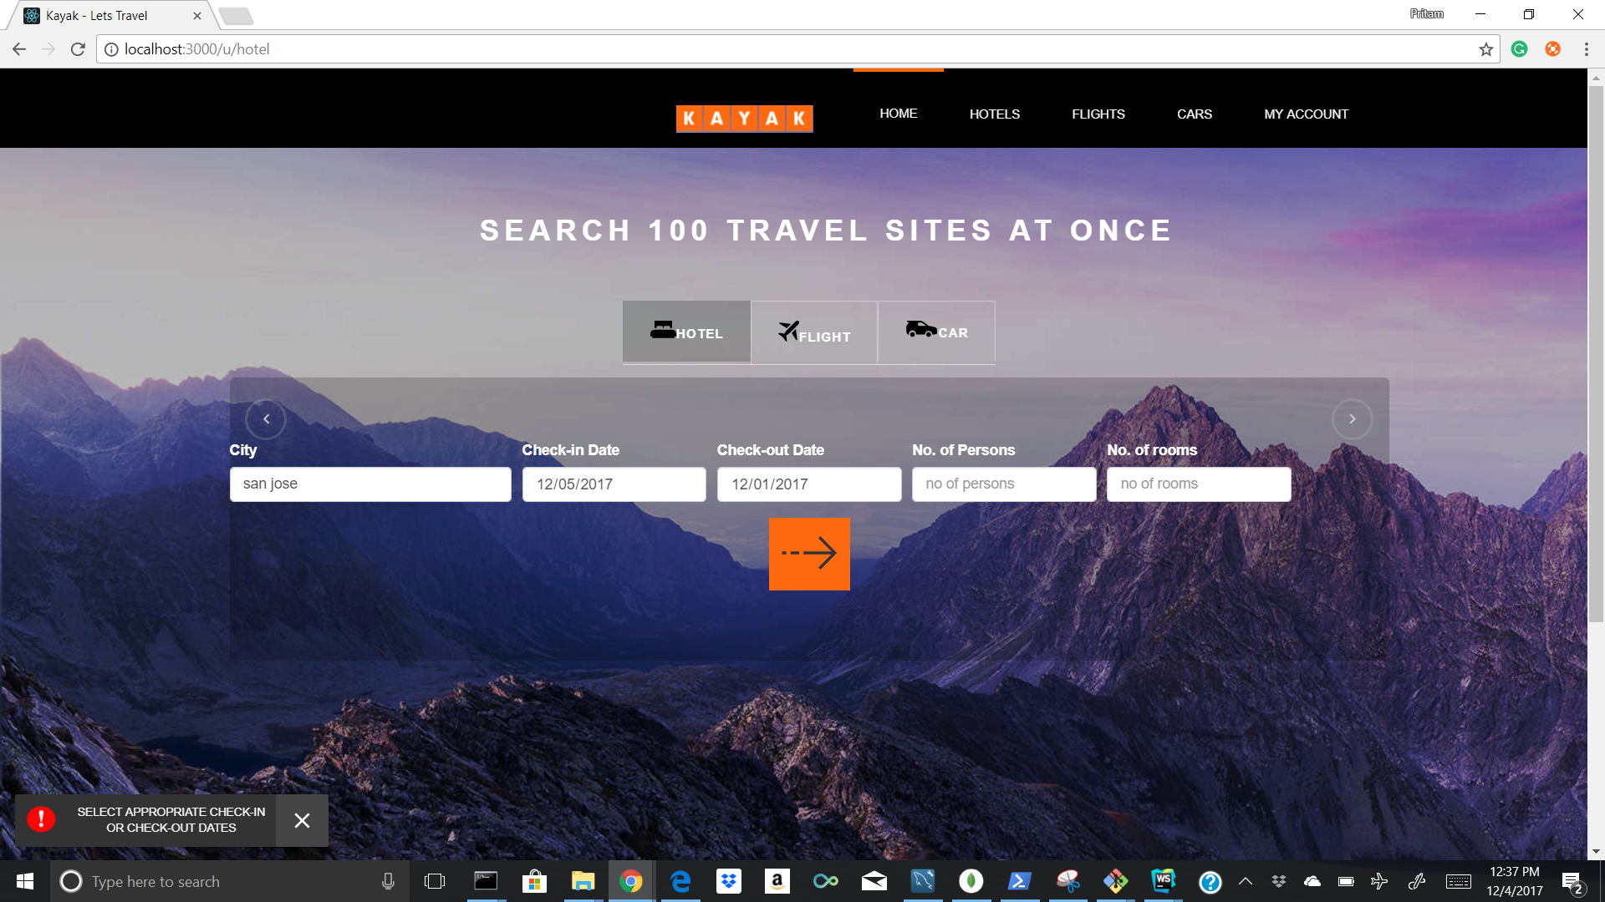

7. Homepage - Hotel Validation (select appropriate number of people)

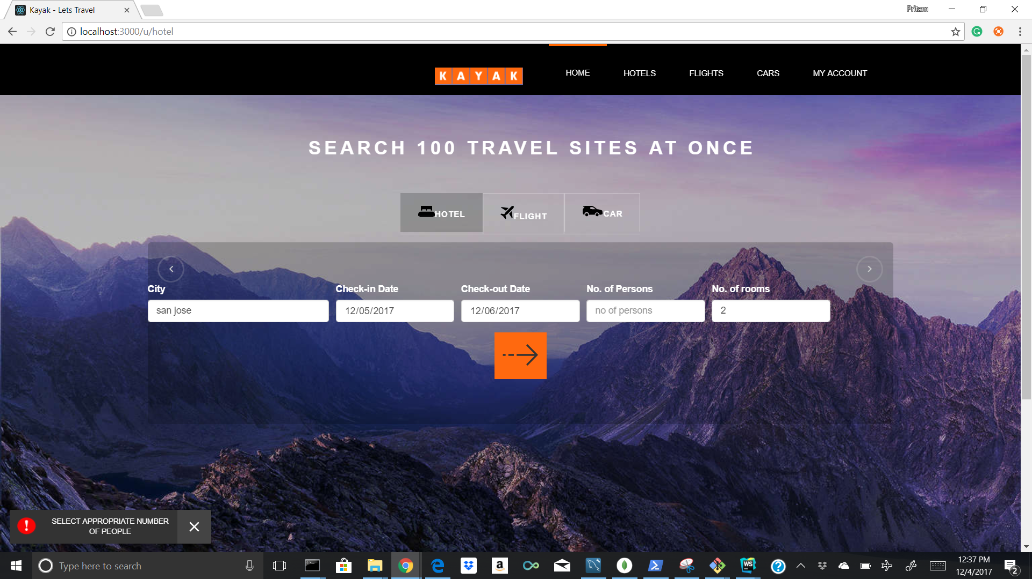

8. Homepage - Hotel Validation (select appropriate number of room)

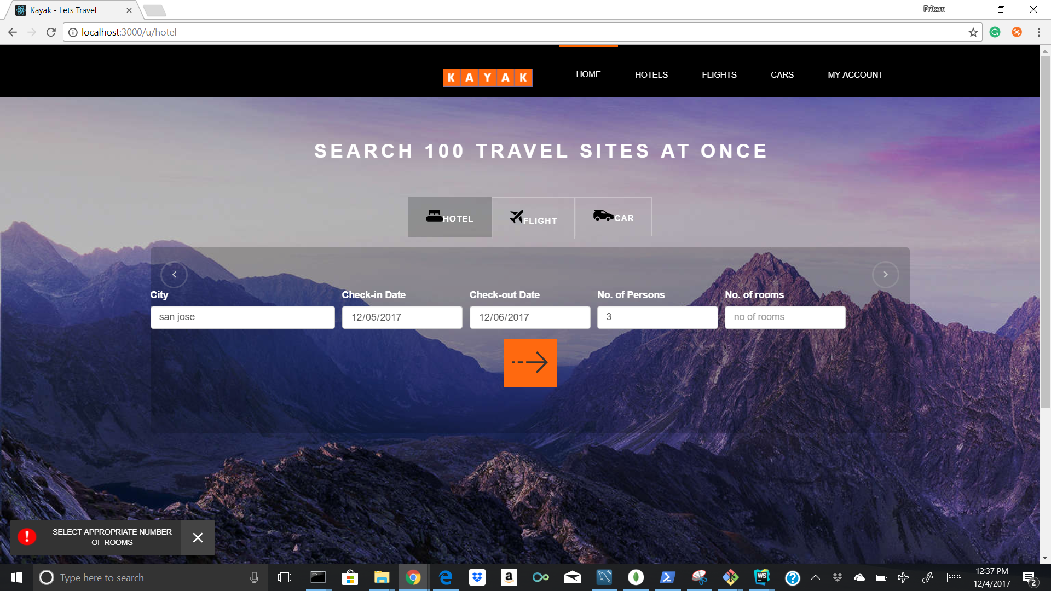

9. Homepage - Flight Validation (select appropriate departure city)

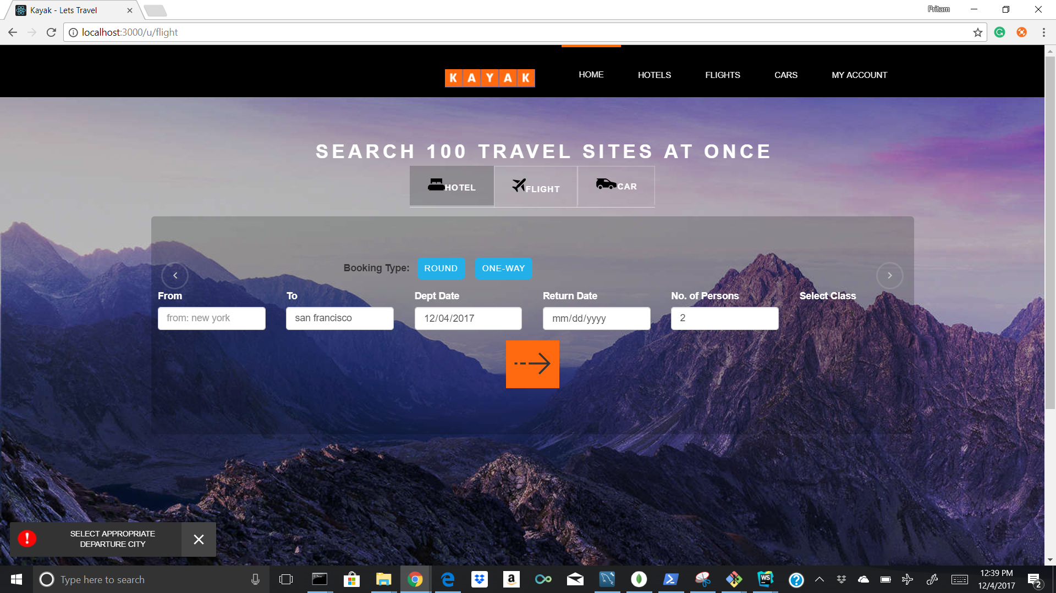

10. Homepage - Flight Validation (select appropriate arrival city)

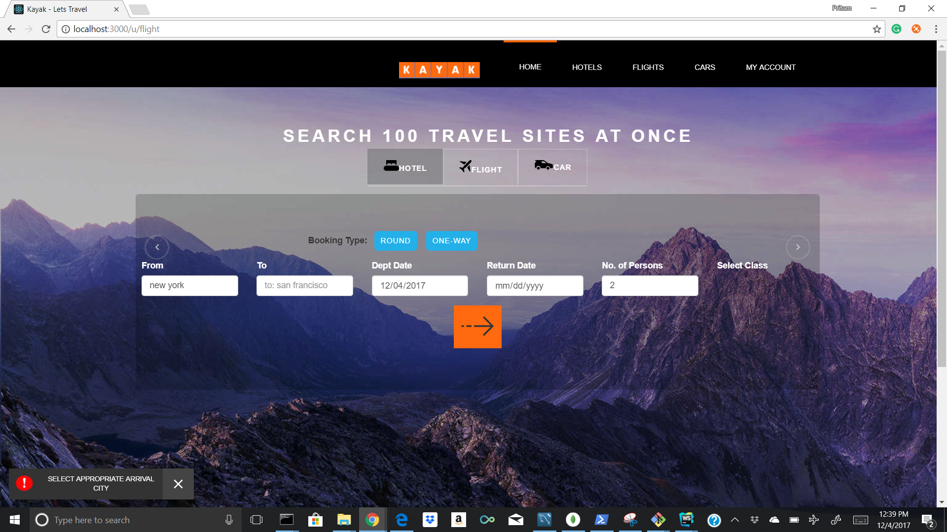

11. Homepage - Flight Validation (select appropriate number of people)

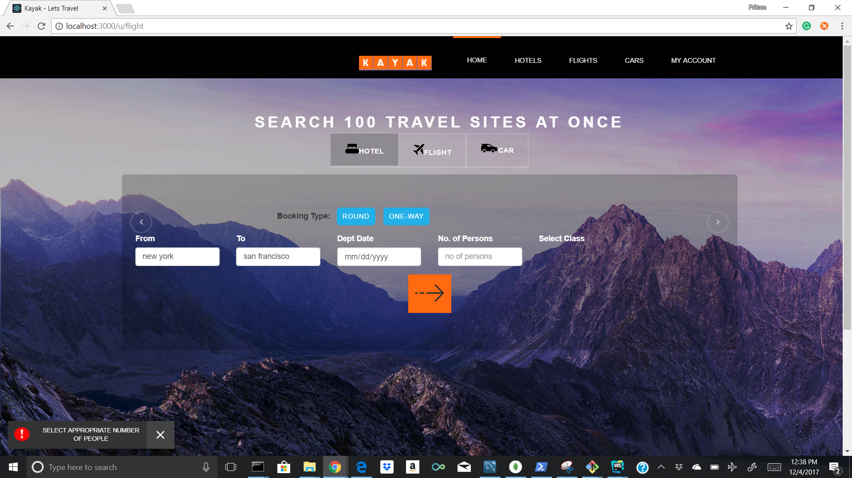

12. Homepage - Flight Validation (select appropriate flight class)

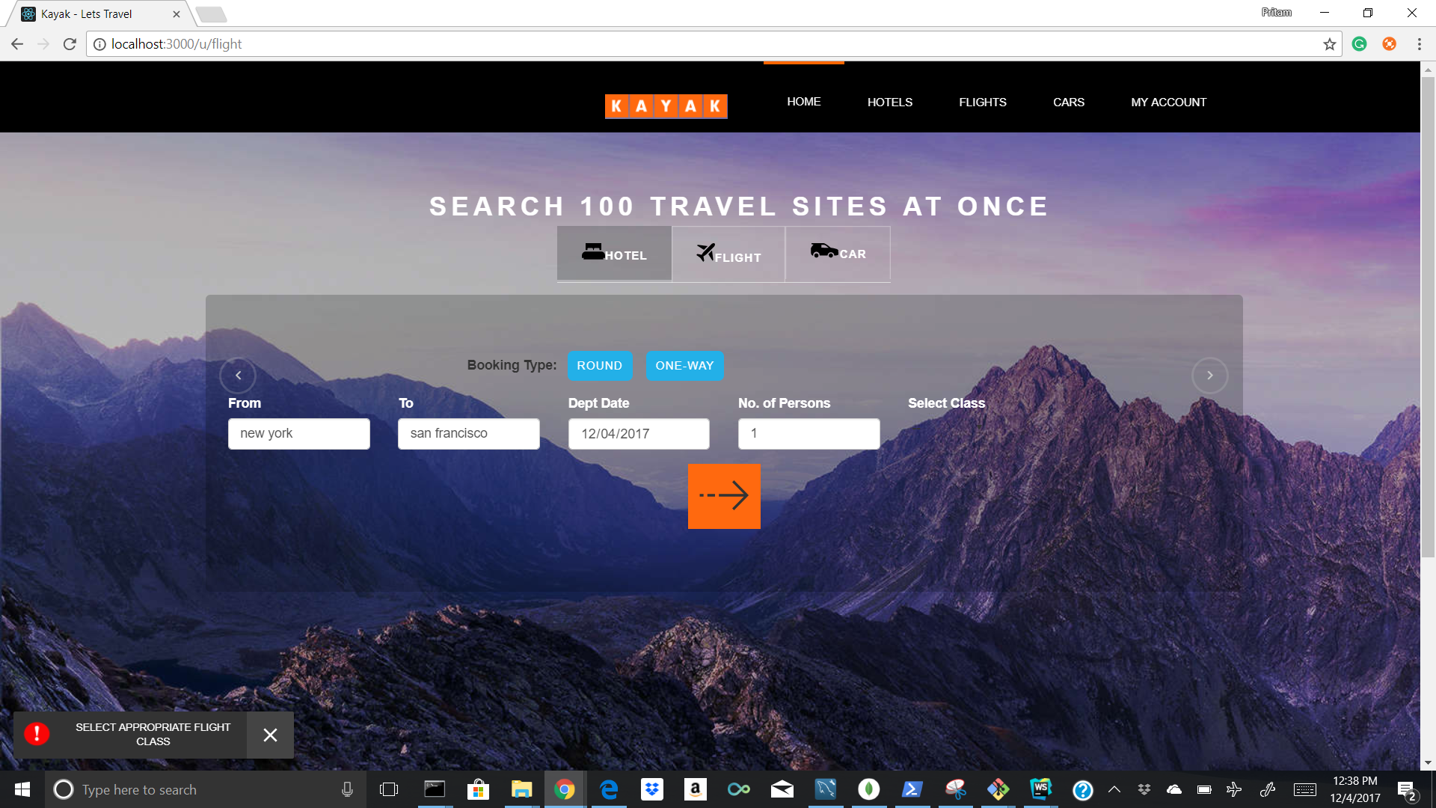

13. Homepage - Flight Validation (select appropriate departure or return dates)

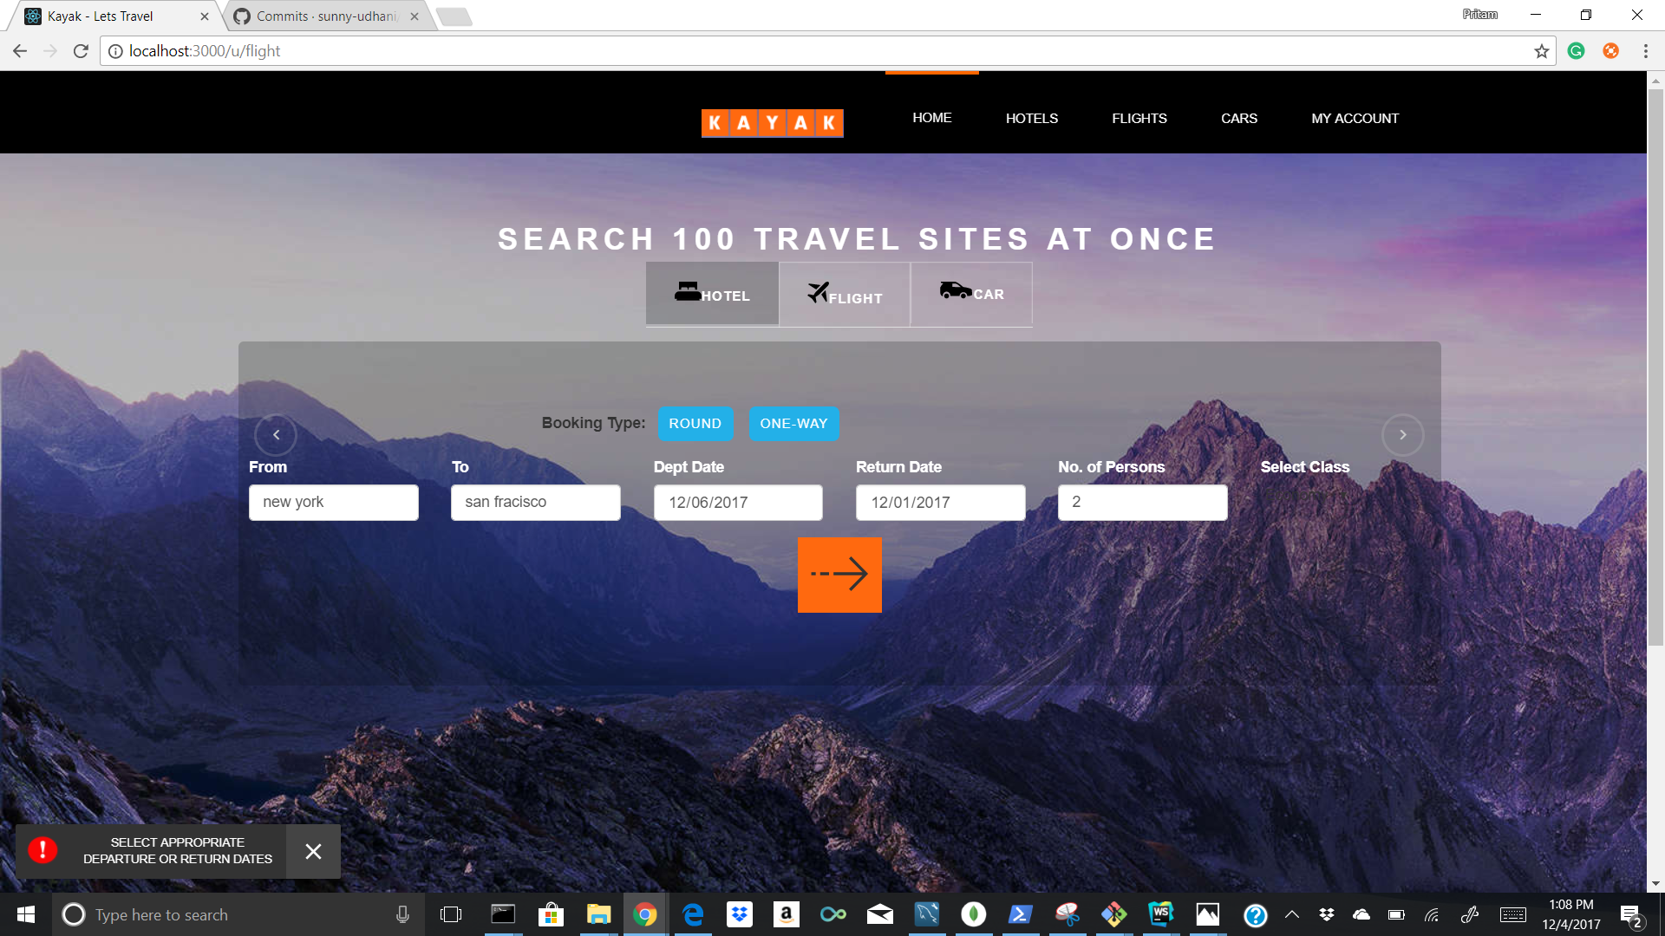

14. Homepage - Car Validation (select appropriate city)

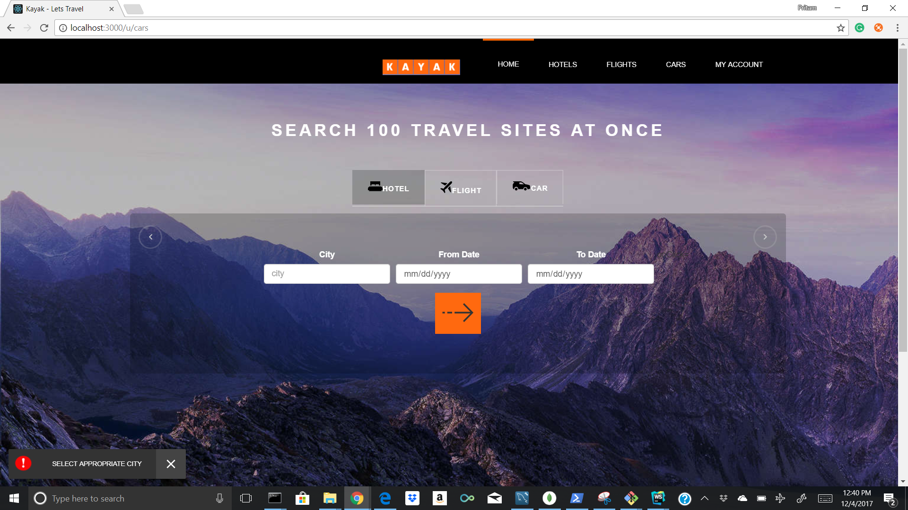

15. Homepage - Car Validation (select appropriate from date)

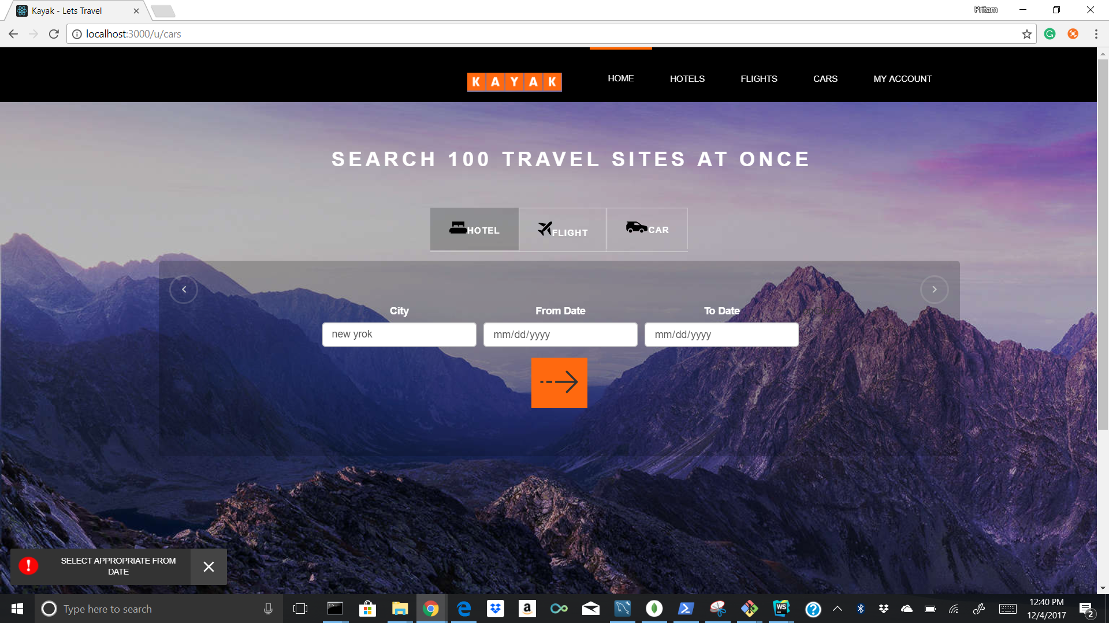

16. Homepage - Car Validation (select appropriate to date)

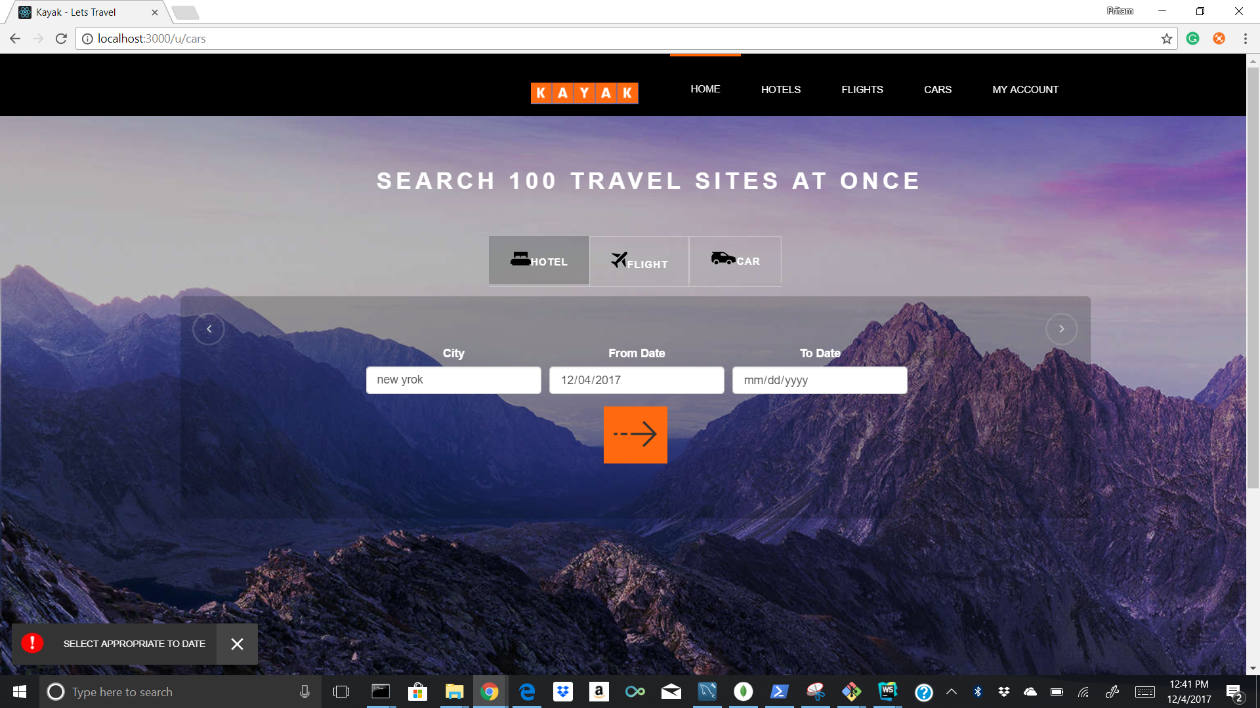

17. Homepage - Car Validation (select appropriate from and to date)

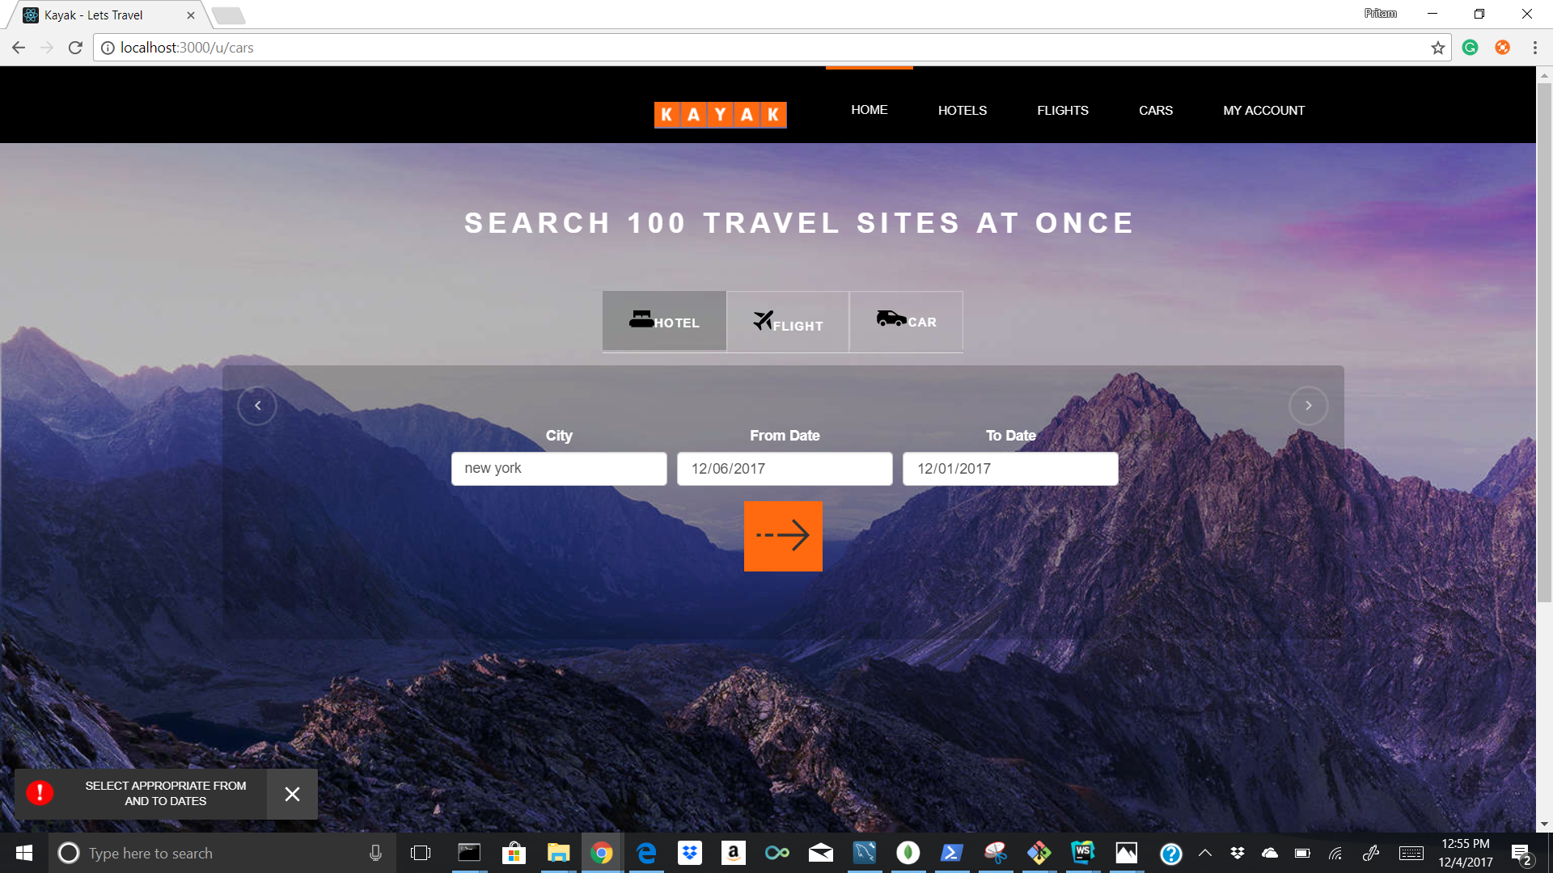

18. Hotel Listing - without filters

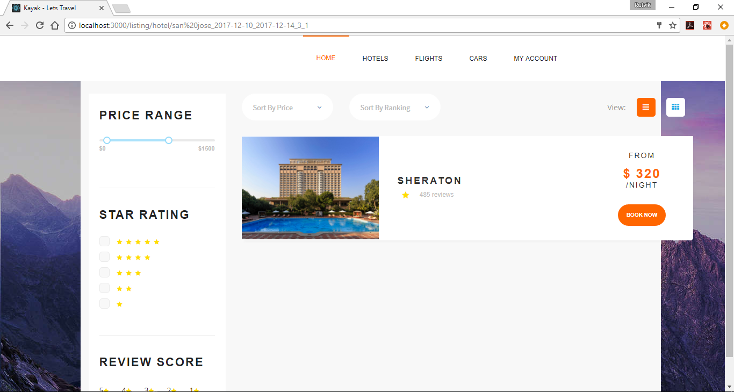

18. Hotel Listing - filter : only 5 star rating (whereas Hotel Sheraton has 4 star rating)

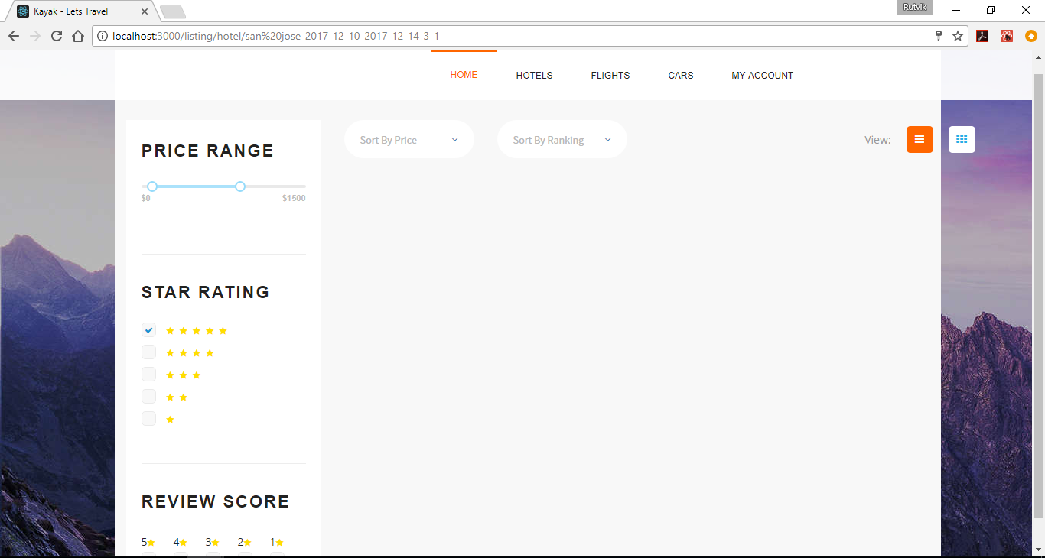

19. Hotel Listing - filter : 4 star rating applied and price range >= $288 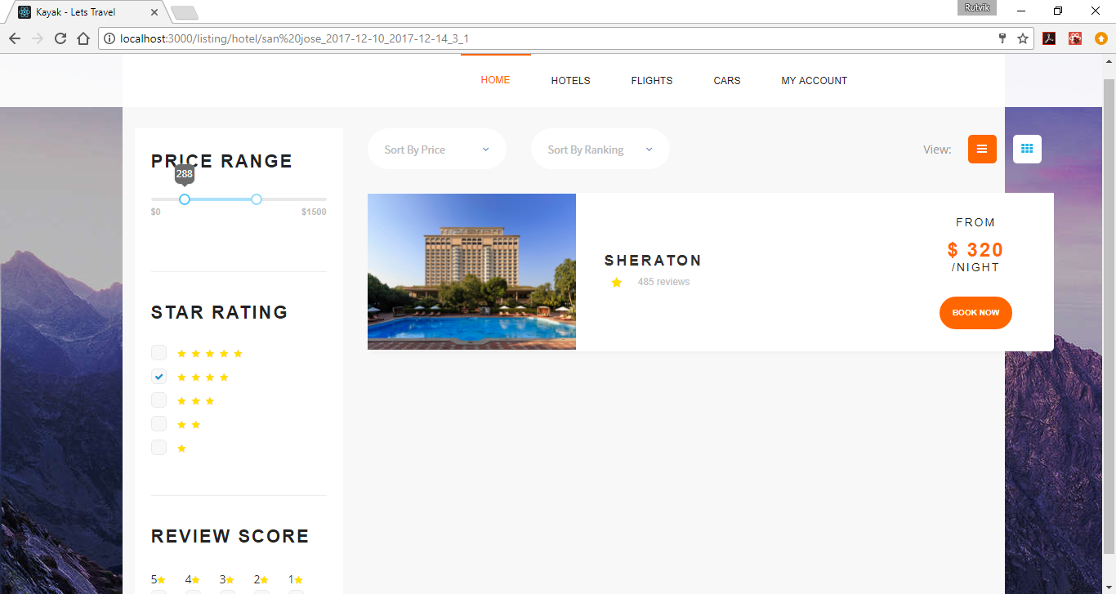

20. Hotel Listing - filter : 4 star rating applied and price range > 320

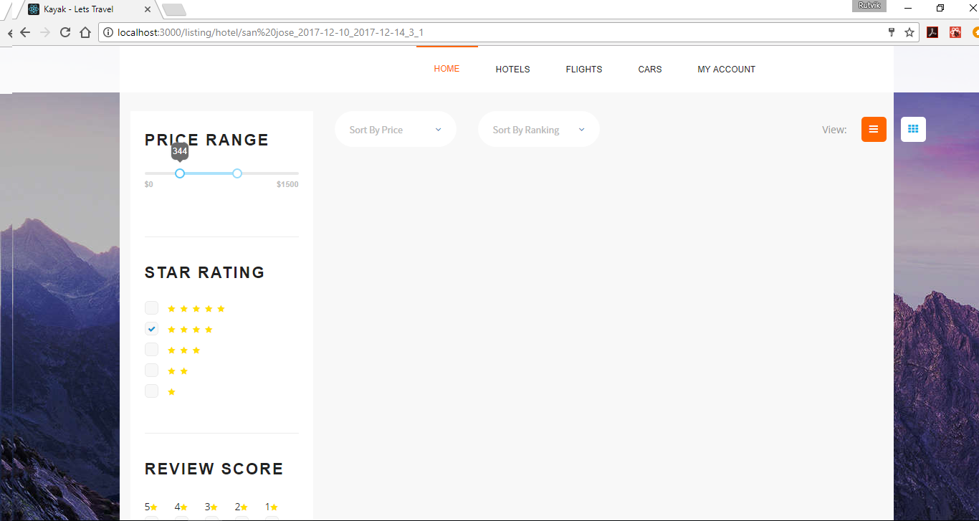

21. Book Hotel - View Payment Details

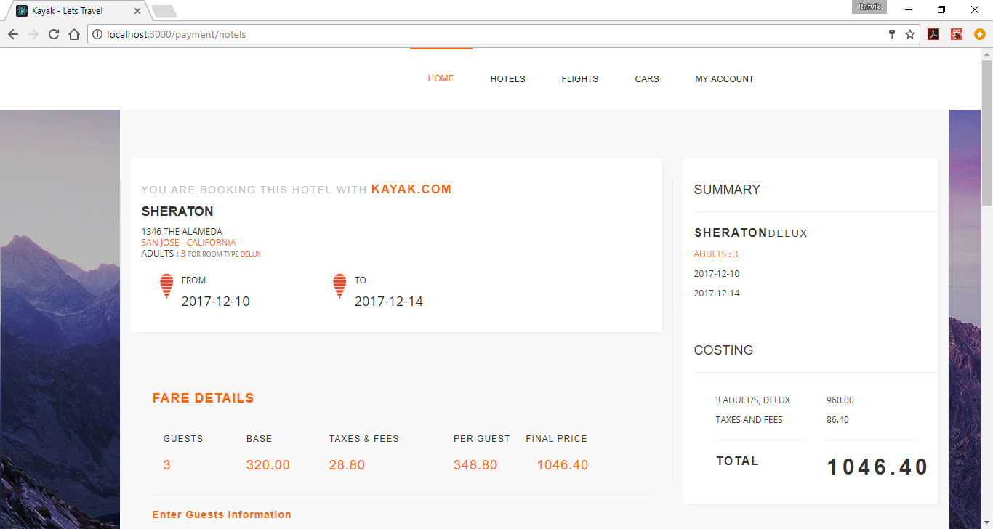

22. Book Hotel - Add Guest and Billing Information

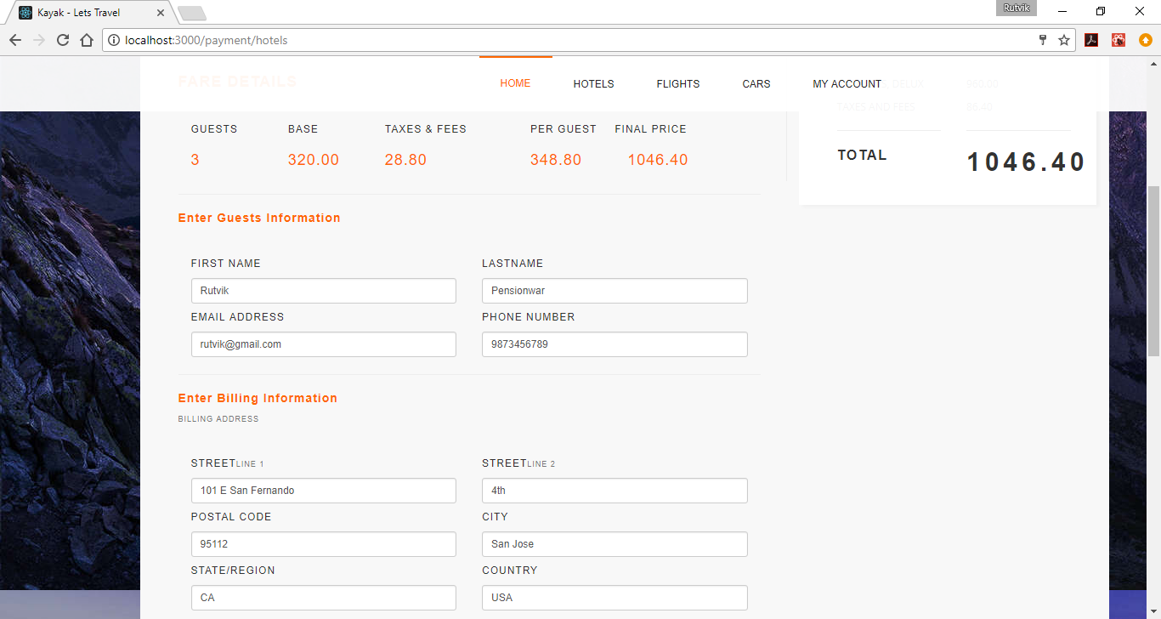

23. Book Hotel - Add Credit Card Details

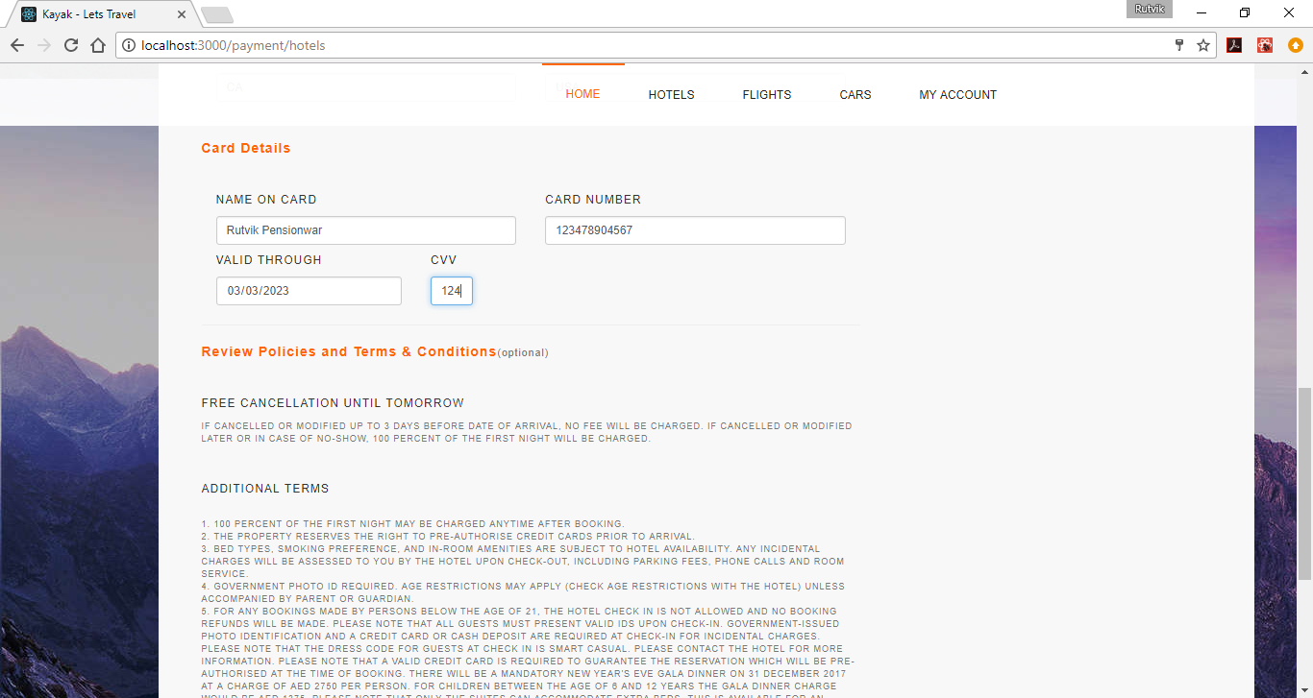

24. Book Hotel

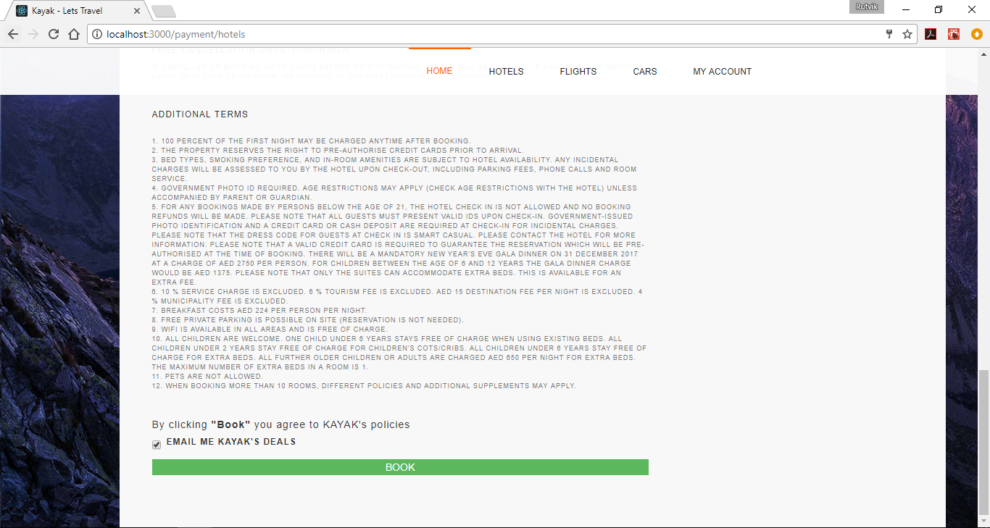

25. Thank you page post Hotel booking (with all relevant details)

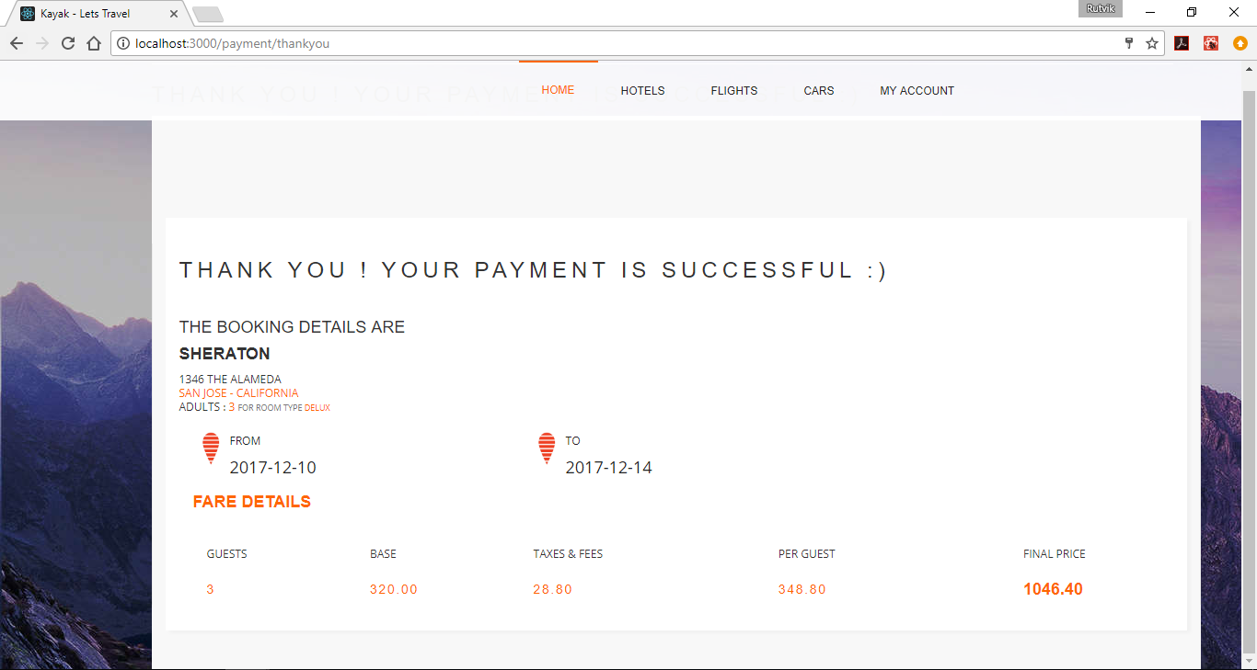

26. Flight Listing - without filters

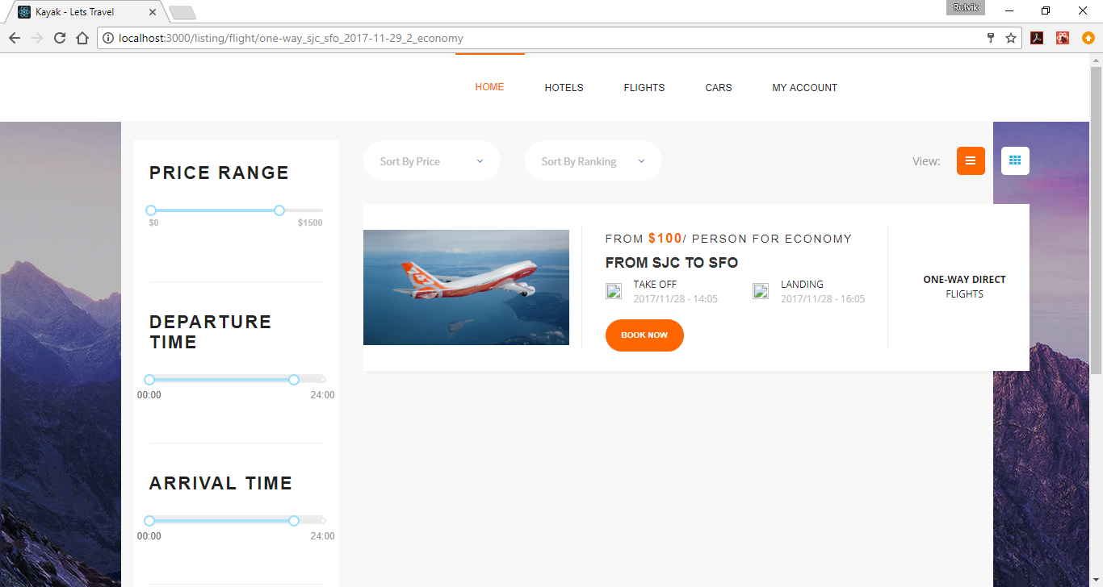

27. Flight Listing - with filter : price range > $355 (whereas flight rate is $100/person)

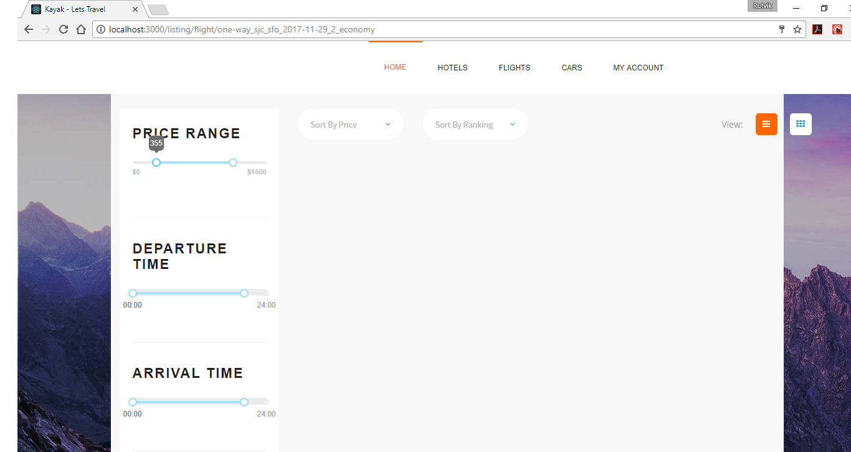

28. Flight Listing - with filter : departure time > 17:00 (whereas flight take off is 14:05)

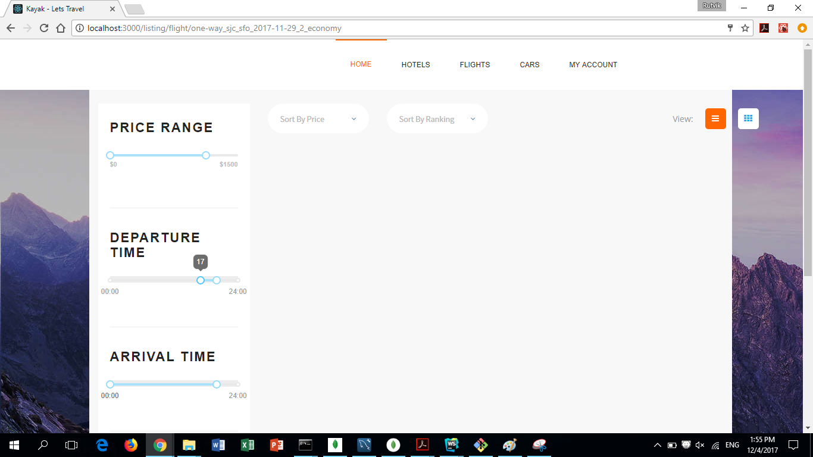

29. Flight Listing - with filter : arrival time > 00:00 & < 15:00 (whereas flight landing is 16:25)

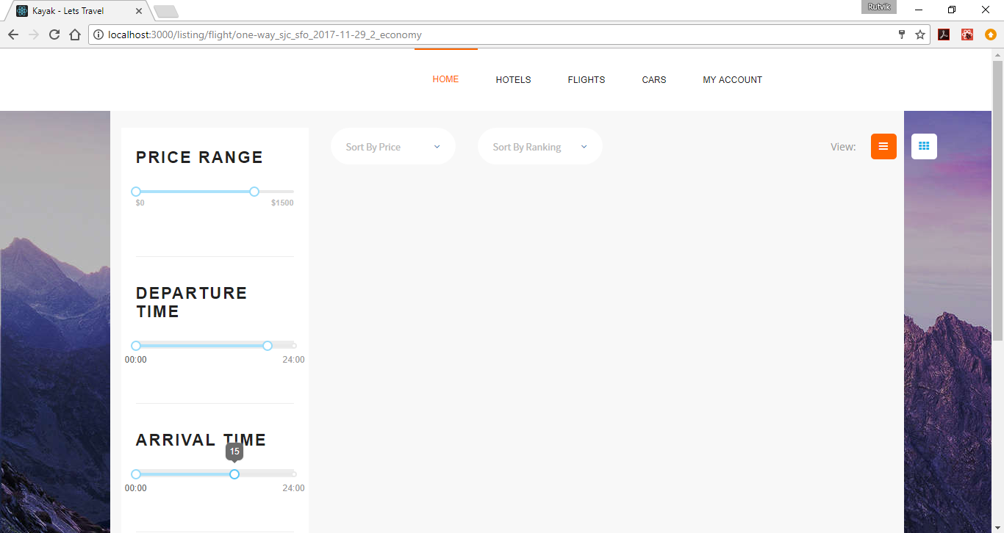

30. Book Flight - Payment Details Page

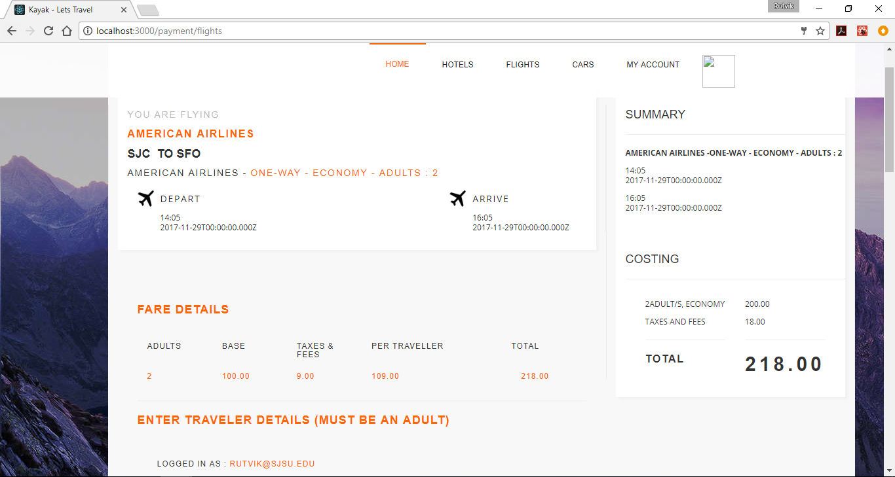

31. Book Flight - Enter Travelers Information (we selected 2 travelers while searching for flights)

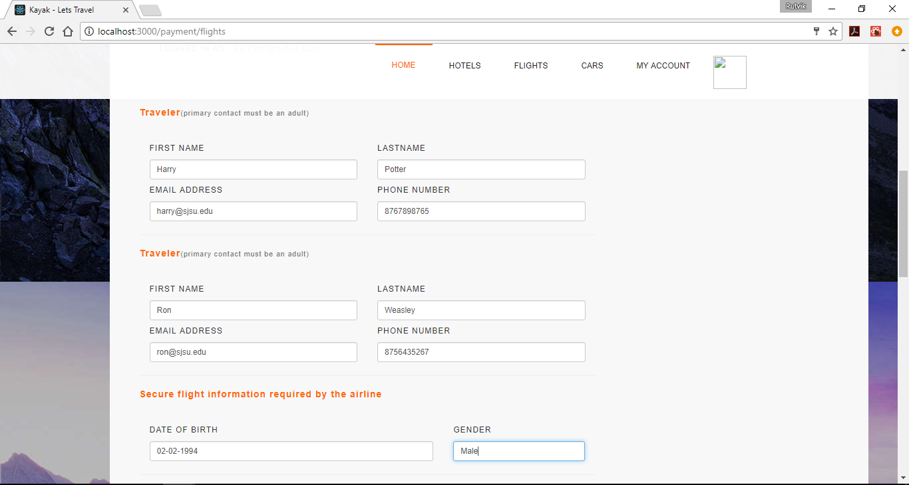

32. Book Flight - Enter Billing Information

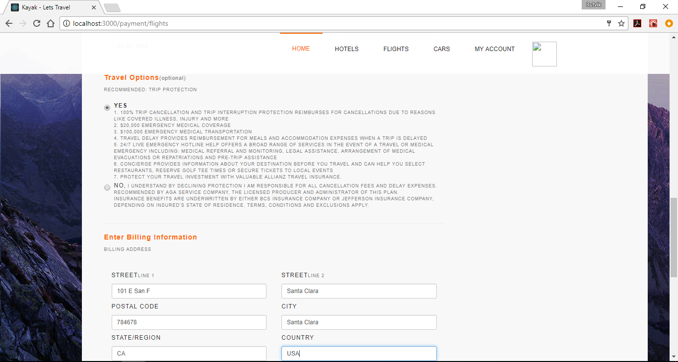

33. Book Flight - Enter Credit Card Details and Book

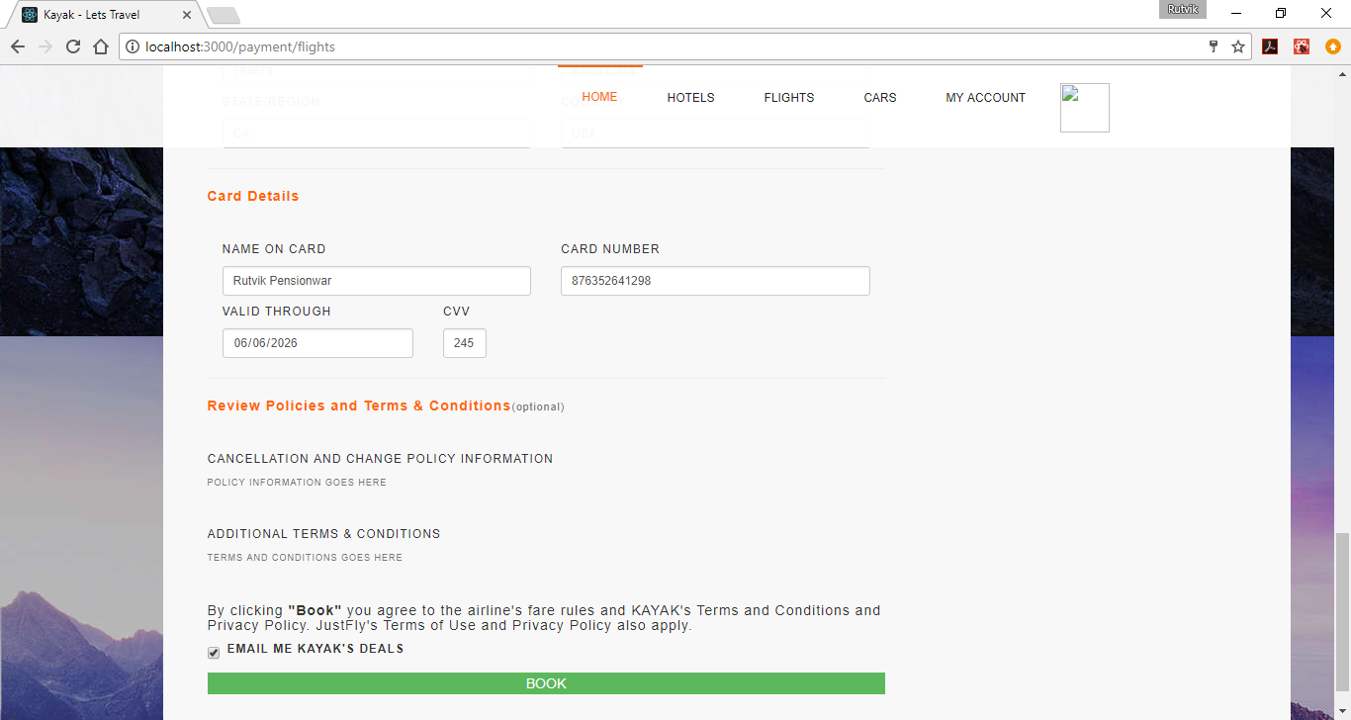

34. Book Flight - Thank you page

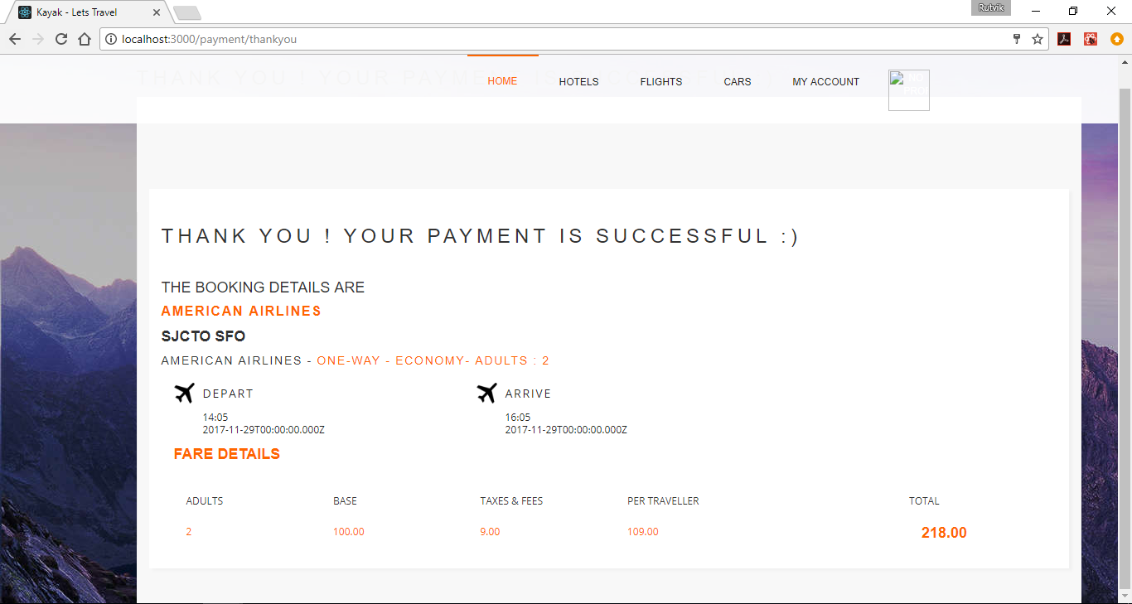

If you notice, I haven’t set my profile picture as of now. You can see that image at the top right corner doesn’t exist because I haven’t set one.

SO LET SET ONE !!!

35. Set Profile Picture

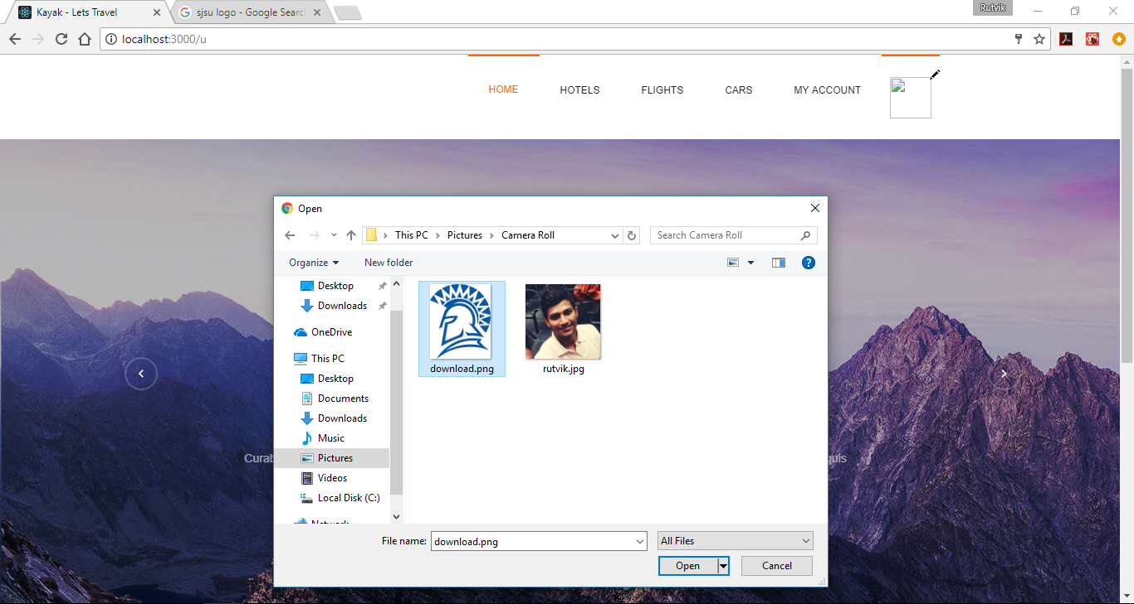

And the profile image of SJSU logo is all set.

Let us proceed with Car Booking

36. Car Booking - View Listing

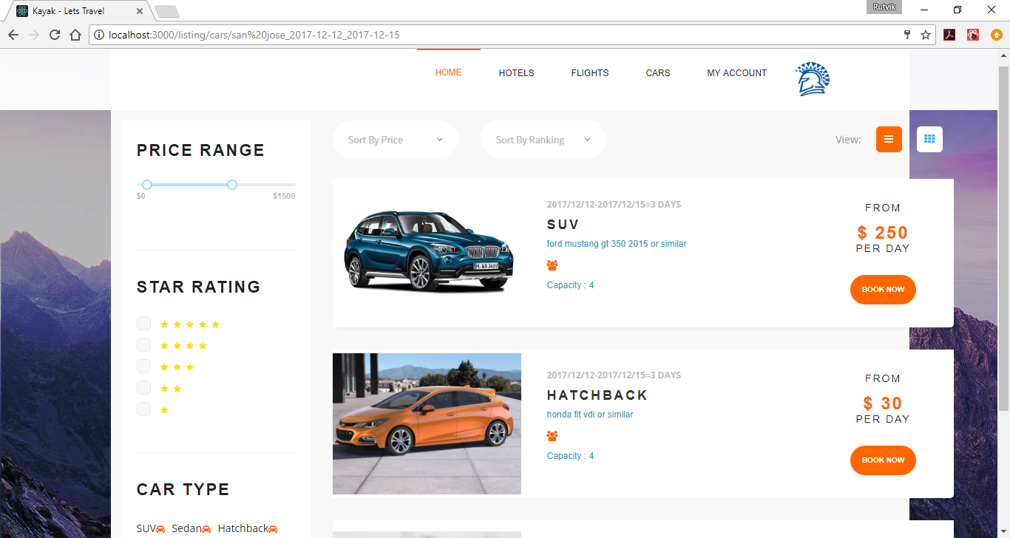

37. Car Booking - Filter Applied Price Range > $ 100 : A car with rate $30 filtered

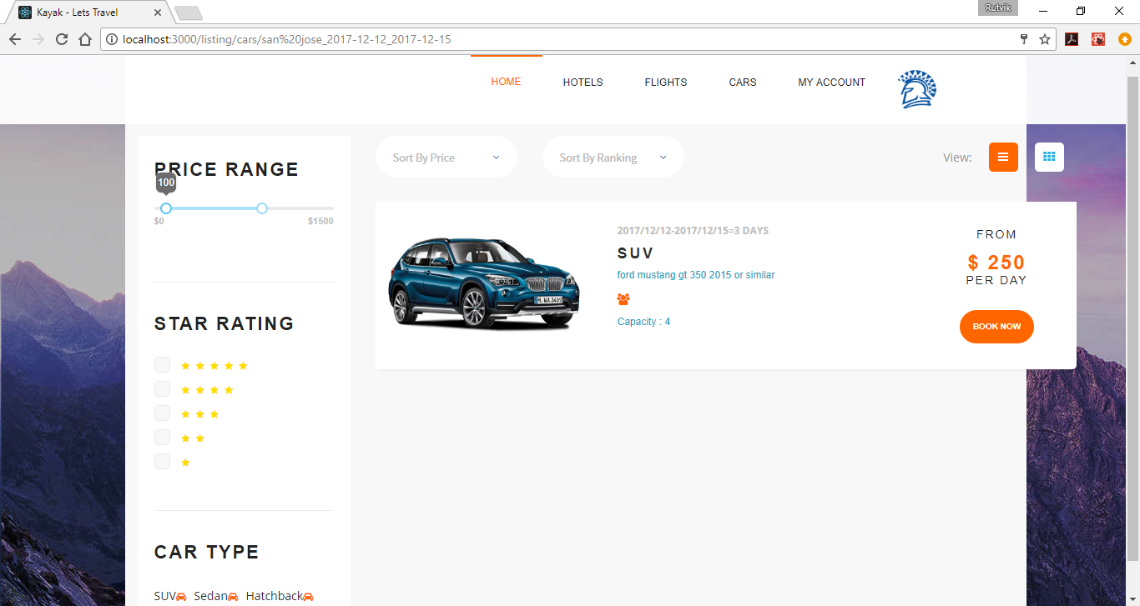

38. Car Booking - View Payment Details

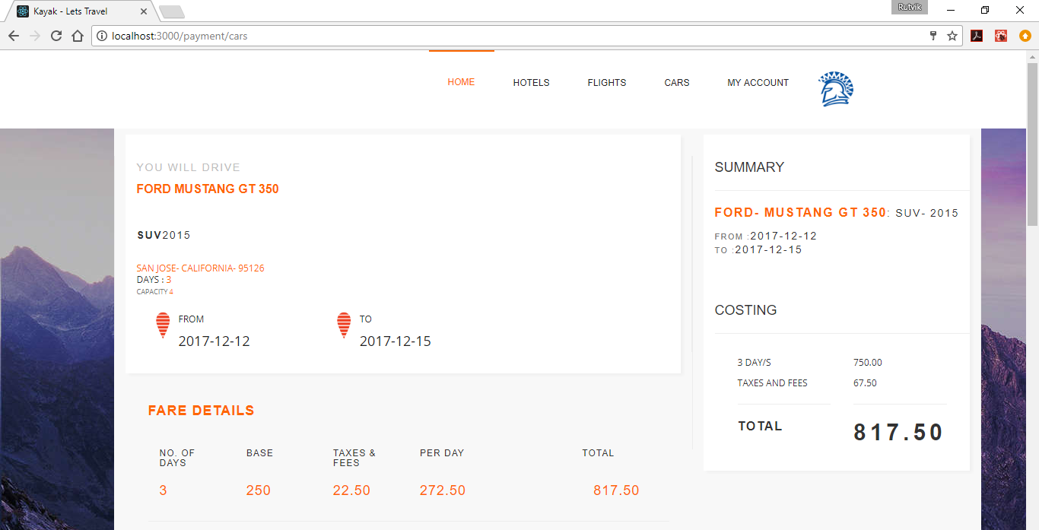

39. Car Booking - Enter Renter and Billing Information

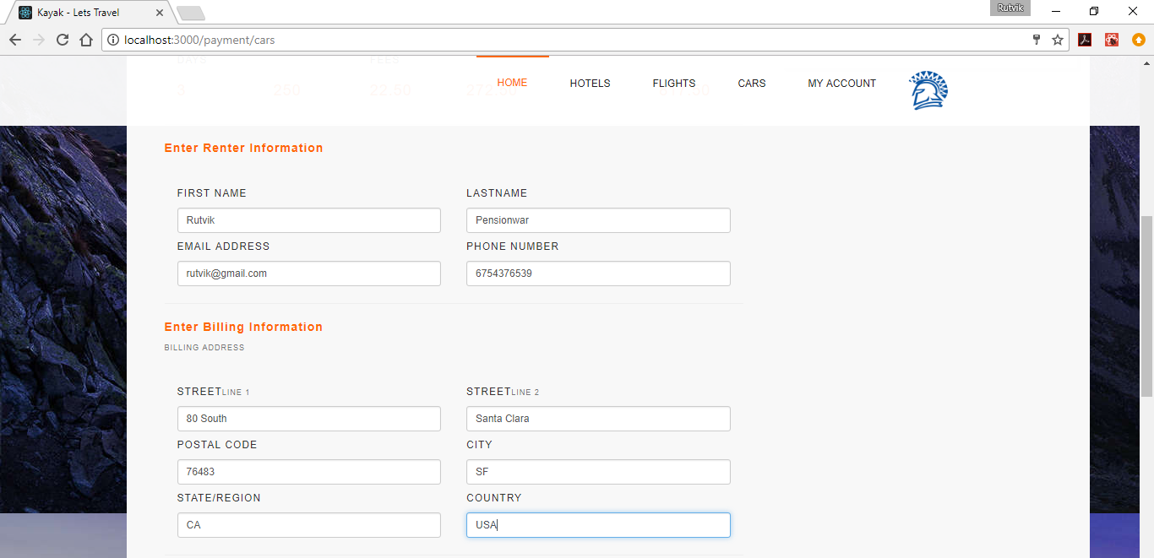

40. Car Booking - Enter Car Details

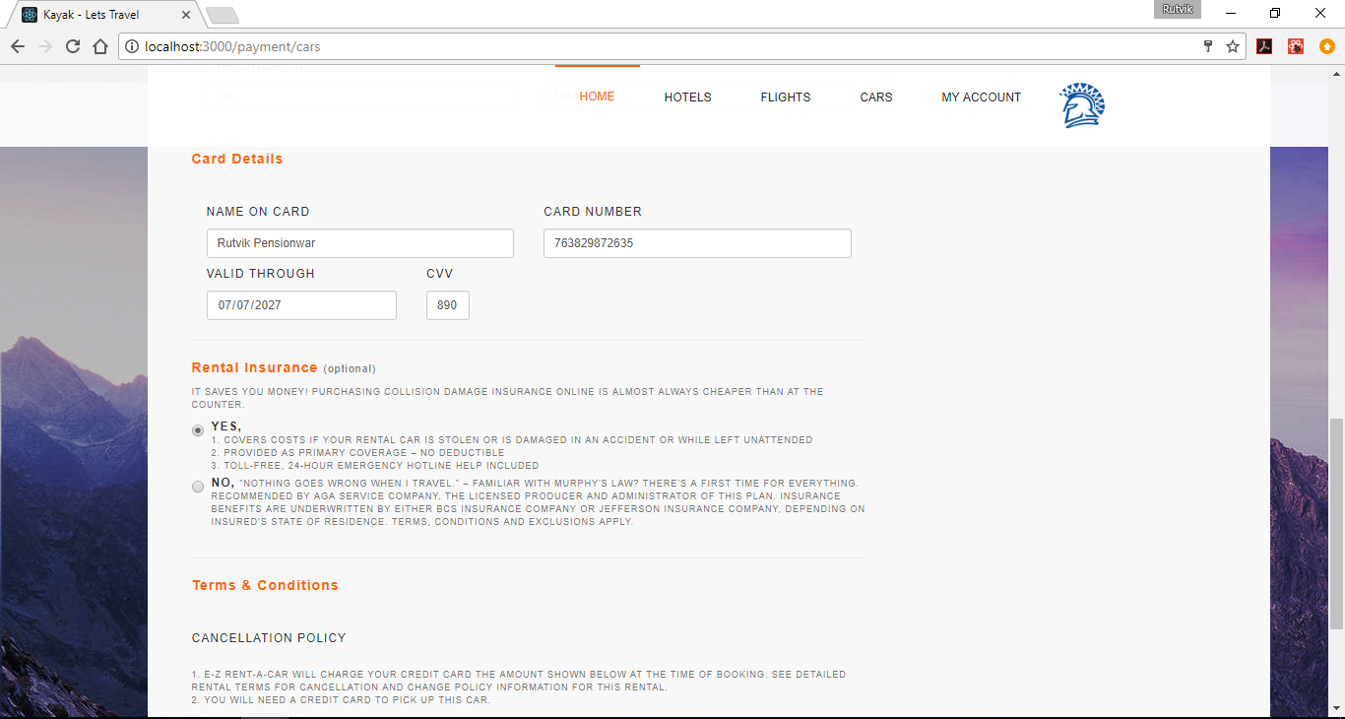

41. Car Booking

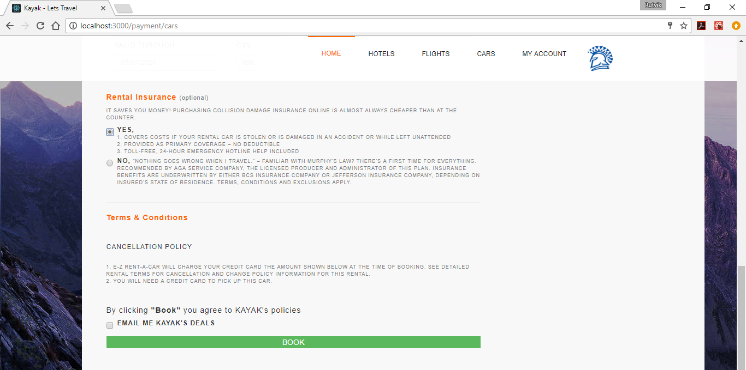

42. Car Booking - Thank you page

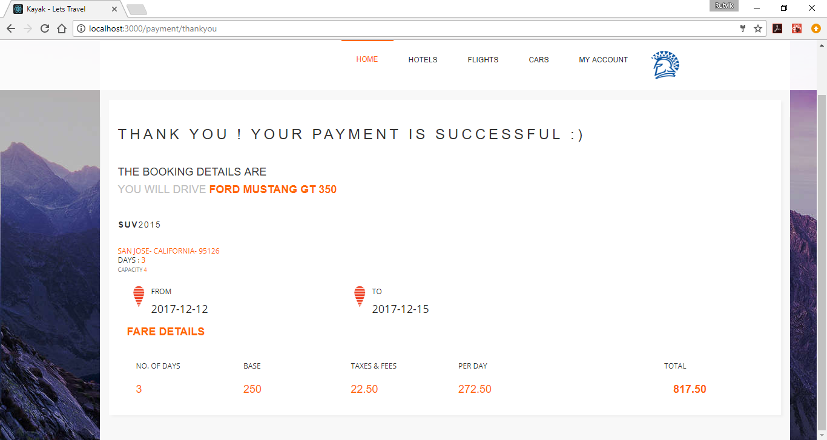

43. Account Preferences Page

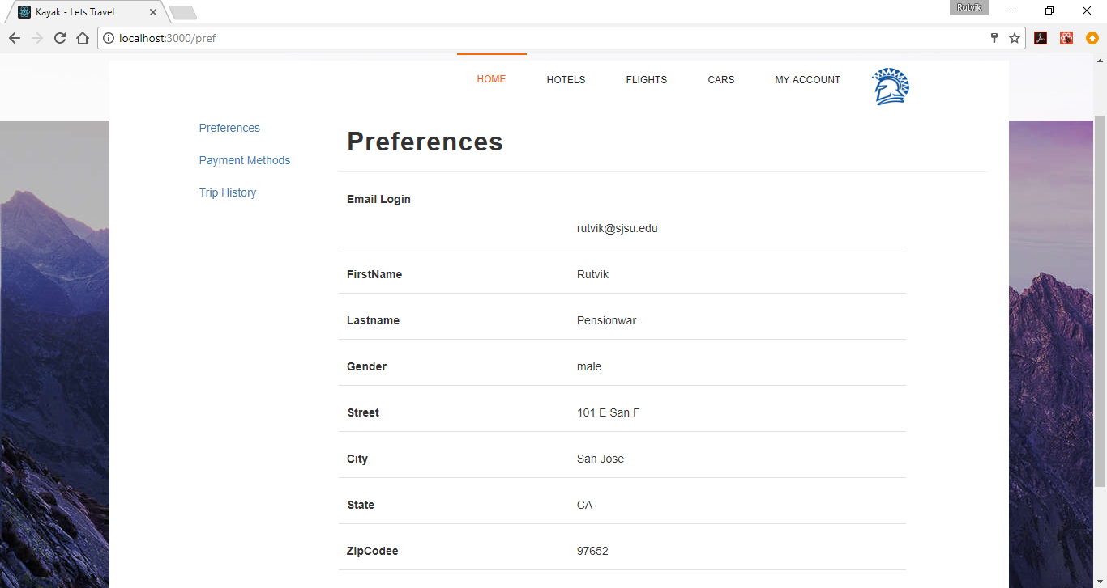

44. Admin Dashboard - Logged in as Admin

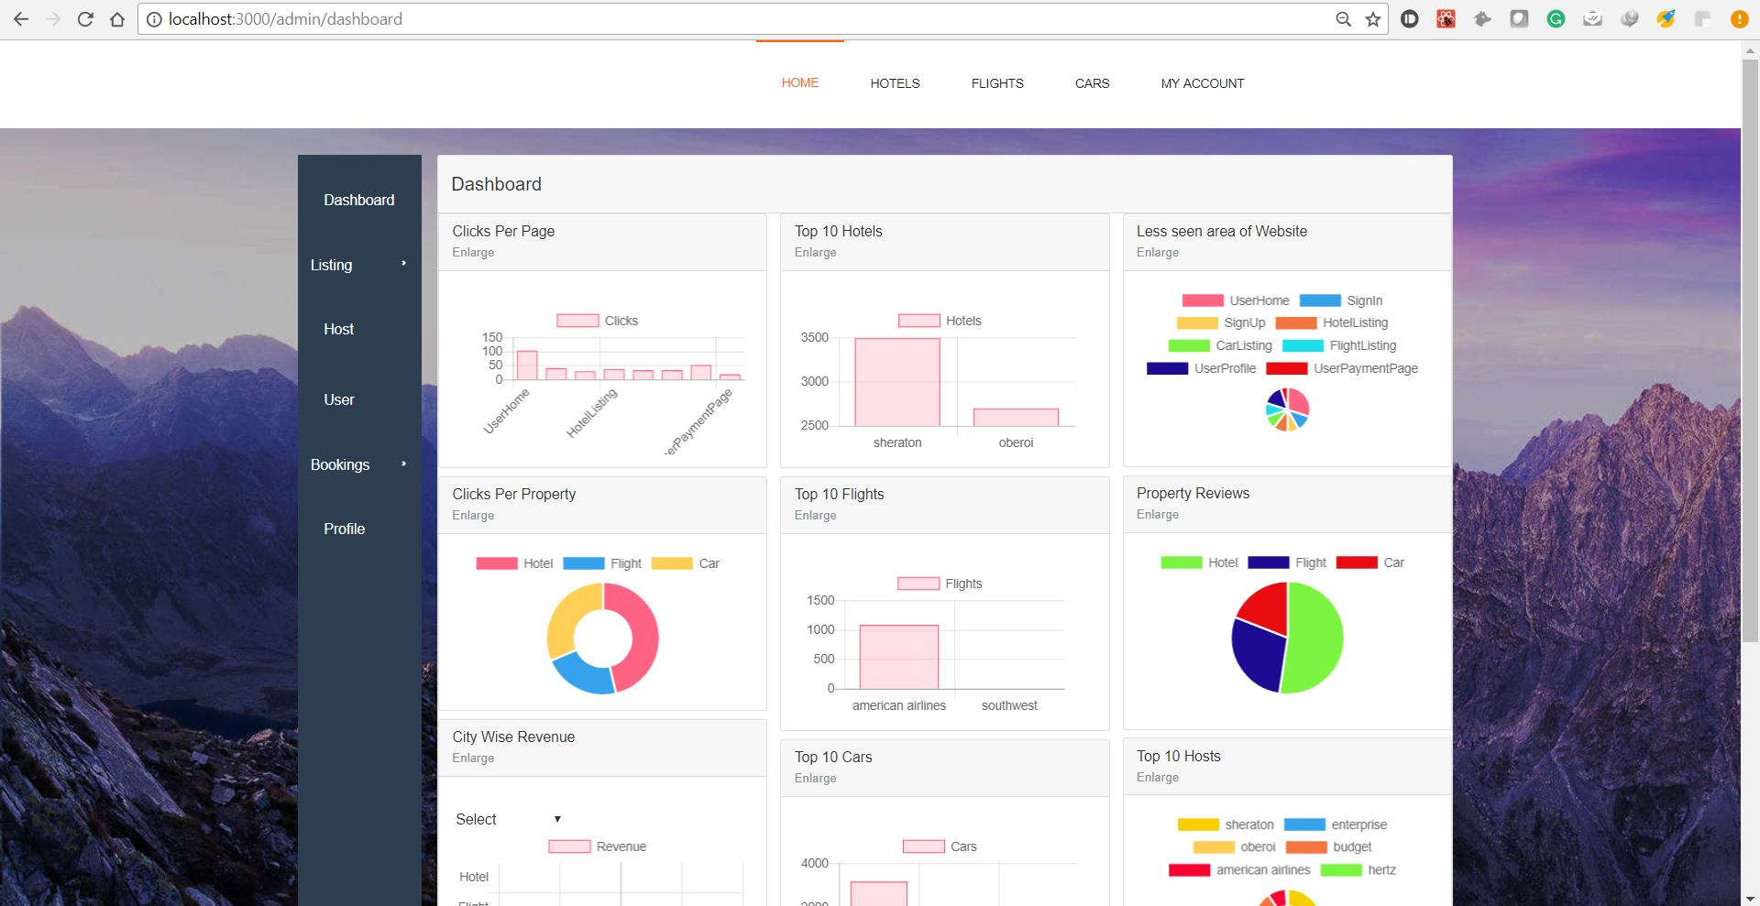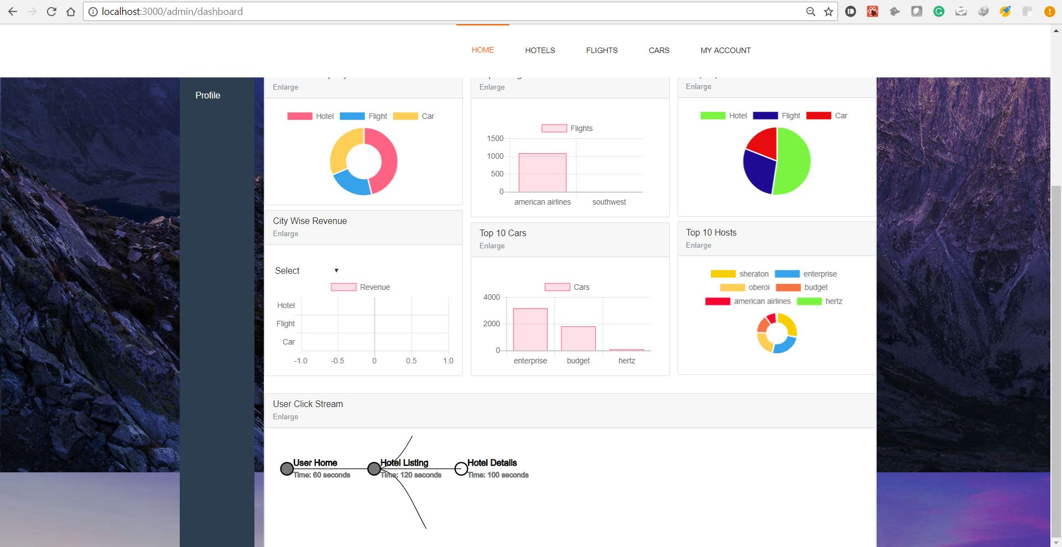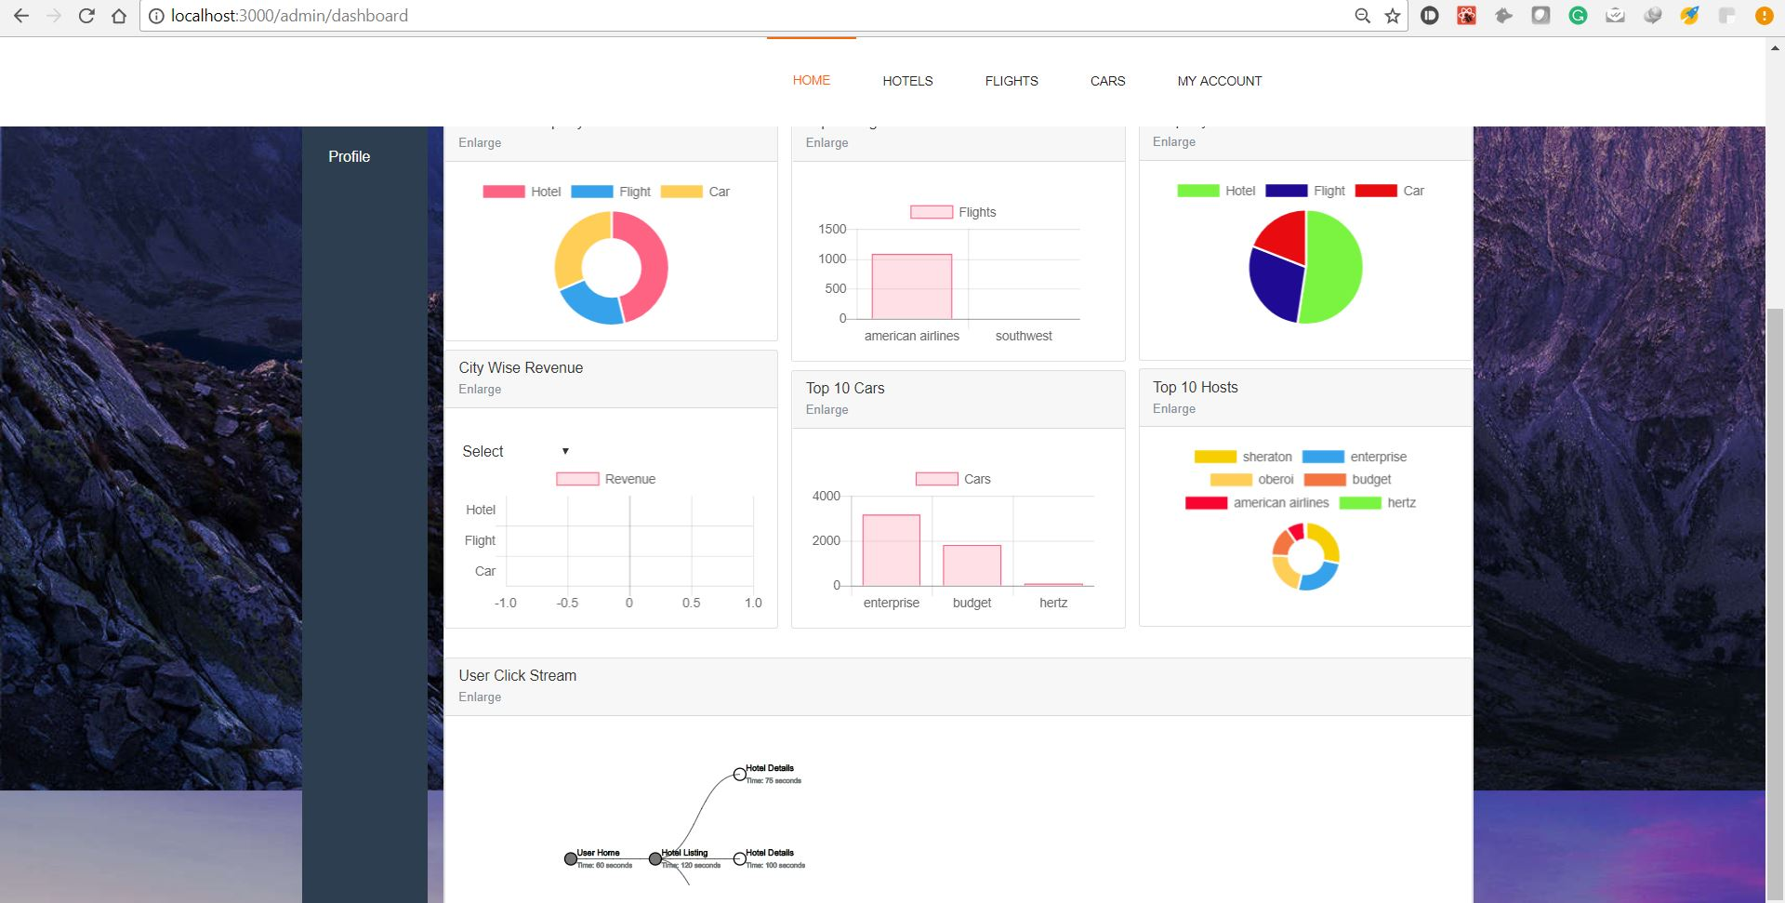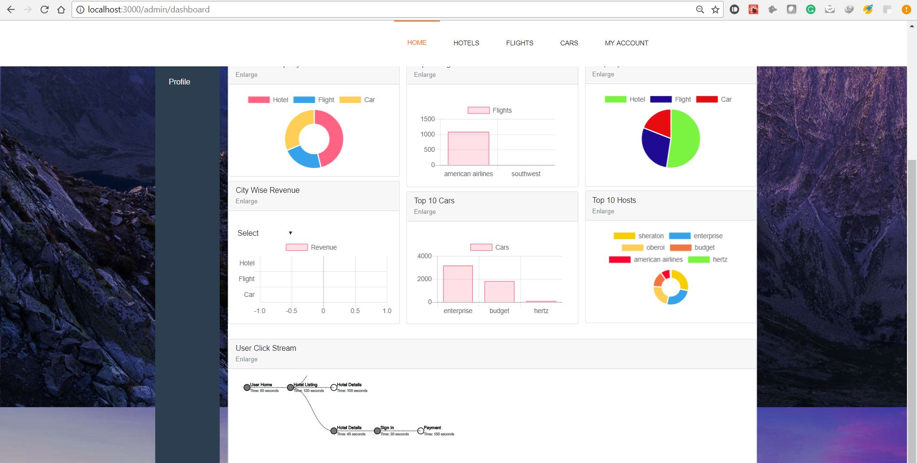

45. Admin - Hotel Listing

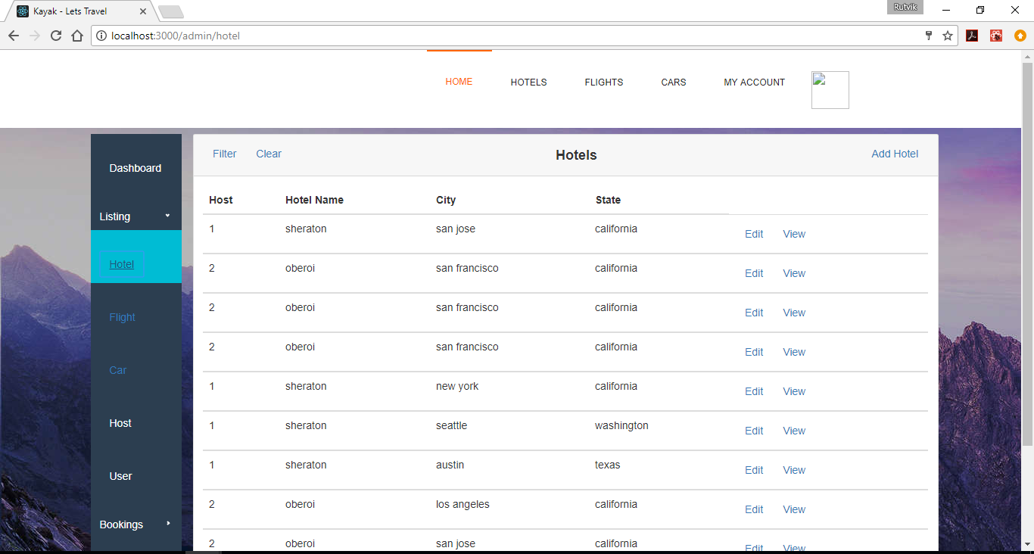

46. Admin - Flight Listing

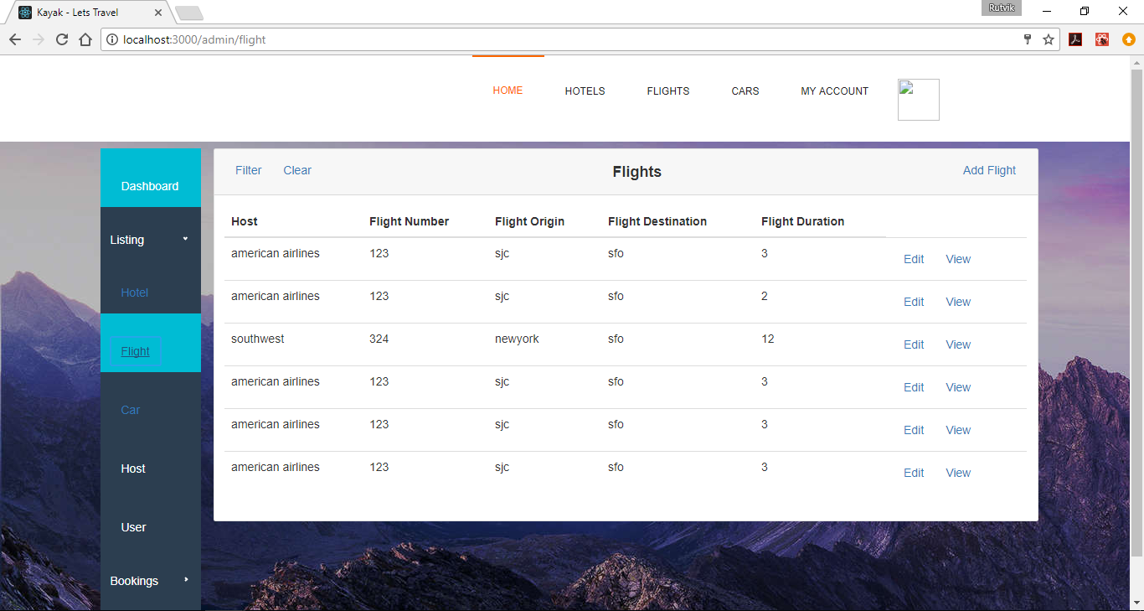

47. Admin - Car Listing

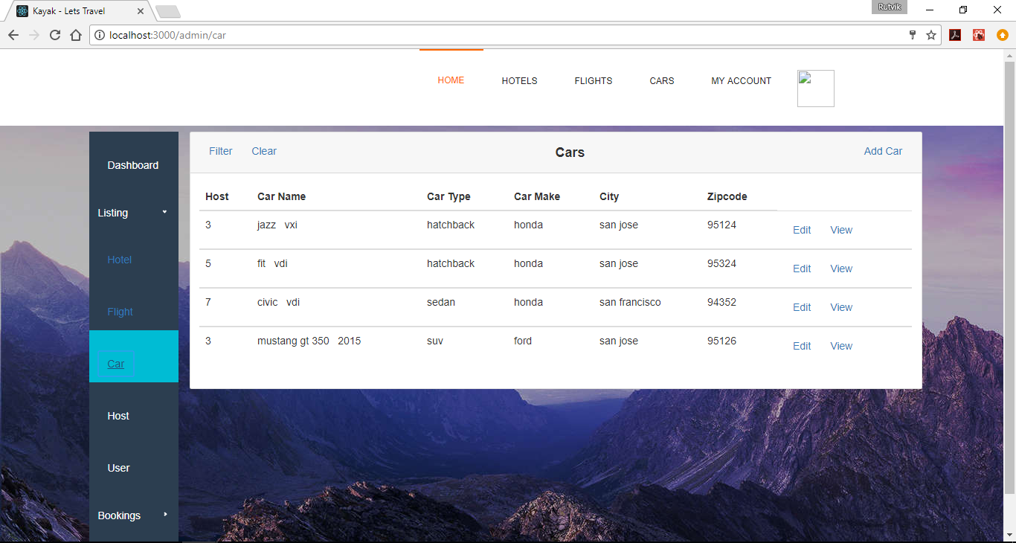

48. Admin - Host Listing

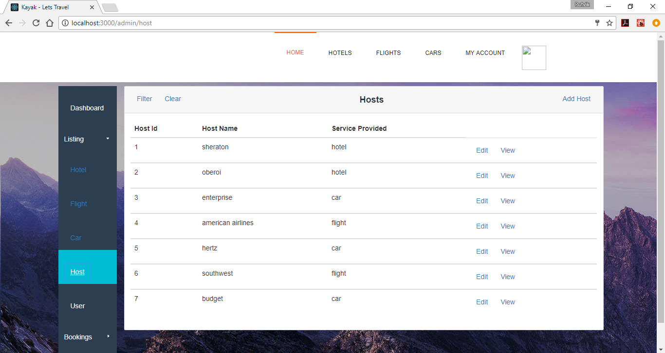

49. Admin - User Listing

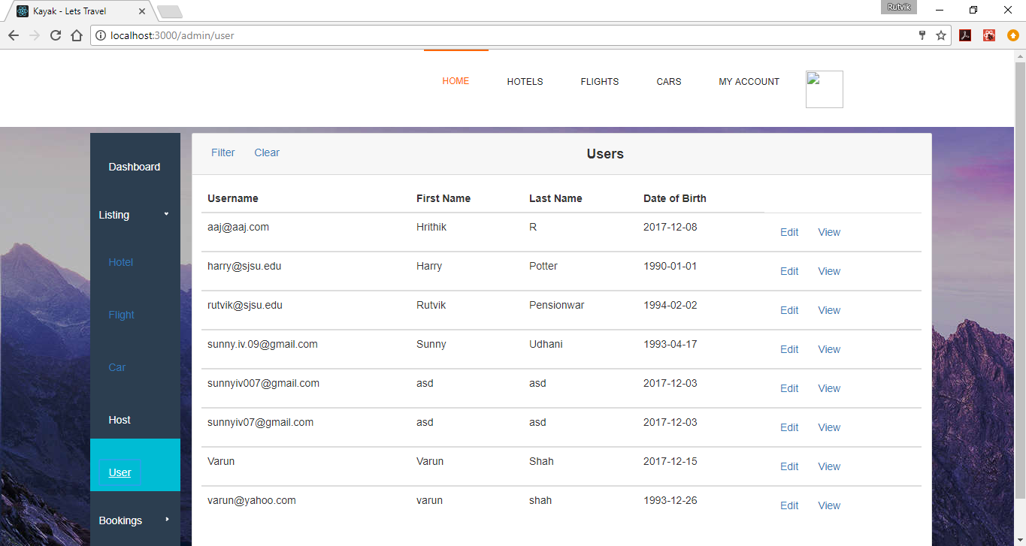

50. Admin - Hotel Bookings

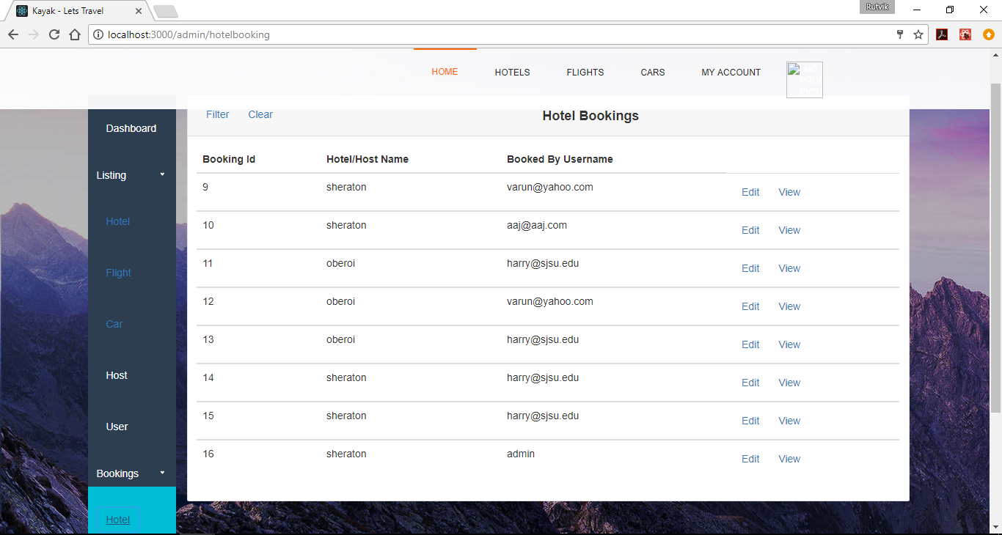

51. Admin - Flight Bookings

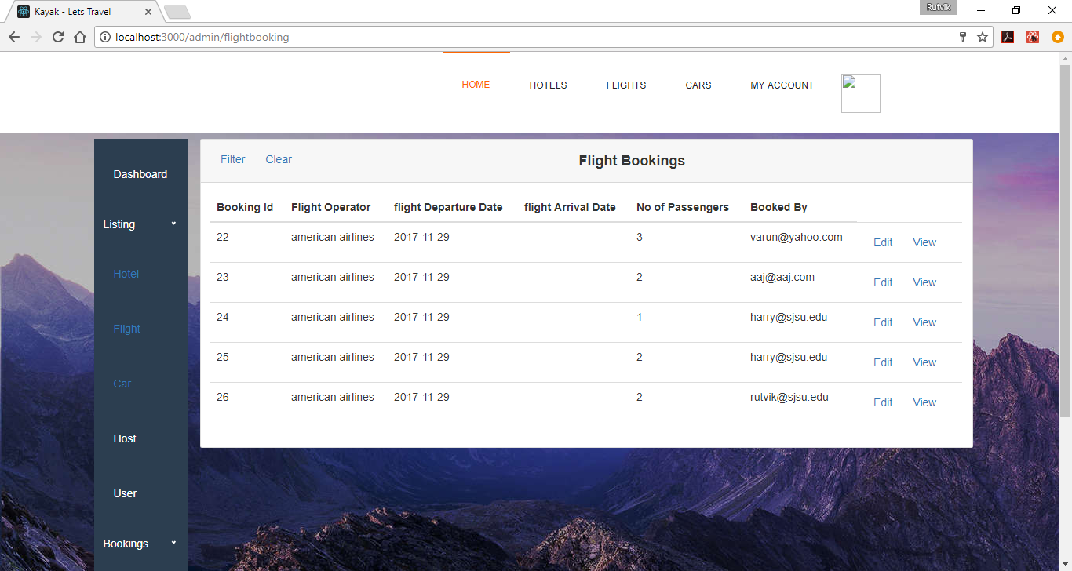

52. Admin - Car Bookings

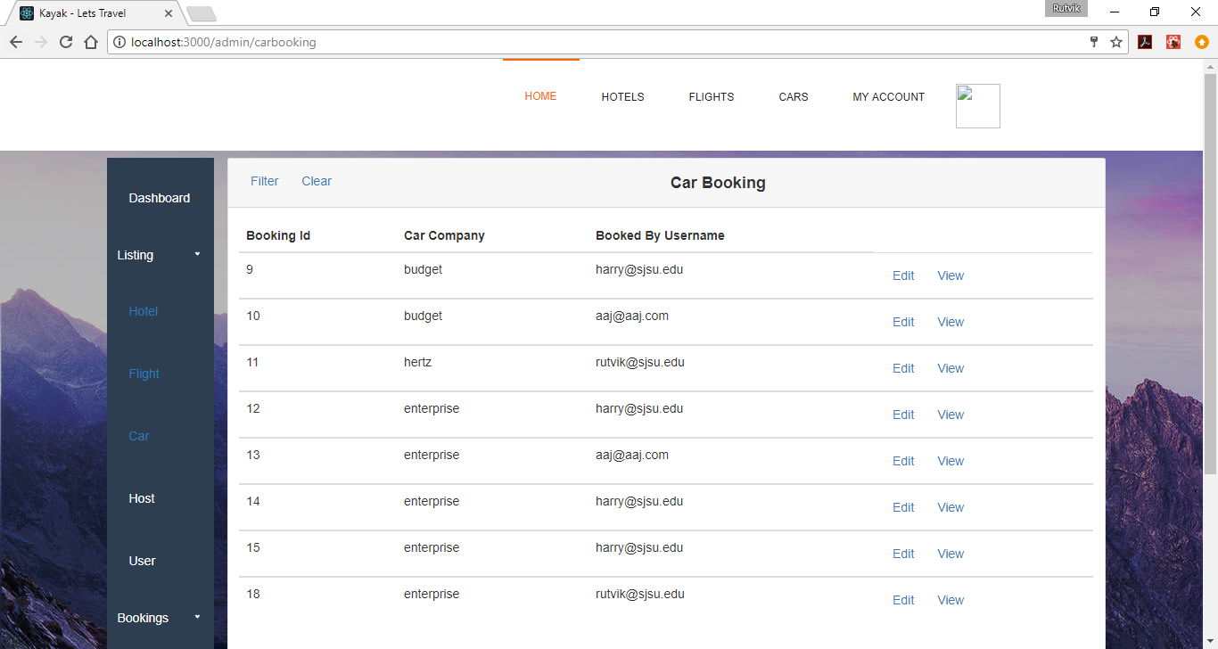

53. Admin - Setting up admin profile

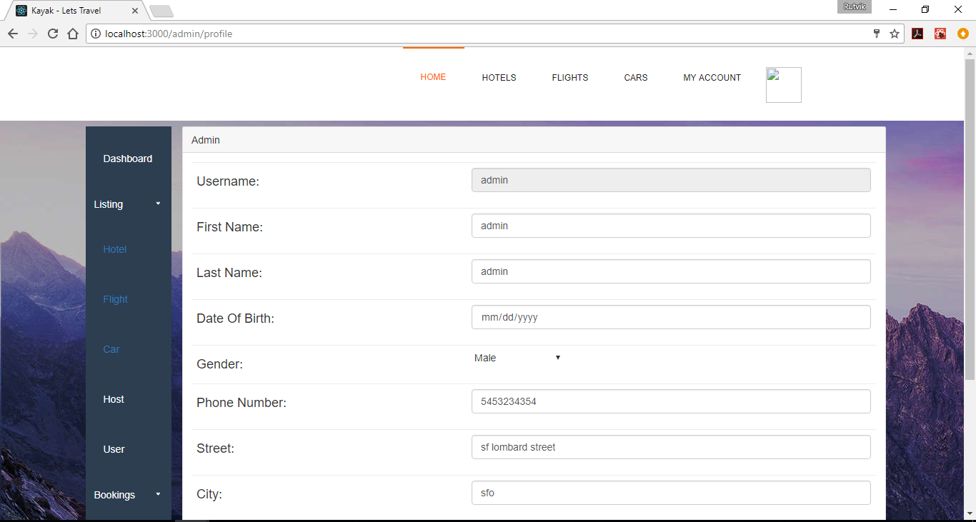

54 - Admin : Search Hotel by categories

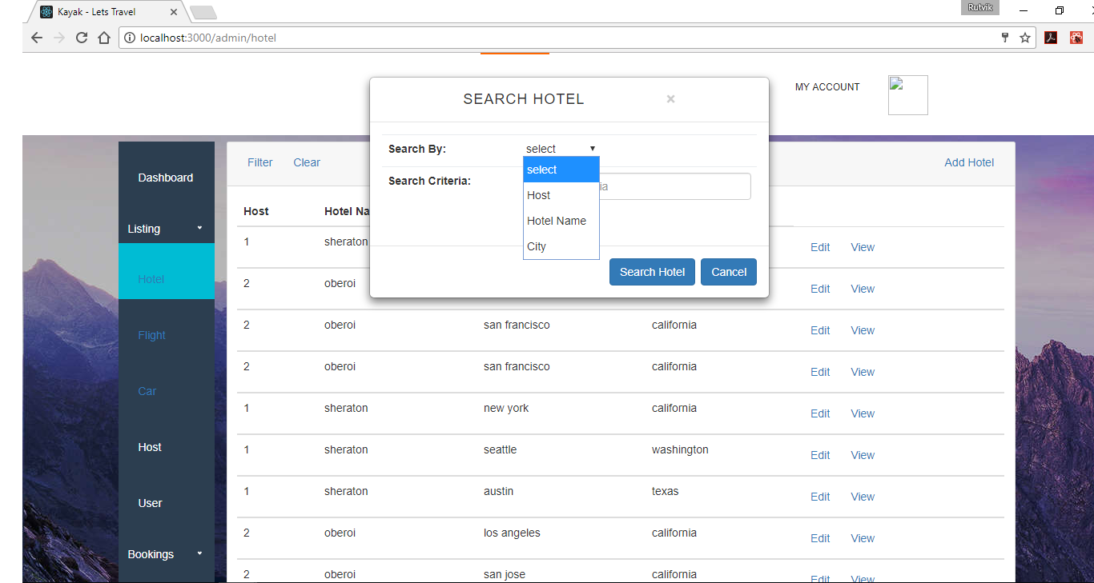

55 - Admin : Search Hotel by categories : Hotel name - Oberoi

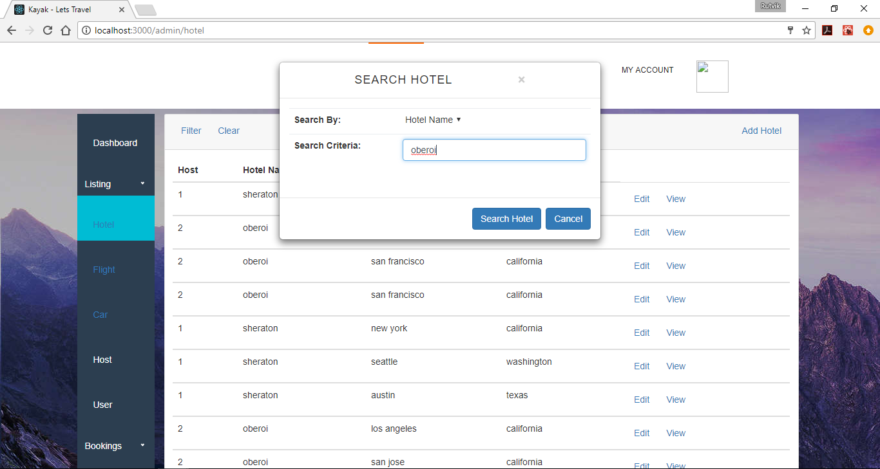

56. Admin : Search criteria results for Hotel Oberoi

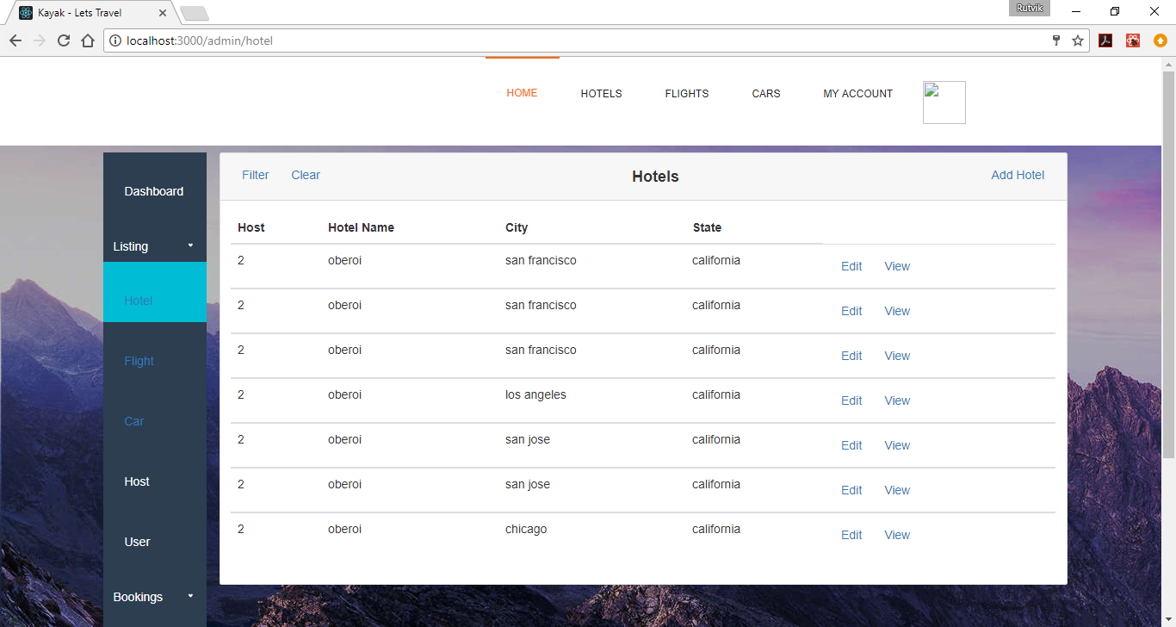

57. Admin: Edit Hotel Details

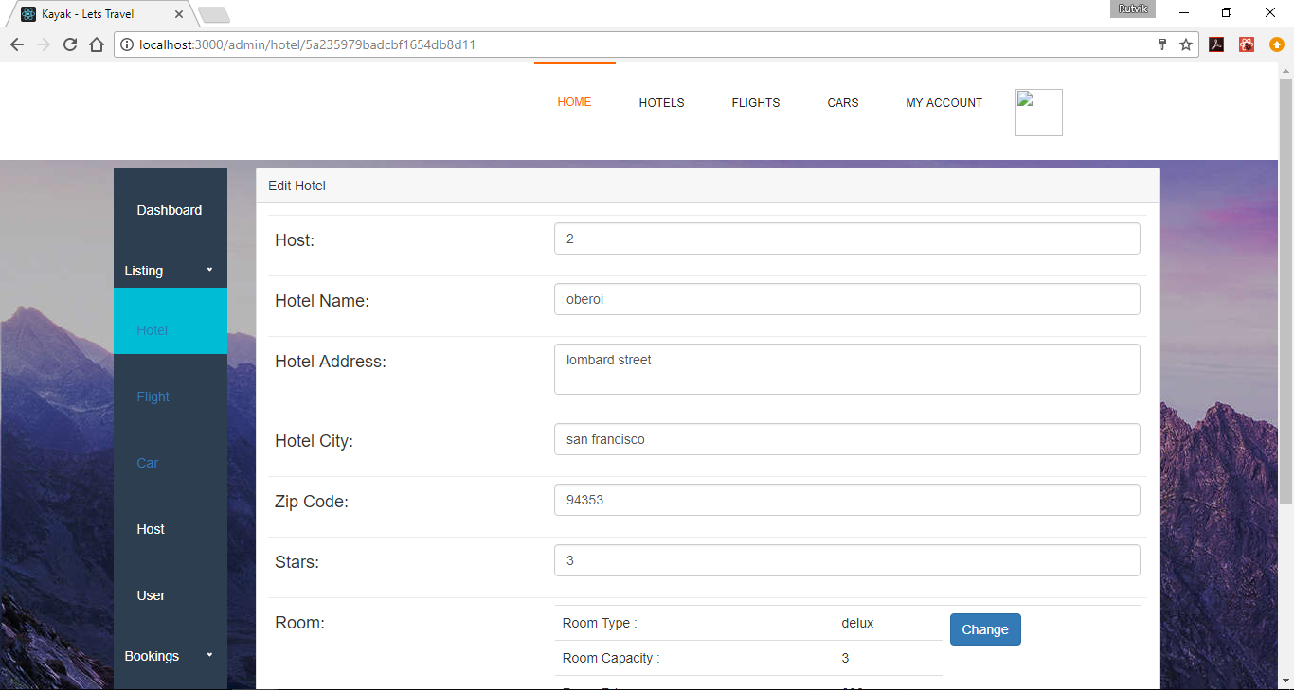

58. Admin - Search flight by criteria

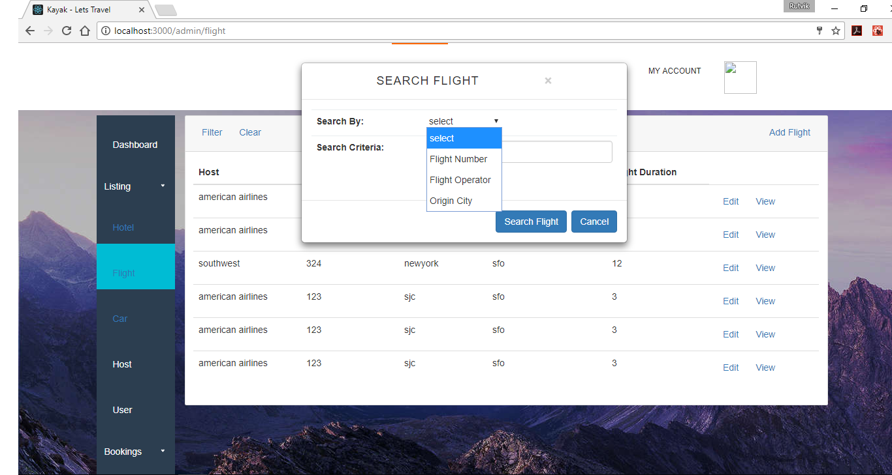

59. Admin - Search Flight (criteria: flight number = 123)

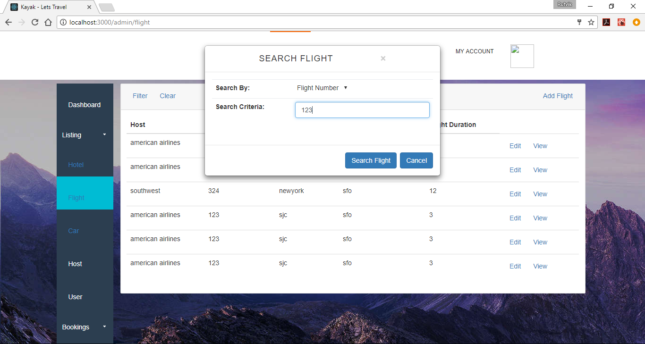

60. Admin - Search Flight (by criteria) - results

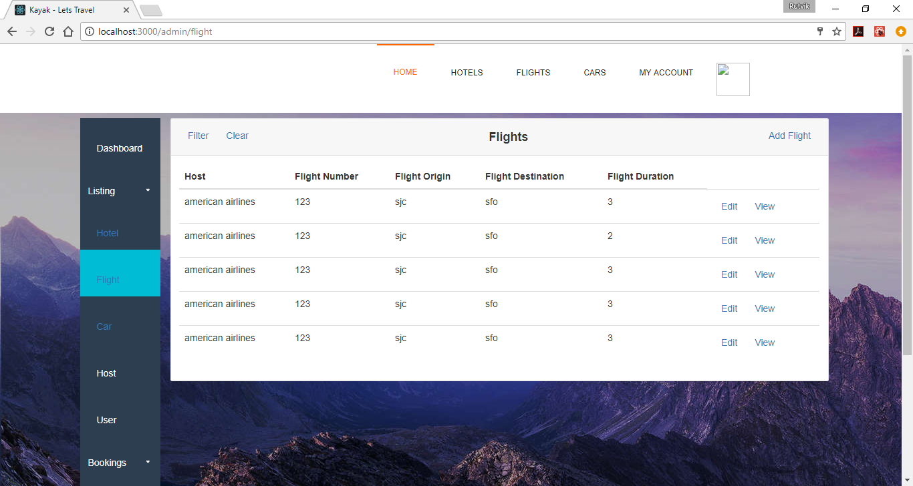

61. Admin - Edit Car details

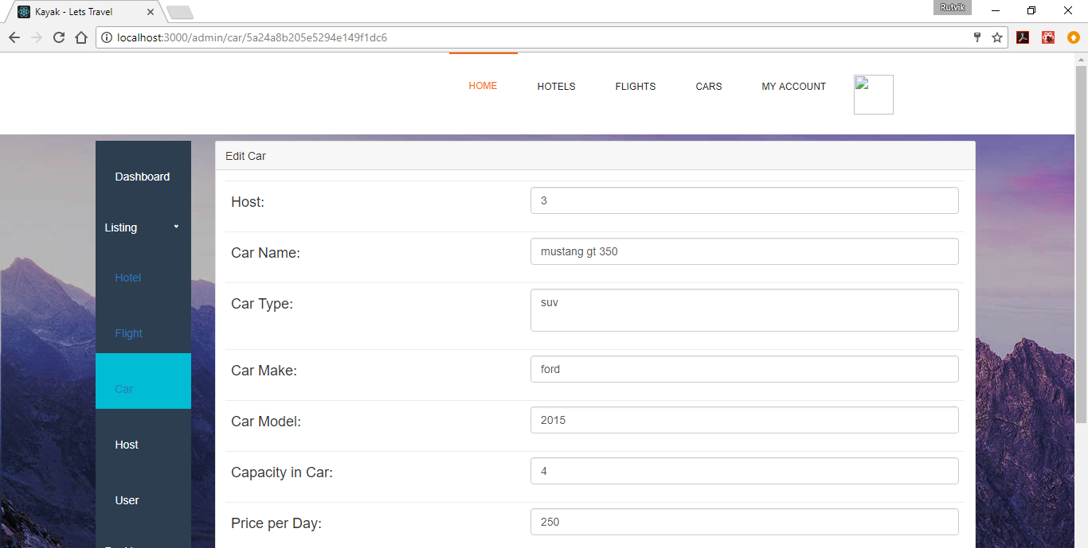

62. Admin - Edit car (From mustang gt 350 - FORD FIGO)

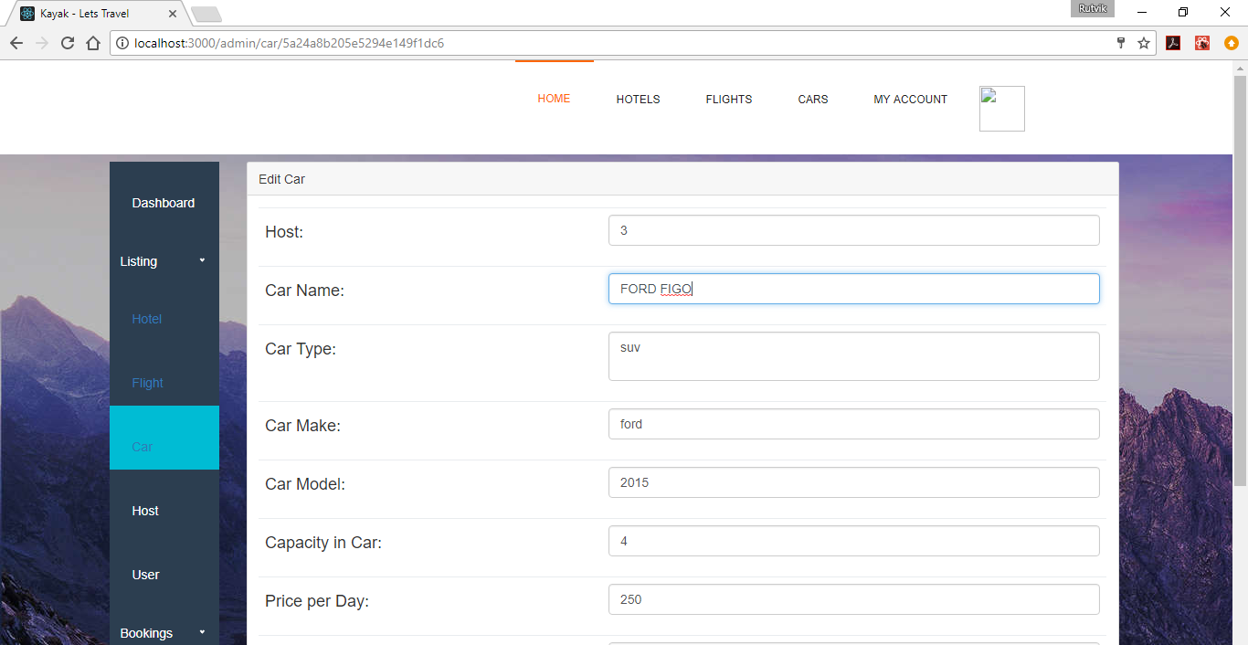

63. Admin - Edit car - Results

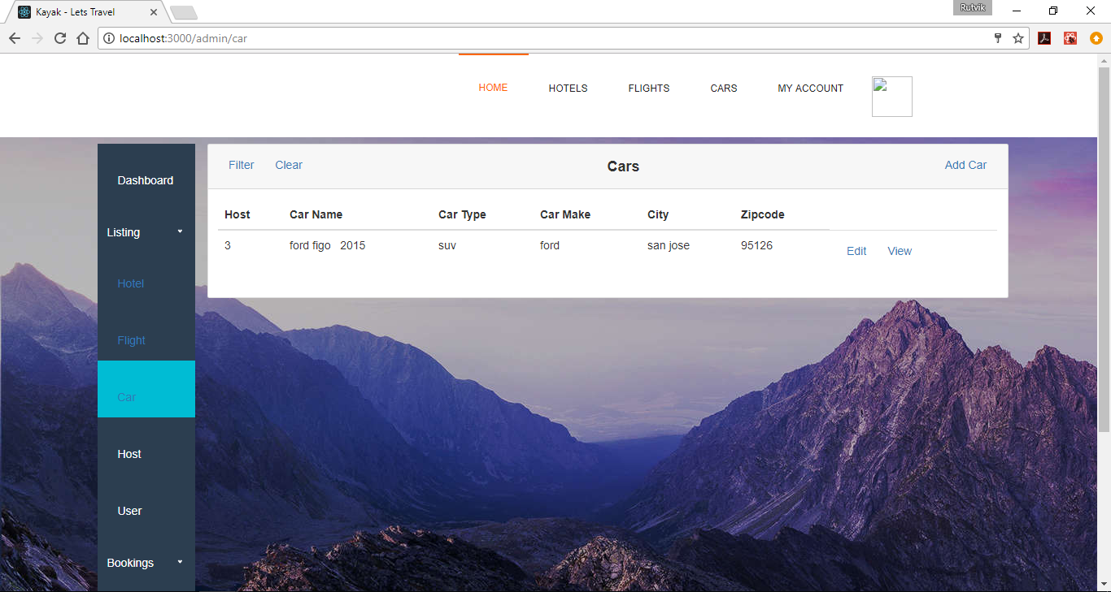

64. Admin - Filter Hotel Bookings - Available criterias - filter by Booking id or Username

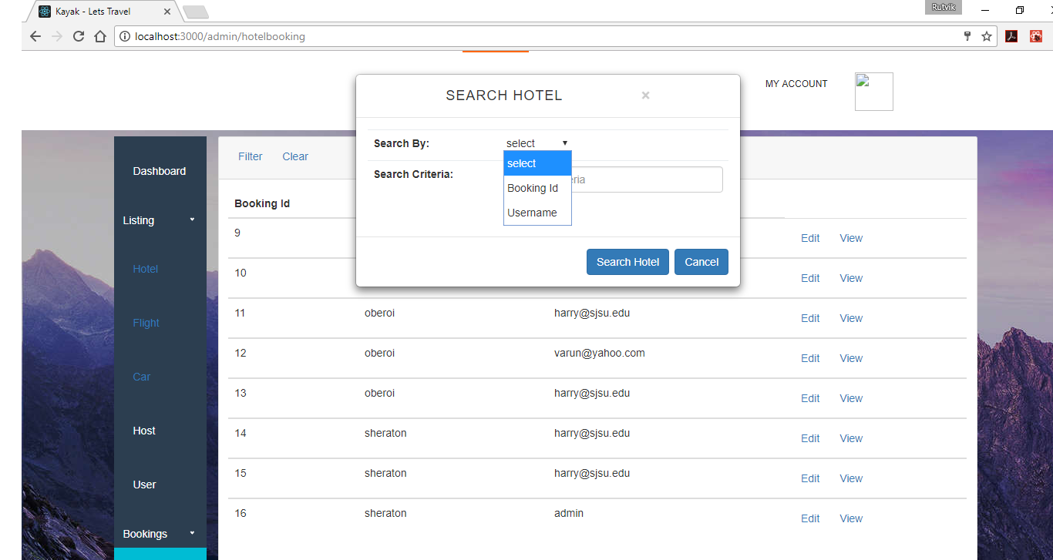

65. Admin - Filter Hotel Bookings - by username = harry@sjsu.edu

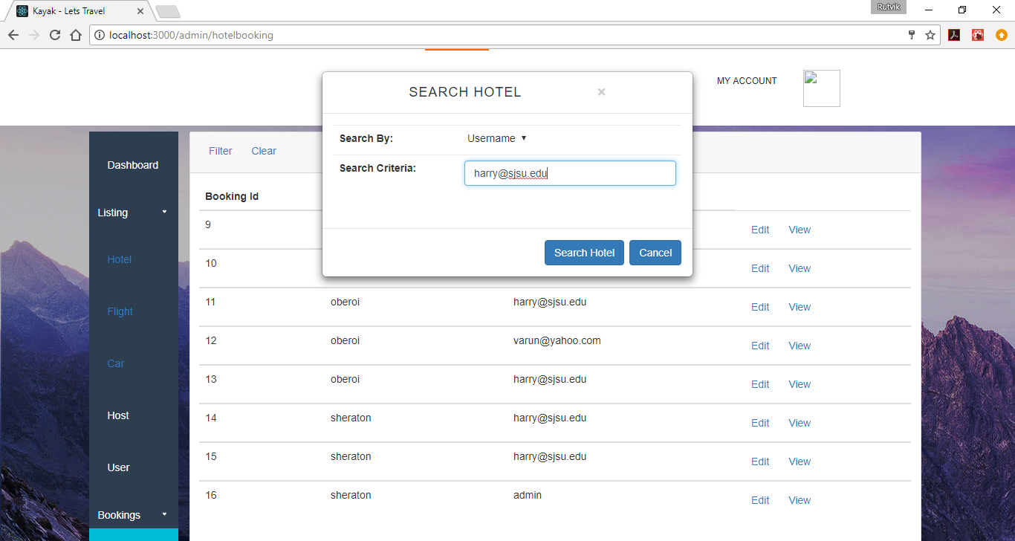

66. Admin - Filter Hotel Bookings - by username = [harry@sjsu.edu](mailto:harry@sjsu.edu) : Results

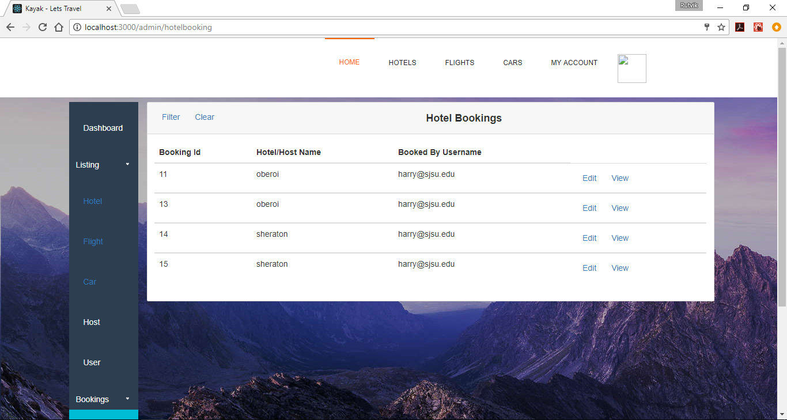

67. Admin - Edit any booking - fields shown below **cannot** be modified

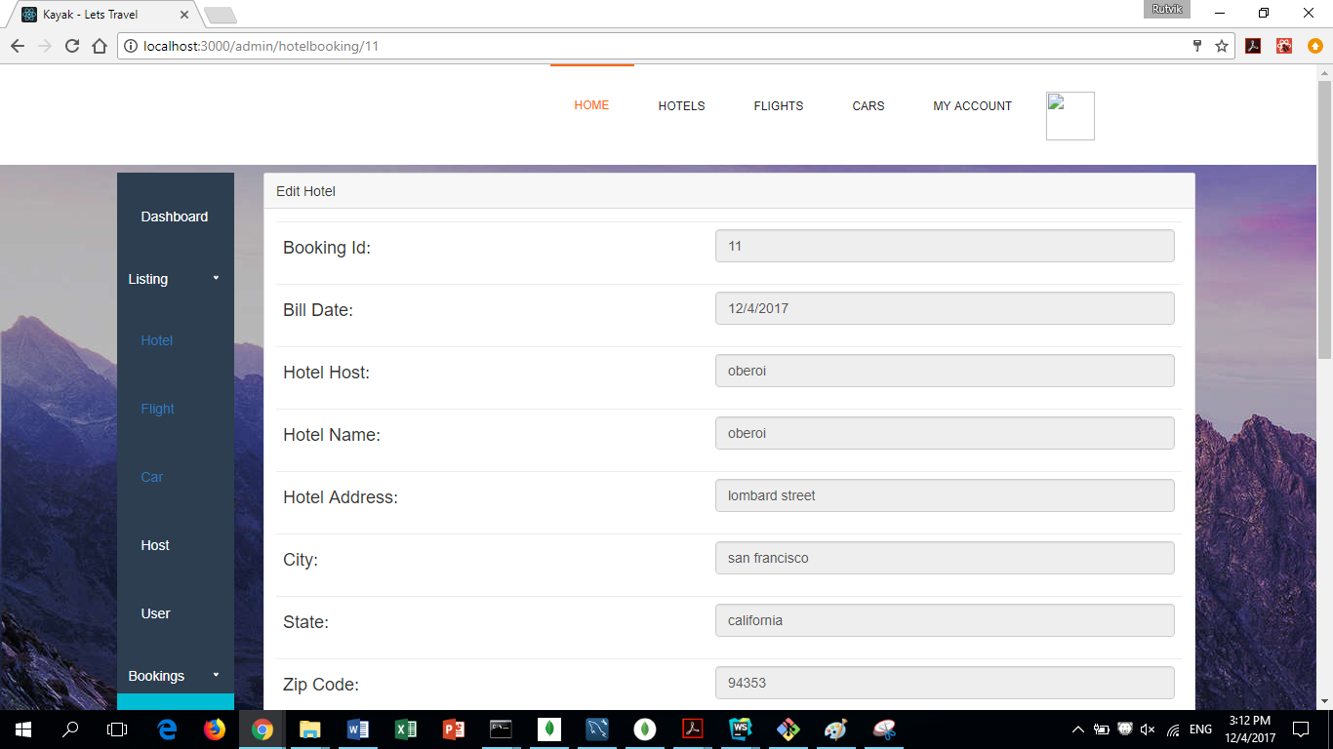

68. Admin - Edit any booking - fields as shown below **can** be modified

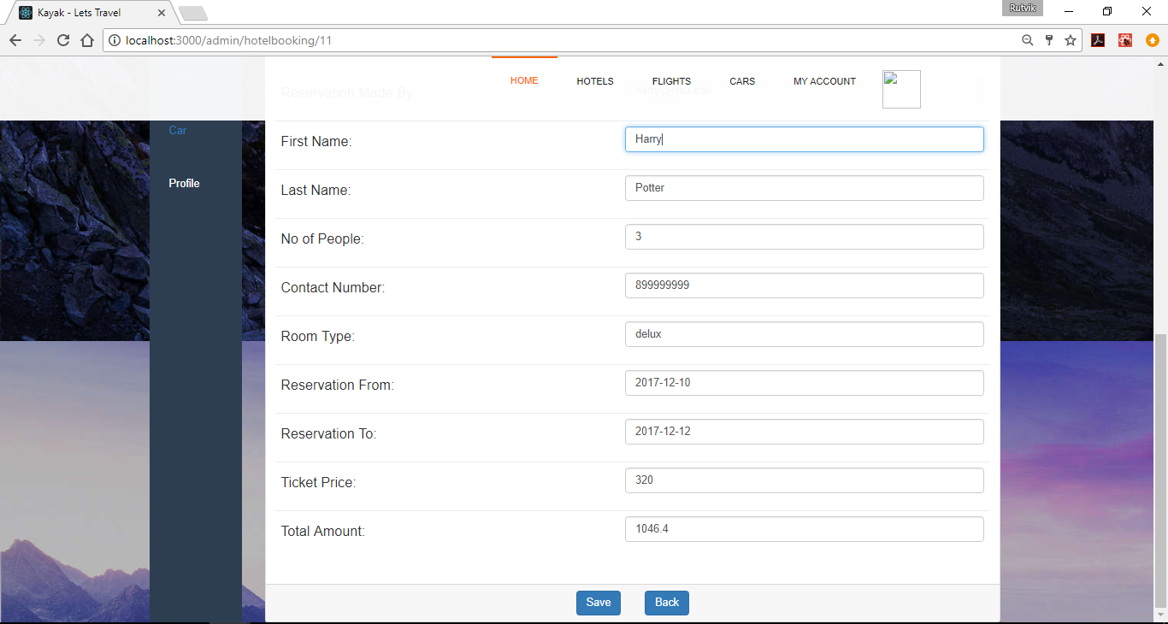

JMETER

1. Base (without kafka, without connection pooling, without redis)
2. No connection pooling , no redis
   1. 100 concurrent users   
      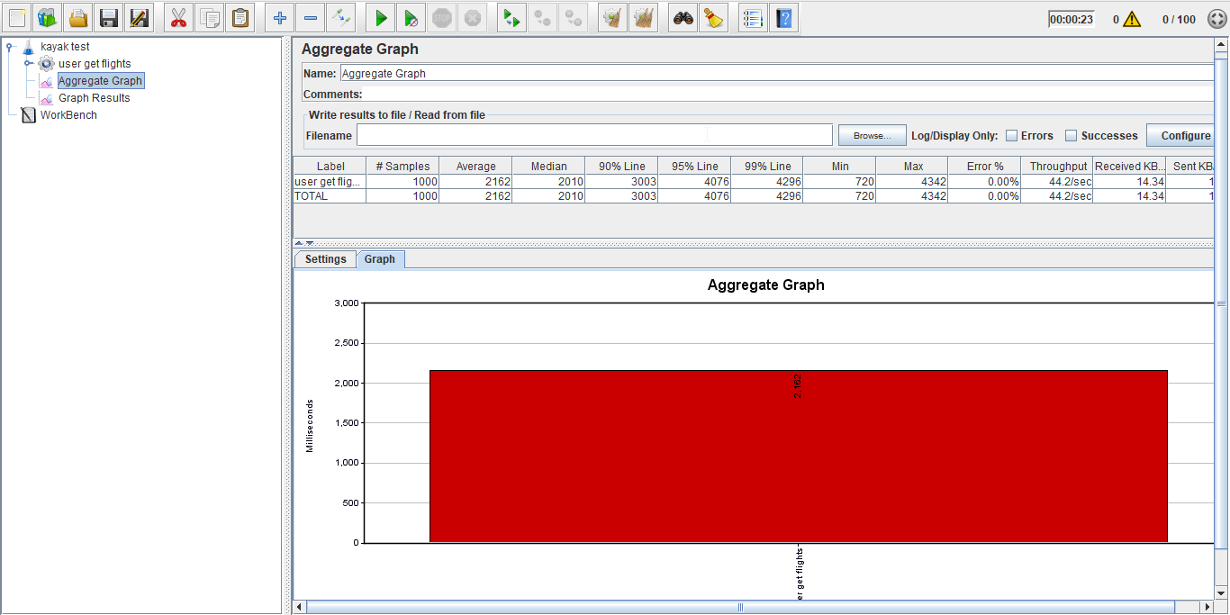  
        
      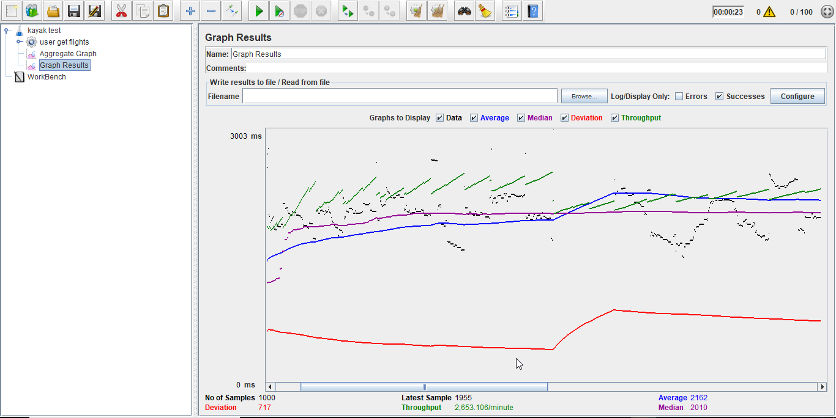
   2. 200 users   
      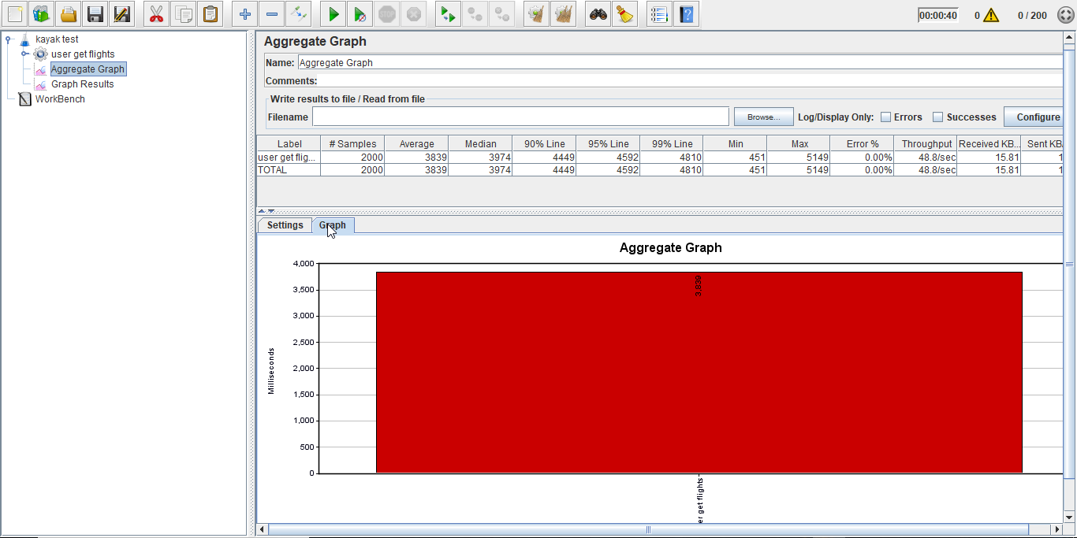  
        
      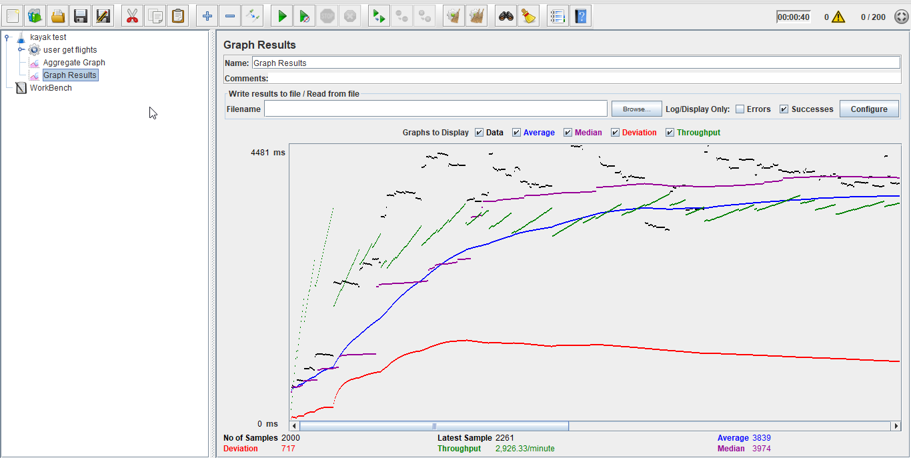
   3. 300 users   
      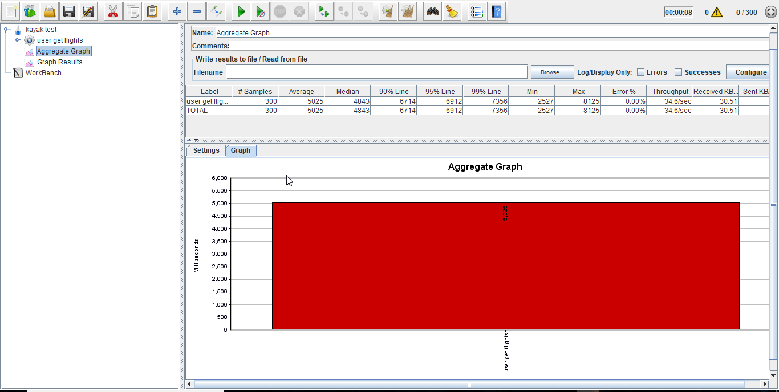  
        
      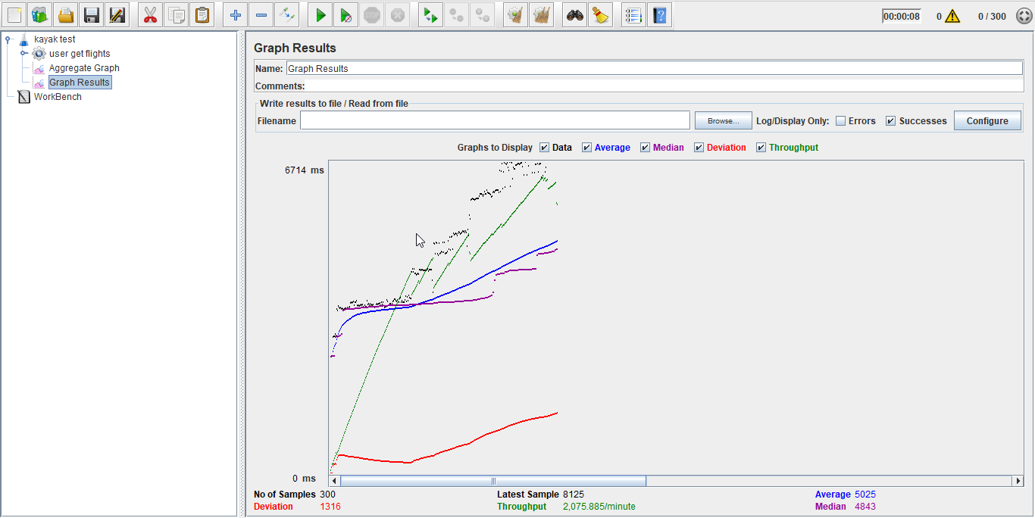
   4. 400 users   
      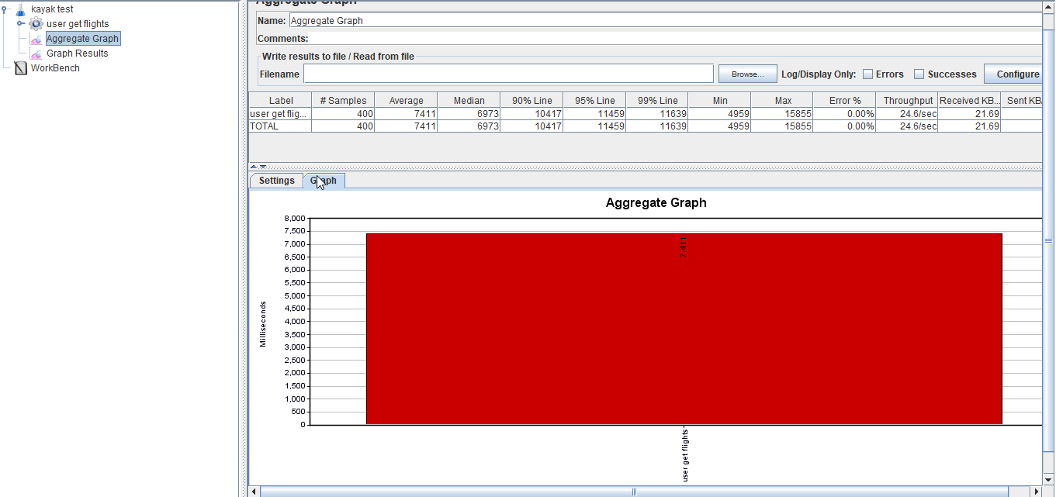  
        
      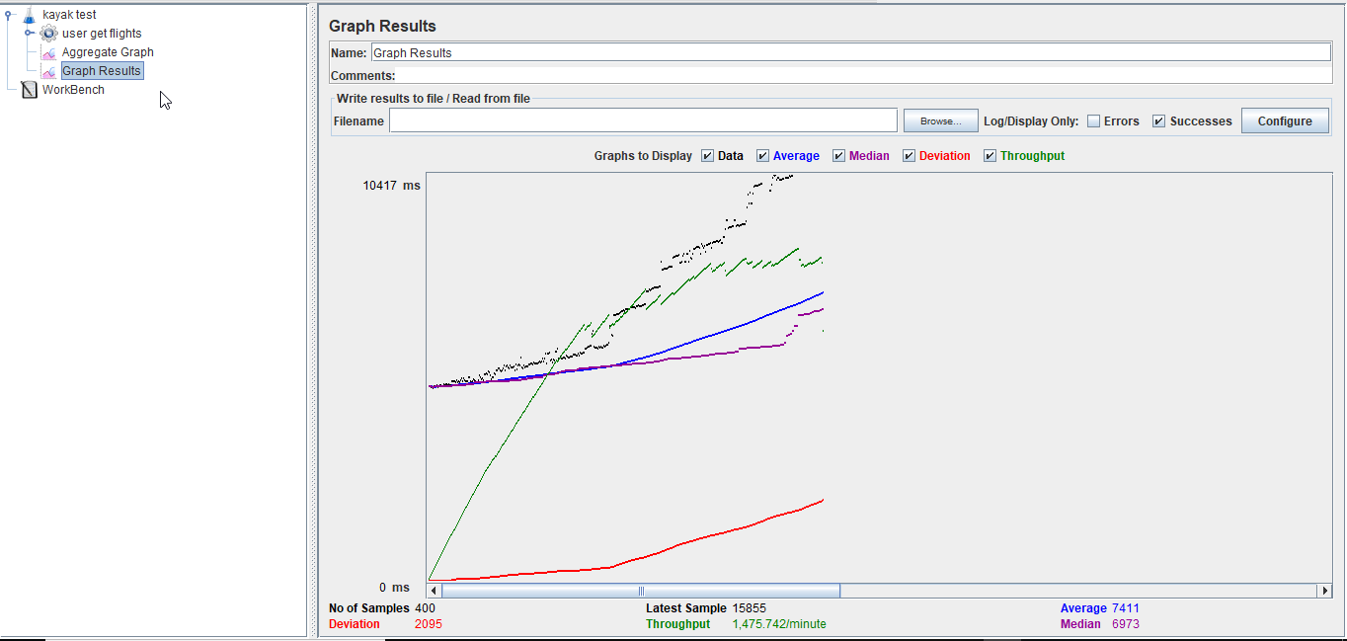
   5. 500 users   
        
      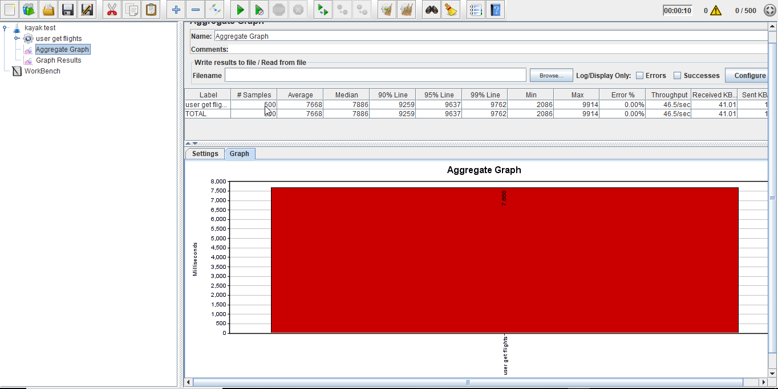  
        
      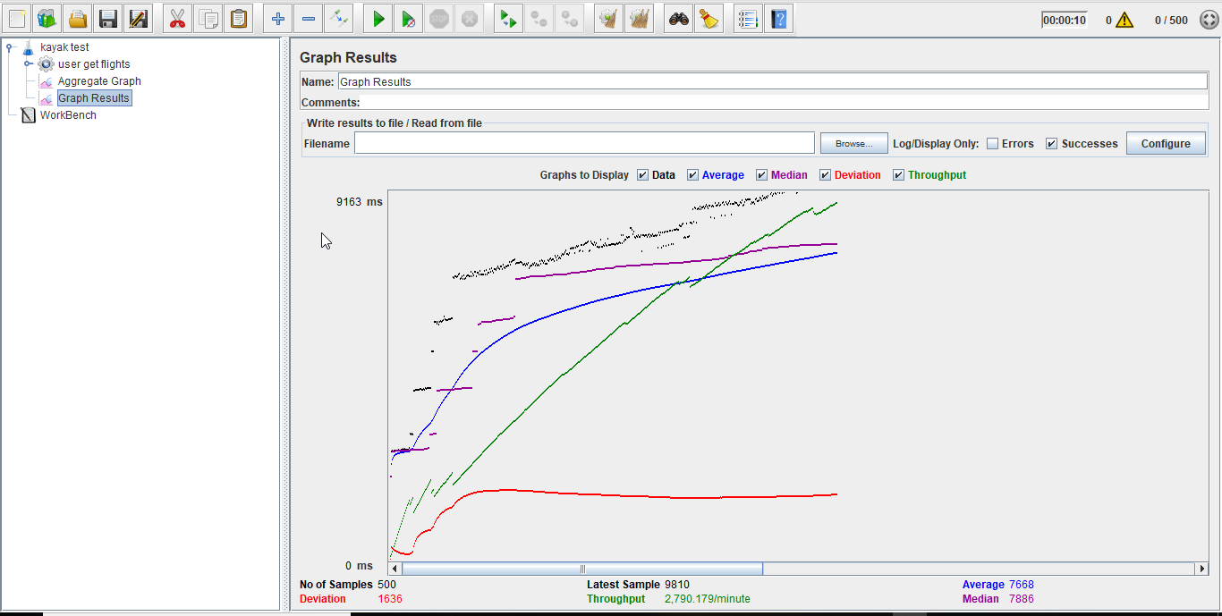
3. With connection pooling , no redis
   1. 100 concurrent users  
      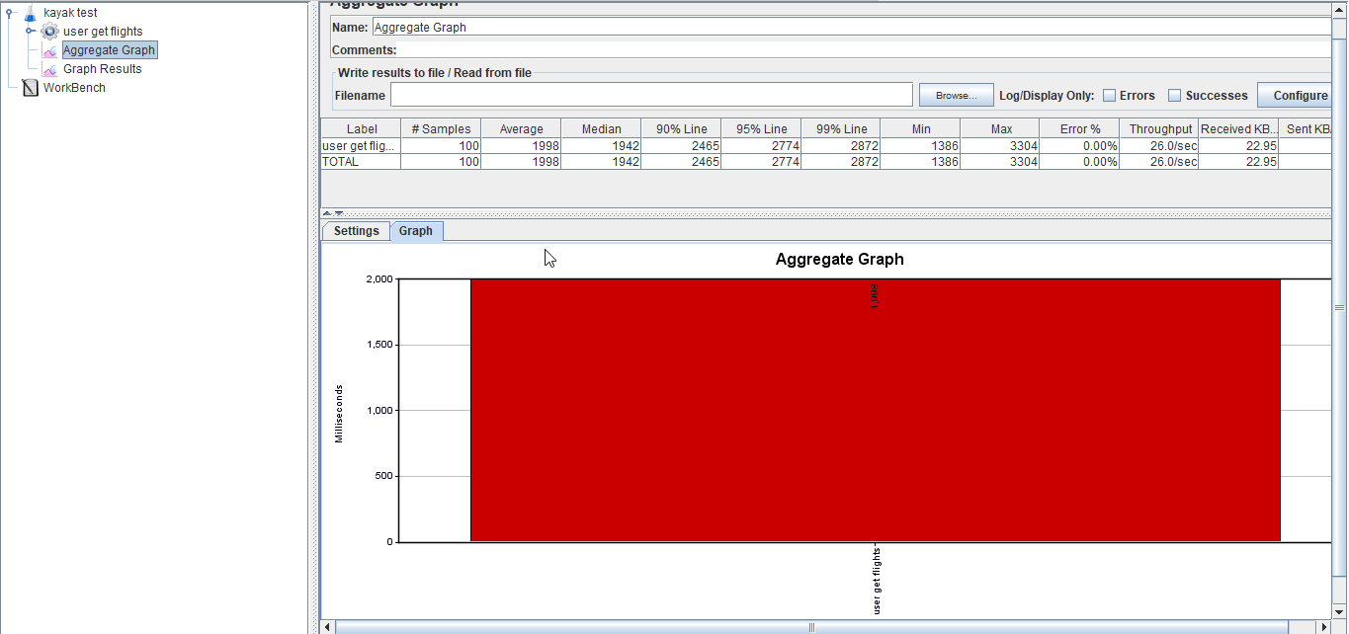  
        
      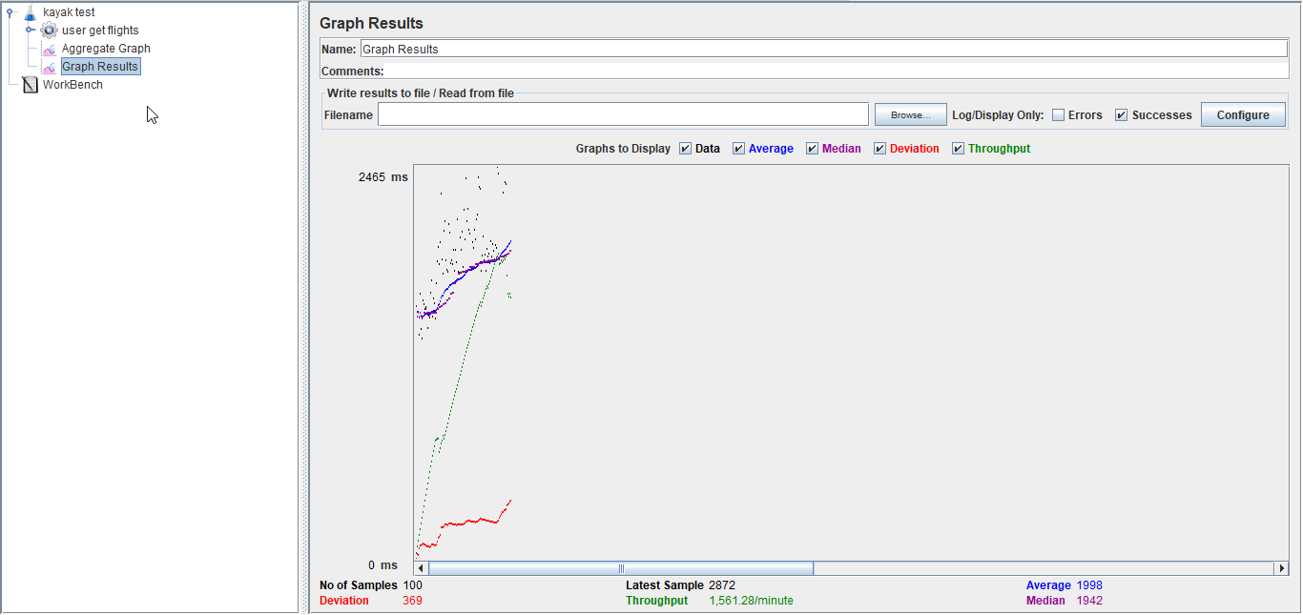
   2. 200 users   
      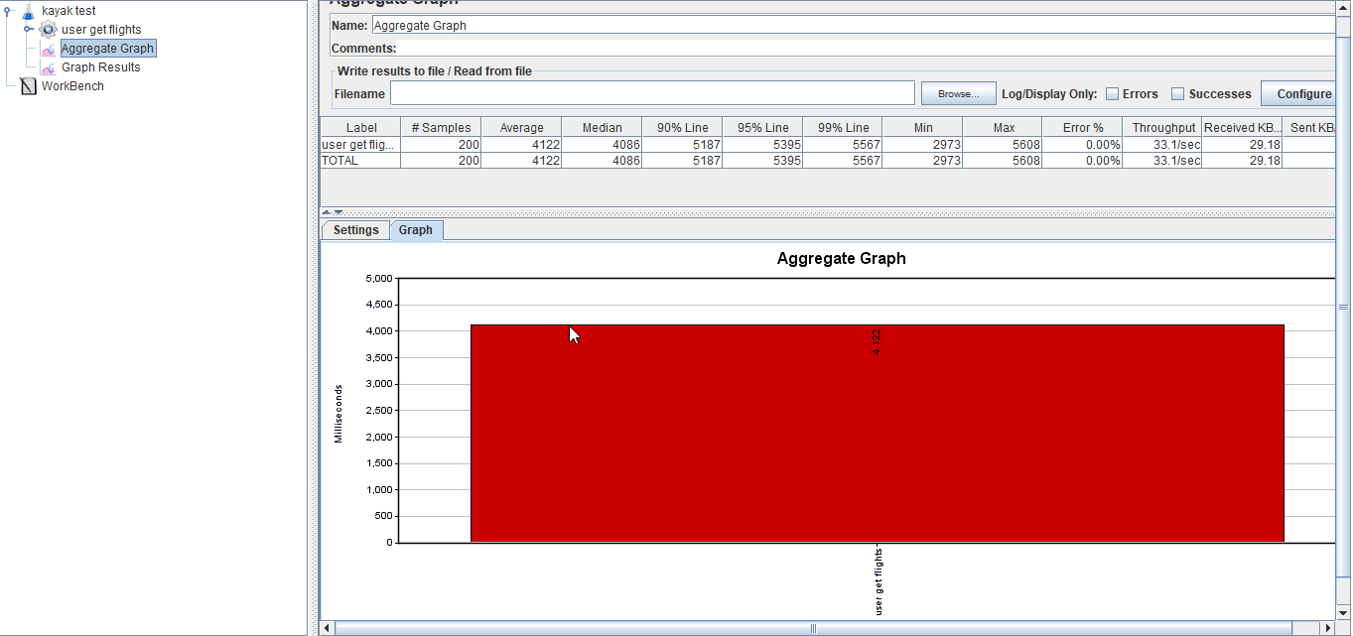  
        
        
      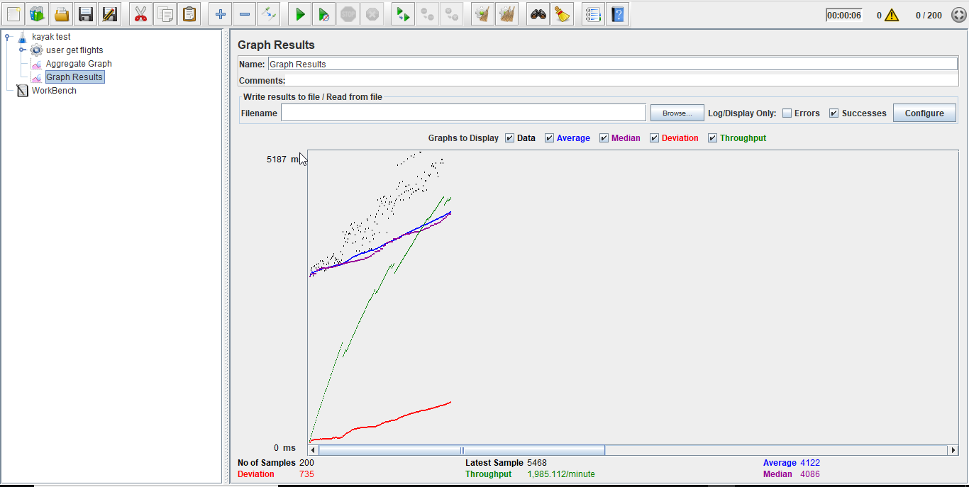
   3. 300 users   
        
      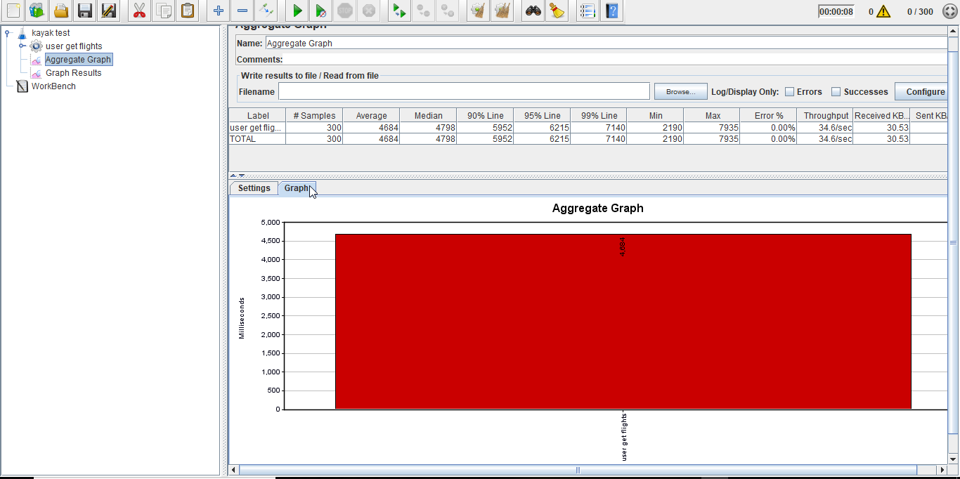  
        
      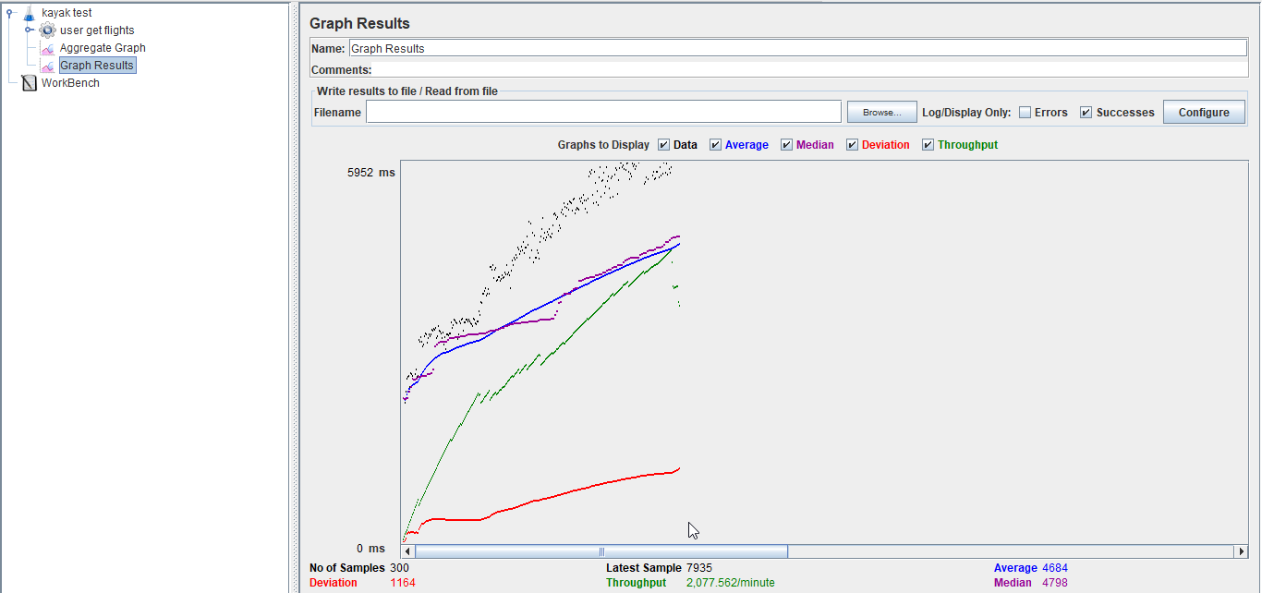
   4. 400 users   
      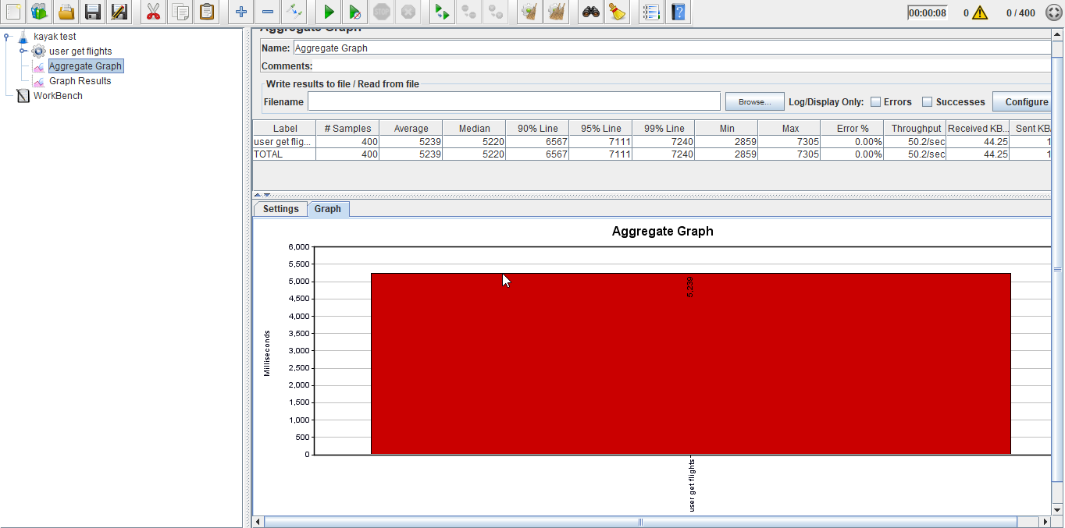  
        
      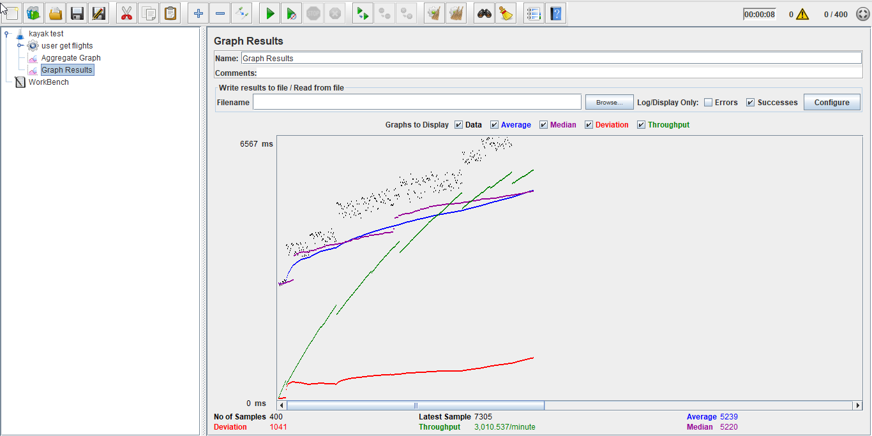
   5. 500 users   
      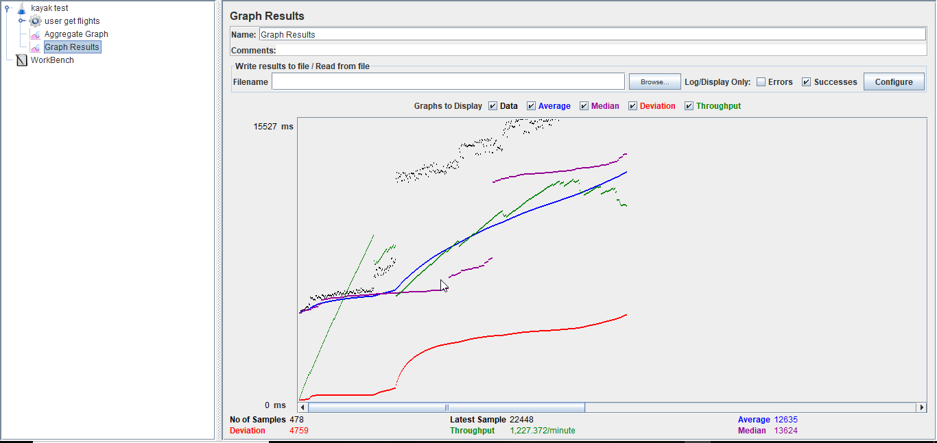  
        
      
4. With connection pooling and redis
   1. 100 concurrent users  
      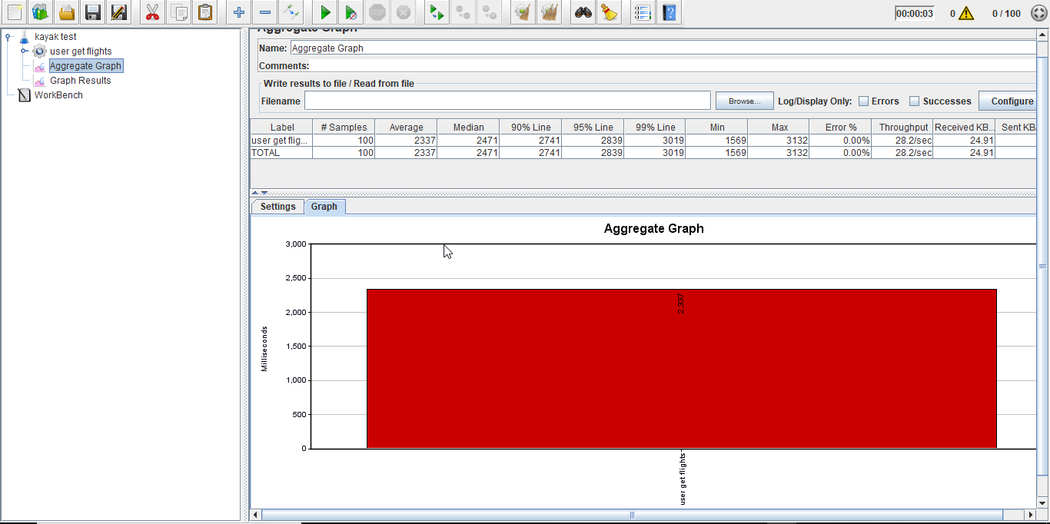  
        
      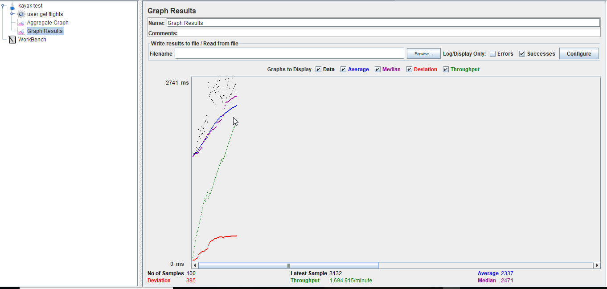
   2. 200 users   
      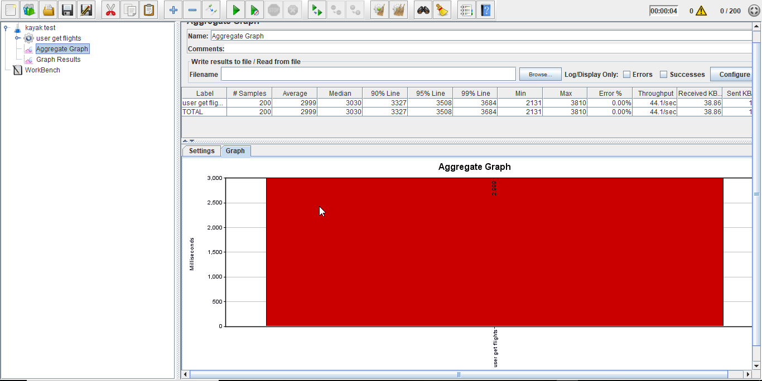  
        
      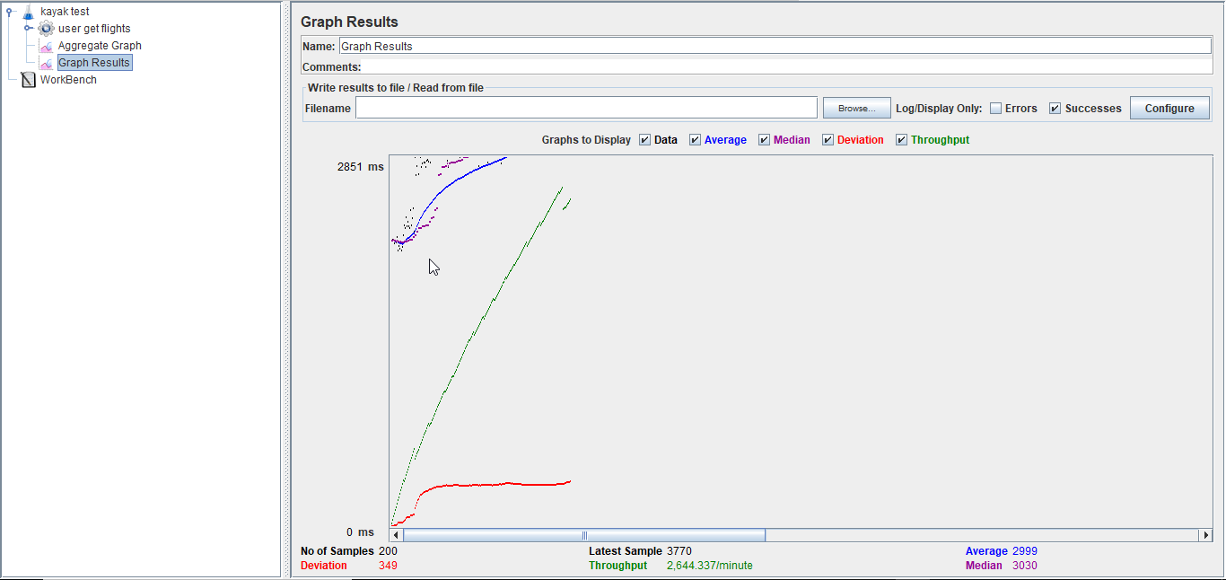
   3. 300 users   
      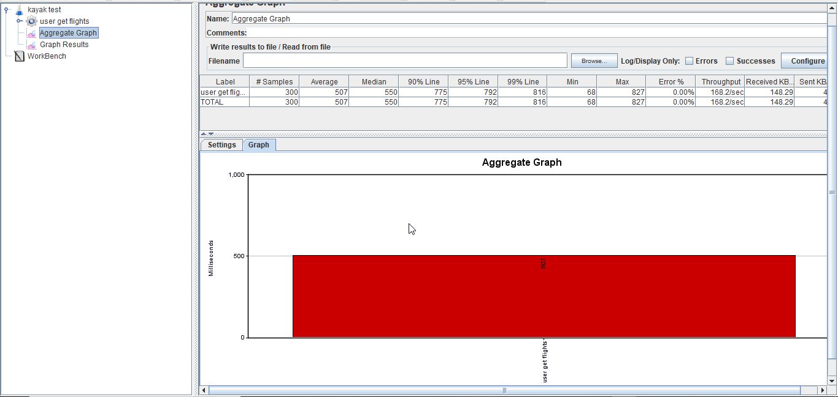  
        
        
      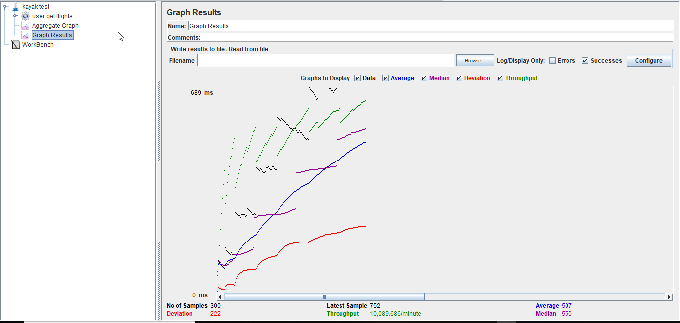
   4. 400 users  
      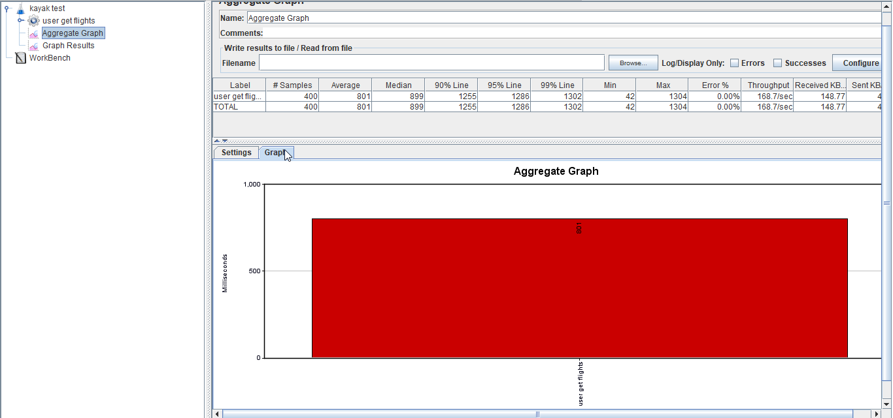  
        
      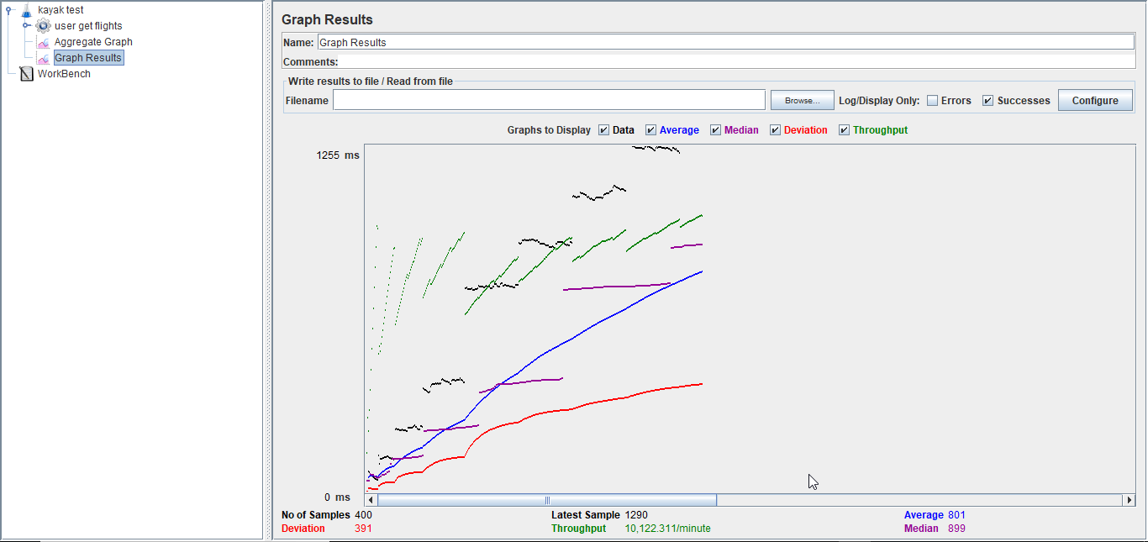
   5. 500 user   
        
      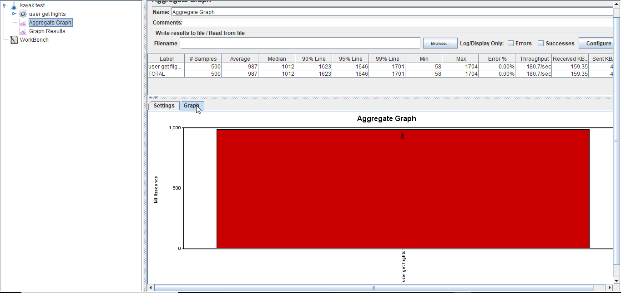  
        
        
      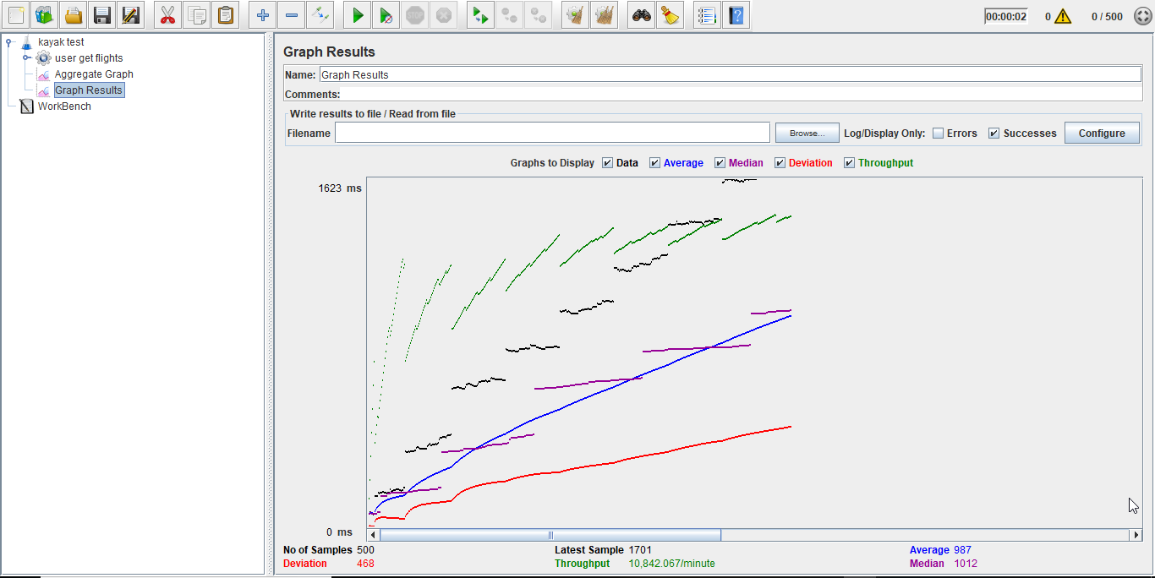

PERFORMANCE:

